 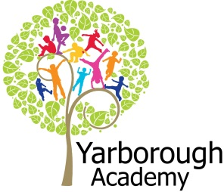

**Curriculum Opportunities**

Personal, Social and Emotional Development

Being more outgoing towards unfamiliar people and more confident in new social situations.

Showing an understanding of boundaries and routines

Communication and Language

Listening to stories with increasing attention and recall

Beginning to understand ‘why’ and ‘how’ questions.

Using simple sentences when speaking

Shows understanding of prepositions such as ‘under’, ‘on top’, ‘behind’ by carrying out an action or selecting correct picture.

Physical Development

Moves freely and with pleasure and con dence in a range of ways, such as slithering, shuf ing, rolling, crawling, walking, running, jumping, skipping, sliding and hopping.

Experiments with different ways of moving.

Literacy

Repeating words or phrases from familiar stories.

Listening and joining in with stories and poems, one-to-one and also in small groups

Distinguishing between the different marks they make.

Hears and says the initial sound in words.

Mathematics

To order 2 or 3 items by size

To touch count to 10 and begin to count beyond 10

To realise not only objects, but anything can be counted, including steps, claps or jumps

Orders two items by weight or capacity

Uses familiar objects and common shapes to create and recreate patterns and build models

Understanding the World

Shows care and concern for living things and the environment.

Can talk about some of the things they have observed such as plants, animals, natural and found objects.

Expressive Arts and Design

Uses simple tools and techniques competently and appropriately.

introduces a storyline or narrative into their play.

**Project Based Learning**

Nursery

Half Term 2

2017

**Project Overview**

Our project until Easter is “Who lives in the woods?” We will be going on a nature trail in the woods to find out who lives there!

The children will be immersed into their learning every week with a ‘wow’ activity relating to the focus. Each week we will be learning about a different story relating to the woods. For our first focus we will visit the three bears cottage in our classroom! We will look at what has happened to furniture in the cottage and talk about who might have been there! For our second focus we will look at the story of the Gruffalo. We will create a gruffalo den to see if we can encourage him into our garden. After that we will read the story of Little Red Riding Hood. We will act out the story to see if we can work out where Grandma might be! We will also play what time is it mr wolf and observe the effect of activity on our bodies! We will then read Squirrel Me Timbers. We will go on a treasure hunt for the Squirrels acorns and then make our own map! We will also count the acorns and put them into a numicon array. Next we will look at the story of Owl Babies. We will talk about our feelings and why our parents are special to us! For the last part of our project we will look at Peter Rabbit. We will link this with Easter and make some easter crafts. We will also weigh eggs and look at repeated patterns with vegetables. Our exhibition will be a trip to the Waterworks woods to go on a woodland nature trail.

**Immersive Environment**

The classroom will be divided into the following areas: creative, artistic, construction, investigation, small world, home, listening, reading, fine motor, computing and games.

These areas will be changed regularly to immerse children into the focus of that week.

**Who Lives in the Woods?**

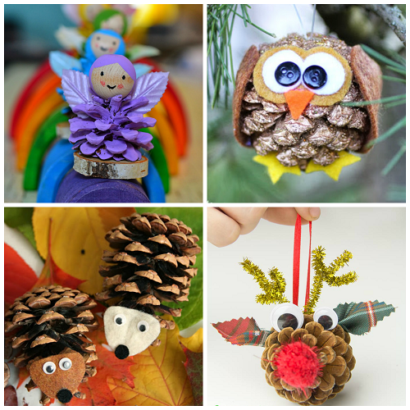

**Project Timeline**

Focus 1

Goldilocks and the Three Bears

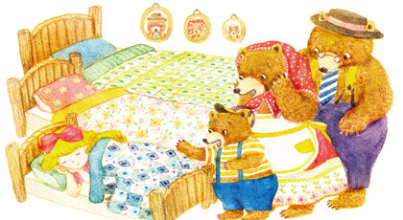

Focus 2

The Gruffalo

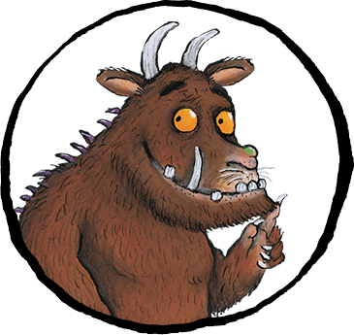

Focus 3

Little Red Riding Hood

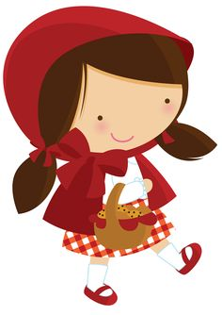

Focus 4

Squirrel Me Timbers

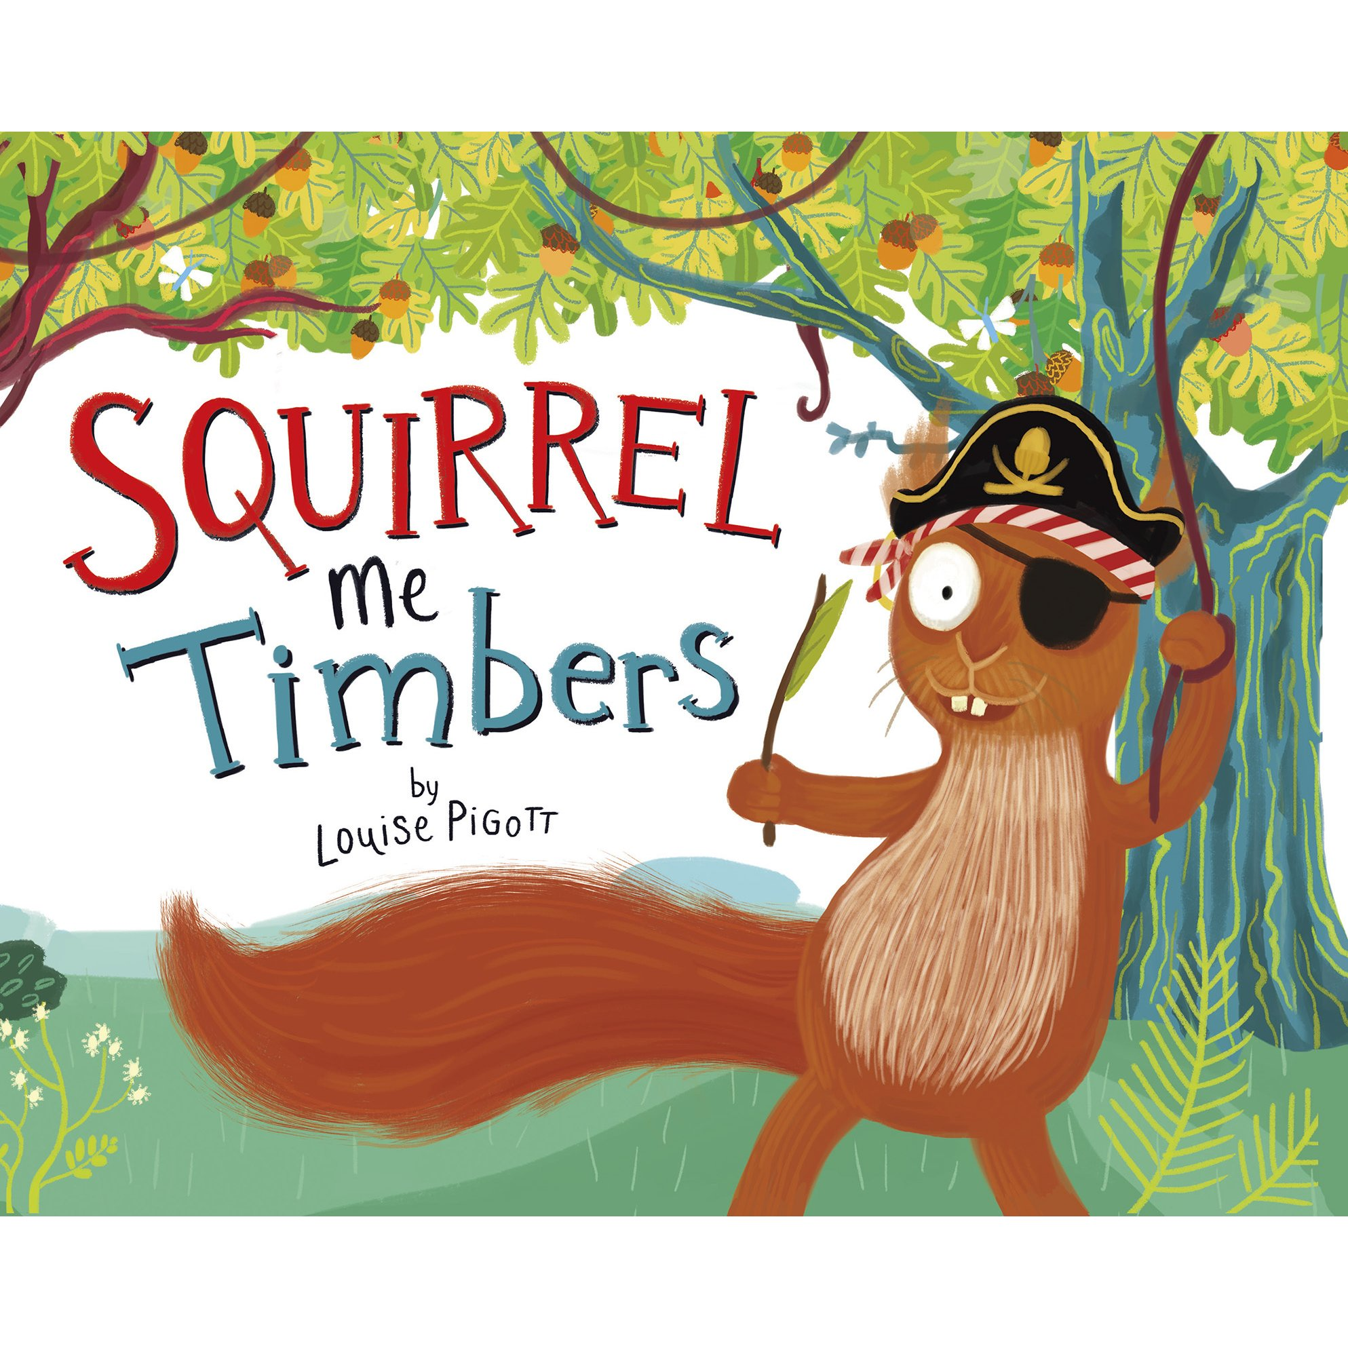

Focus 5

Owl Babies

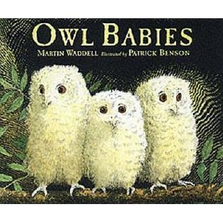

Focus 6

Peter Rabbit

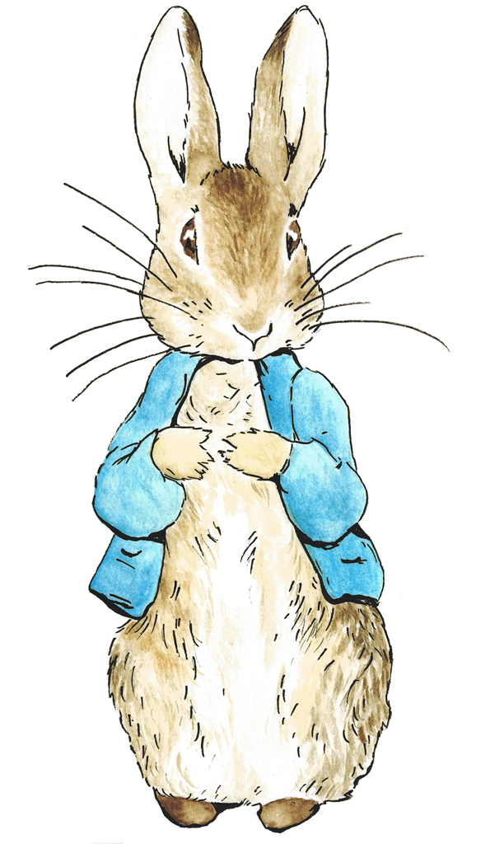

**How can you help?**

If you feel you can help us with our project this term we would love to hear from you!

You can also help with the project by doing the following at home:

* Going on walks to the woods and talking about the trees and wildlife
* Retelling stories and using lots of story language such as ‘once upon a time’
* Playing rhyming and initial sound games
* Looking at the different sizes of objects and using the language of ‘tall’ and ‘small’

Useful website for parents:

[www.cbeebies.co.uk](http://www.cbeebies.co.uk), <http://www.peterrabbit.com/play/> , <http://www.gruffalo.com> , <http://www.bbc.co.uk/cbeebies/search?q=wood>

**Project Outcomes**

This project will involve the children using cross-curricular skills to help them answer the essential question of “Who lives in the woods?’’

The final exhibition will be on the 23rd March starting at school and then a short walk to Waterworks woods. Morning children at 9am and the afternoon children at 2pm. This will be an opportunity for you to go on a woodland nature trail with your child!

**Project Enhancements**

Trips and Visitors

We hopefully will be having a visit from an Owl when reading the story of Owl Babies. We will also be going on a woodland nature trail in Waterworks woods.

Class books – Goldilocks and the Three Bears, The Gruffalo, Little Red Riding Hood, Squirrel Me Timbers, Owl Babies, Peter Rabbit, We’re Going On a Bear Hunt, The Jolly Postman, Mr Wolfs Pancakes, What Time Is It Mr Wolf?, Fantastic Mr Fox, The Owl who was Afraid of the Dark.

Clips/ Vidoes online – Yogi Bear, Paddington, Cbeebies – Meet Duggee and the Squirrls, Cbeebies - Dance Like a Squirrel, Cbeebies - Melody and the Owl, Cbeebies – Rabbit Dance, Three up a tree

Creatve Home Learning – Can you collect a fir cone on your next visit to the woods and make a woodland creature?