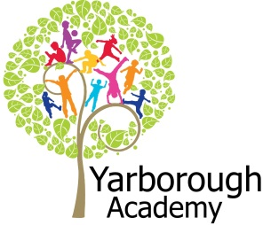

**How can we create our own Fairytale kingdom?**

**Project Overview**

**Our project this term is all about fairytales and how we can create our own fairytale kingdom. We will be listening to stories relating to fairytales and becoming familiar with the structure and language of them.**

**The children will be hooked into the learning by going to a fairytale ball in which they can dress up as a prince or princess! A fairytale character will also be making a special appearance!**



**Project Based Learning**

Reception/FS2

Term 1

2015-2016

**Immersive Environment**

**Our classroom will be transformed into a fairytale kingdom and will include:**

**A dragon’s lair**

**Beauty and the Beasts’ castle**

**Sleeping beauty’s bedroom**

**An enchanted forest**

**Curriculum Opportunities**

Personal, Social and Emotional Development

Discussing how different actions make others feel

Discuss times we feel happy, sad, scared, worried, excited

Communication and Language

Listening to the stories

Building up the vocabulary relating to fairytales

Sequencing the stories

Watching clips of the films and discussing the key events

Physical Development

Learning how to hold tools effectively

Using our fine motor skills to cut, manipulate and sew

Literacy

Reading -becoming familiar with a wide range of fairytales,

Writing - character descriptions about a villain, labelling a dragon, creating a story map

Mathematics

Creating a castle using 3D shapes

Using capacity to make fairy potions

Understanding the World

Learning about different communities and places to live (e.g. castles)

Expressive Arts and Design

Mixing colours to paint a castle

Creating a dragon out of clay

Making a lollipop stick fairy prince or princess

Making a villain finger puppet

Using our imaginations to role play with the castle and characters

**Project Outcomes**

This project will involve the children using cross curricular skills to help them answer the essential question of ‘How can we create our own fairytale kingdom?’

The final project will be a creation of our own fairytale land and characters/props. Our final exhibition will be will be a stay and play session. You will have the opportunity to be involved in your child’s performance by role playing with the props they have made.

**Project Enhancements**

Trip - To Lincoln Castle to see Dennis the Dragon

To the auditorium to see a ‘Snow White’ pantomime

Visitors - A visit from a fairytale character

Class books- Sleeping Beauty, Snow White, Beauty and the Beast, The Frog Prince

Creative Home Learning – Can you create your own magical carriage?

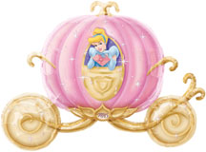

**Project Timeline**

Focus 1

To become familiar with the structure and language of fairytale stories

Focus 2

Making a 3D castle using junk modelling equipment

Focus 3

Creating a dragon out of clay and labelling it

Focus 4

Creating a magic potion using capacity skills

Focus 5

Making a hero character such as a prince, princess or knight

Focus 6

Creating a villain finger puppet and writing a character description

Focus 7

Creating a story using our castle and characters

**How can you help?**

If you feel you can help us with our project this term we would love to hear from you.

You can also help with the project by doing the following at home:

* Reading fairytales at home
* Bring in your child’s favourite fairytale to share in class
* Bring in your child’s favourite fairytale character or toy to share with the class

Useful websites:

<http://www.speakaboos.com/theme/fairy-tales>

online stories and games relating to fairytales

<http://www.topmarks.co.uk/Search.aspx?q=capacity> games relating to capacity