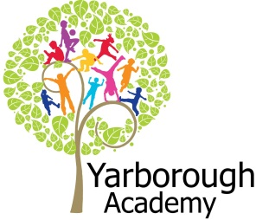

**Project Overview**

Our project this term is all about diseases and how they affect the human body. We will begin by looking at the history of pandemics and how cures have changed over time including the Black Death and Spanish Flu. ‘Bring out ye dead!’

We will be growing and monitoring microorganisms and recording our findings in charts and graphs to show the changes over time.

The children will be hooked in to their learning by a ‘mysterious disease’ to which they will need to find the cure!

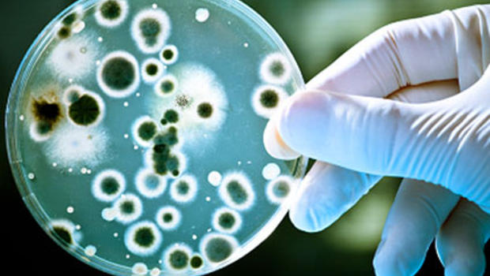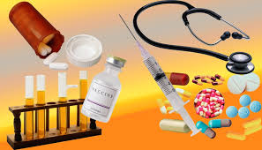

**Project Based Learning**

Year 6

Term 1

2015-2016

**How can we as scientists cure the disease?**

**Immersive Environment**

Our classrooms will have a ‘rotten, diseased, decaying theme’ with a science lab area for research purposes. There may be a need for a quarantine zone too should the need arise!

Displays will include the history of diseases and research the pupils carry out.

**Curriculum Opportunities**

Writing

- Write diaries from the times of the Black Death

- Poetry that convey an image

- Explanation text about how cures and beliefs of medicine have changed

- Fictional writing including the character making an escape!

- Non-chronological reports about a disease of the pupil’s choice

Maths

- Gather, organise and interpret data

- Fractions, percentages and statistics of data

- 3D shapes

Science

- Look at the human digestive system, circulatory system, muscles and skeletons

- Examine the classification of animals, plants and microorganisms

- Considering the effects of drugs on the human body

Geography

- Locating the countries that different diseases originated in

History

- Create a timeline of diseases and research how medical knowledge has changed

Computing

- Code a game

**Project Enhancements**

Trip

A visit to the Thackeray Museum of Medicine, Leeds on Monday 21st September to participate in a workshop involving contracting a disease and how this would affect them.

Visitors

Mr Cox from Novartis to discuss the prescription drug industry in November

Class book

‘The mystery of London Blue Death and a boy called Eel’ by Deborah Hopkinson

**How can you help?**

If you feel you can help us with our project this term we would love to hear from you.

Find out about the side effects of prescription drugs and which medicines are taken by family members at home.

Pupils can read the deliciously gory ‘Horrible Science’ range of books. But not immediately before bedtime! Yuk!

**Project Outcomes**

This project will involve the children using cross curricular skills to help them answer the essential question of

‘***How can we as scientists cure the disease?***’

Their final project will be to make a cure to the ‘mystery disease’.

The final exhibition will be to showcase and persuade local chemical companies to produce their vaccine.

**Project Timeline**

Focus 1

Disease through history

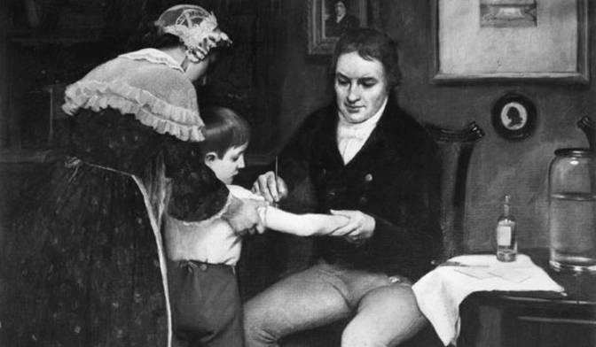Focus 2

How diseases are spread

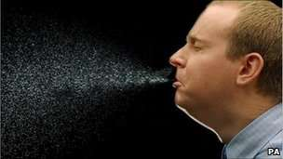

Focus 3

How diseases affect our bodies

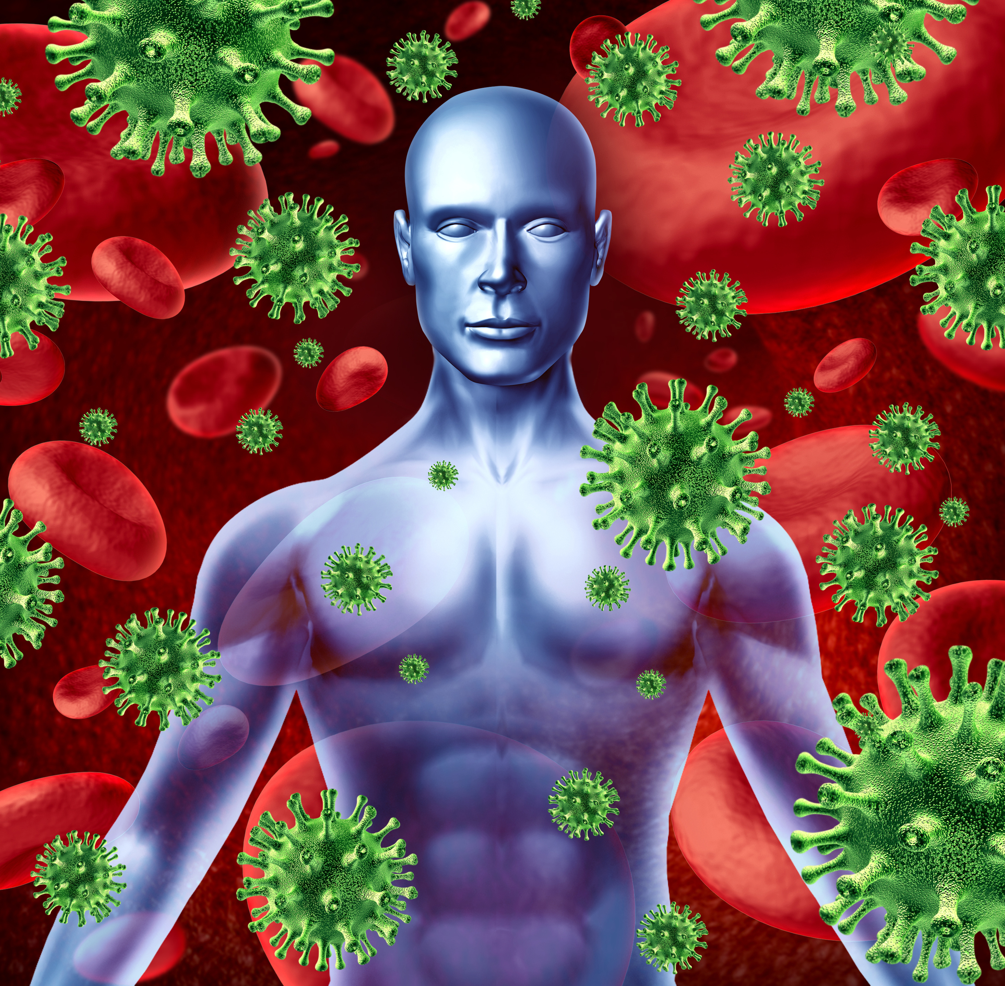

Focus 4

How can diseases be prevented and cured