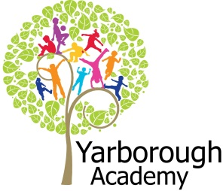

**Immersive Environment**

- Our classrooms will have a superhero theme.

- A Bat cave for the reading area

- Comic strip timeline

**Curriculum Opportunities**

**Writing**:

Write stories set in places. children have been

Write in a journalistic style

Write biographies

**Maths:**

Use the properties of shapes and angles in increasingly complex and practical contexts, including in construction and engineering contexts

**Religious studies:**

Study at least two other religions in depth. Choose from Buddhism, Hinduism, Islam, Judaism or Sikhism

**Design and Technology:**

Through a variety of creative and practical activities, pupils should be taught the knowledge, understanding and skills needed to engage in an iterative process of designing and making. They should work in a range of relevant contexts

**Computing:**

Understand computer networks including the internet; how they can provide multiple services, such as the world wide web; and the opportunities they offer for communication and collaboration

**Music:**

Listen with attention to detail and recall sounds with increasing aural memory.  
 Appreciate and understand a wide range of high-quality live and recorded music from different traditions and from great musicians and composers.  
**Science**Look at the human circulatory system.  
Look at the effect of diet, exercise and drugs  
**Art:**Learn about the great artists, architects and designers in history  
Improve mastery of techniques  
Use experiences, other subjects across the curriculum and ideas as inspiration for artwork

**Project Overview**

Our project this term will entail looking at several Heroes that have changed the world and uncovering what qualities they have that makes them special. The final part of the project will be studying local heroes and what they do for our community. We will then appeal in the Grimsby Telegraph and Compass FM for unsung local heroes. The pupils will then present them with an award honouring their charitable work at an award ceremony, organised by them, which is our exhibition. In our hook sessions the pupils will be invited to an awards ceremony where they will learn all about what the project has in store. During this project we will learn lots of new skills: as writers the pupils will create a story in the style of Roald Dahl, as mathematicians pupils will work to test and prove Pythagoras’ theory, as designers pupils will create a Buddhist banquet for staff celebrating Vehaka, as writers the pupils will create a biography about Tim Berners-Lee, as musicians, pupils will create a music video to the song ‘Imagine’ by John Lennon, as writers pupils will create a newspaper report about the first ever heart bypass, as artists, create a piece of art in the style of Andy Warhol inspired by a personal hero, as members of the community research, select and honour a local unsung hero to form part of an award ceremony.

**Project Based Learning**

Year 5

Term 3

2015-2016

**What makes a hero?**



**Project Timeline**

**Focus 1**

R L Stein

**Focus 2**

Pythagoras

**Focus 3**

Siddhartha Gautama

**Focus 4**

Tim Berners-Lee  
  
**Focus 5**

John Lennon

**Focus 6**

Michael DeBakey

**Focus 7**

Andy Warhol

**Focus 8**

Local Heroes

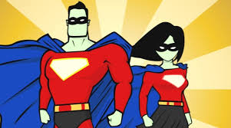

**Project Outcomes**

This project will involve the children using cross curricular skills to help them answer the essential question of:

‘**What makes a hero?**’

Their final project will be combining all of the characteristics that makes a hero and finding local unsung heroes to honour.

The final exhibition will be an awards show to celebrate the local unsung heroes.

**Project Enhancements**

Trip

A visit to local charities to find local heroes

Visitors

Local charities

Help for heroes

Buddhist meditation in Grimsby

Class book

I am Malala by Malala Yousafzai

Creative Home Learning

Design and make your own musical instrument

**How can you help?**

- If you feel you can help us with our project this term we would love to hear from you! Especially if you have any links with local charities or know someone who has!

- Read some of RL Stein’s ‘Goosebump’ books.   
Useful websites:

<http://www.helpforheroes.org.uk/>

<http://historysheroes.e2bn.org/whatisahero/whatmakesahero>