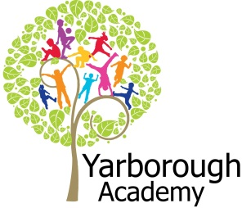

**What is it like to be a farmer?**

**Project Overview**

Our project this term will be all about a farmer and his farm. We will start by talking about a farmer and what job a farmer does. Next we will look in detail about animals that live on the farm. We will be counting animals, looking at where they live, making animal crafts. This will then lead us on to what products do we get from animals, such as the story of milk and where wool comes from. We are going to hatch some real chicks in the classroom. All this work will lead us on to our exhibition based on the story ‘What the Ladybird Heard.” The children will make their own map, including animals, areas of a farm and buildings around the farm. The conclusion of our project will be a farm set up by the children in the hall with all the children’s art work displayed.

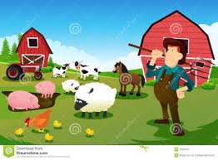

**Project Based Learning**

Nursery/FS1

Term 2

2015-2016

**Immersive Environment**

Our inside and outside classroom will have a farm theme including: a tractor, animal pens, small world farms, books based on farms, farmers market, duck pond, a reading area with animal beanbags, a class scarecrow, dressing up clothes, hay bales to climb on and real chicken eggs ready to hatch!

**Curriculum Opportunities**

**Personal, social and emotional development** – self portraits, working together to feed the animals, care of animals, visit, talk about rights and wrongs of stealing the prize cow.

**Communication and language** – animal sounds, talking about animals, working together to make a farm map.

**Physical development** – dressing up, keeping warm outdoors, climbing on hay bales, tasting animal produce, pencil skills.

**Literacy** – farm stories, sounds on a farm, writing lists of animals, writing animal names, listing products of animals.

**Maths** – counting, sorting, pictograms of favourite animals, counting vegetables, money, categorize animals to correct pens, directions, positional language, size of animals.

**Understanding the World –**animal games on ipad, story of milk, animal products, where animals live on the farm

**Expressive arts and design –**small world farm, singing farm songs, animal crafts, use animal puppets to make up own story, farmers market role play, designing own farm map.

**How can you help?**

If you feel you can help us with our project this term we would love to hear from you.

If you have any old checked shirts, dungarees, flat caps or body warmers we would be very grateful, please inform a member a staff.

Please read any farm books with your child and watch farm shows, so they have a basic understanding of farms

Sing farm songs, such as “Old MacDonald had a farm,” “Farmers in his den” and “Baa baa black sheep.”

**Project Enhancements**

Trip and Visitors

Visit Hall Park Farm

Dinky Mobile Farm to visit

Chicken eggs

Class book

Farmer Duck by Martin Waddell and Helen Oxenbury

Creative Home Learning

Make own shoe box farm, visit a farmers market, talk about where milk comes from

**Project Outcomes**

This project will involve the children using cross curricular skills to help them answer the essential question of “What is it like to be a farmer?”

Their final project will be based on the book “What the Ladybird Heard.” The children will design their own farm map and we will be basing our farm exhibition on these maps. The final exhibition will be an indoor farm set up by the children, on Wednesday 16th March at 10.45am and 1.45pm.

**Project Timeline**

Focus 1

What is a farm? What is a farmer?

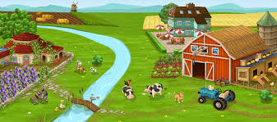

Focus 2

What animals live on a farm?

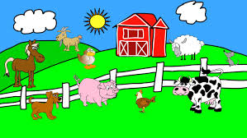

Focus 3

How do we get food from a farm?

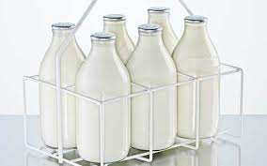

Focus 4

What the Ladybird Heard

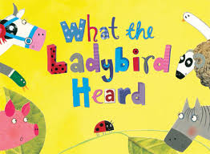

Focus 5

Easter – focus on chicks and eggs

