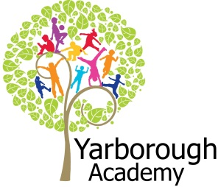

**Project Overview**

**Our project this term is all about the circus, what makes a good circus and what skills we would need to perform in a circus. We will be watching circus related films and listening to stories related to the circus. The children will be hooked into their learning during a circus activity day, where we will be painting faces, watching Madagascar 3 (where the animals join a travelling circus) and playing circus games.** 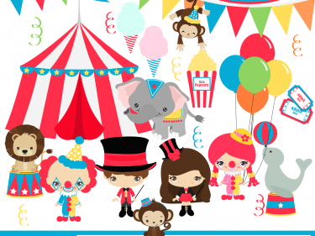

**Immersive Environment**

Our classroom will be transformed into a Circus Big top and will include:

A Lions den

Acrobat’s creative kingdom

Clowns dressing room

Ticket office

Ringmaster’s performance area

**What makes a good Circus?**

**Project Based Learning**

Reception/FS2

Term 2

2015/2016

**Curriculum Opportunities**

Personal, Social and Emotional Development

To work as a team during activities

Discuss feelings – how we can make others feel

Communication and Language

Following instructions during circus games

Discuss the rules of the circus games

Ask questions about the circus

Expand their vocabulary and learn specific words around the circus

Physical Development

Developing ball skills during circus games

Exploring movement when on climbing and balancing equipment, both inside and outside

Making large and small movements using chalks, ribbons and other circus equipment

Discuss which food they may like or dislike

Discuss what food is healthy

Literacy

Writing instruction about how to make popcorn

Writing caption and labels related to the circus

Finding different ways to present information

Mathematics

Investigating number bonds to 10 using pies

Investigating money and selling popcorn at the circus

Understanding the World

Looking at different jobs in the circus

Investigating animals that may be kept at the circus

Expressive Arts and Design

Creating an advertising poster for our circus

**Project Outcomes**

This project will involve the children using cross-curricular skills to help them answer the essential question of ‘What makes a good Circus?’

The final project will be on the 17th March and will consist of the class deciding what circus acts we would like in our own circus. Our final exhibition will involve the children performing our chosen circus acts for you. The times for each of the class’ exhibition will be as follows: Fir class 9:30am, Willow class 11am and Cherry class 1:30pm. All exhibitions will be in the hall.

**Project Enhancements**

Visitors – There will be 2 visits from Earth Bound Misfits, who will perform some circus acts and skills for us, as well as teaching us to perform some of these skills.

Class books – Dr. Seuss’s Circus McGurkus 1 2 3, Wolves don’t Bite, Spot goes to the Circus, Nelly the Elephant, Dumbo

Creative Home Learning – Can you make your own circus game?

**Project Timeline**

Focus 1

Circus games – Creating a pie throwing game

Focus 2

Circus performances – Creating our own circus performance

Focus 3

Circus animals – Investigating what animals might be in the circus

Focus 4

Circus jobs – Investigating the different jobs in the circus (Ringmaster, clowns, acrobats, popcorn sellers)

Focus 5

Advertising our circus – Making a poster to tell people about the circus

Focus 6

Arranging the ticket prices – Selling popcorn and raising money for Born Free Foundation

**How can you help?**

If you feel you can help us with our project this term we would love to hear from you.

You can also help with the project by doing the following at home:

* Reading Circus stories at home
* Bring in any pictures or other items if you have had a circus experience
* Play circus type games at home

Useful websites:

<http://www.kidactivities.net/post/circus-and-carnival-theme-for-kids.aspx> - has some nice games to play at home

<http://www.supermommyclub.com/tot-school-circus-activities-crafts/> - some nice craft activities