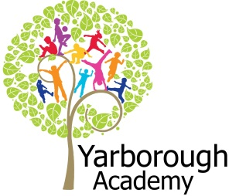

**Curriculum Opportunities**

Science

Understanding animal lifecycles and how to categorise animals using this information.

Investigate adaptations of animals to various environments.

Communication

Taking part in a debate and sharing our viewpoint with others.

English

Writing a newspaper article as a balanced argument about zoos.

Creating a non-chronological report about an animal of the pupil’s choice.

Planning, editing and writing a flashback story involving a wild animal in captivity.

Maths

Using measurements to design a zoo.

Using statistics to analyse the visitors to a zoo.

Geography

Understand where zoo animals originate from and the ethics behind transportation.

**Immersive Environment**

We will turn our classroom into zoos with different sections for different types of animals. These include:-

Life in the Jungle

Reptile House

Butterfly World

Elephant House

**Project Overview**

Our project this term is all about zoos. Our hook will involve some surprising discoveries in our classrooms and a message from Yorkshire Wildlife Park.

Our project will begin by looking at the types of animals and how we categorise them. We will explore natural habitats of wild animals in order to compare them to their enclosures within a zoo.

We will investigate the role of zoos related to endangered species. Also the impact of animals being kept for human entertainment and financial gain.

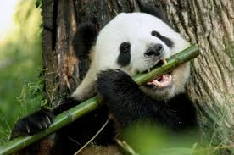

**Are zoos ethical?**

**Project Based Learning**

Year 6

Term 2

2015-2016

**Project Outcomes**

This project will involve the children using cross-curricular skills to help them answer the essential question of ‘Are zoos ethical?’

The final project consists of pupils creating a documentary on their findings for Yorkshire Wildlife Park.

Pupils will also participate in a debate, expressing their viewpoint on the essential question.

**Project Enhancements**

Trip

A visit to Yorkshire Wildlife Park

Visitors

Zoolab

Class book

We Bought A Zoo by Benjamin Mee

Creative Home Learning

Create an enclosure for an animal of your choice.

**How can you help?**

If you feel you can help us with our project this term we would love to hear from you.

**Useful websites:**

<http://www.worldwildlife.org>

<http://yorkshirewildlifepark.com>

**Useful texts to read would be:**

Non-fiction books about animals found in zoos

**Project Timeline**

Focus 1

Are all zoos the same?

-Zoo around the world

-Non Chronological Reports about an animal

-Newspaper article

Focus 2

How would you improve the design of Yorkshire Wildlife Park?

-Design a zoo using accurate measurements

-Create a zoo using Minecraft

-Explain in details our zoo designs

Focus 3

Would you like to live in Yorkshire Wildlife Park?

- Fiction writing as an animal in a zoo

Focus 4

Do zoos have a positive impact on animals?

-Statistics on who visits

-Persuasive writing

-Debate using language & terminology

-Create documentary iMovie

