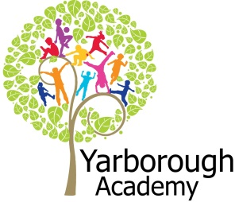

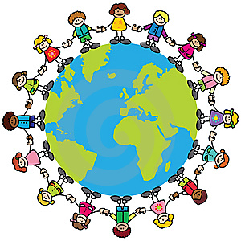

**Project Overview**

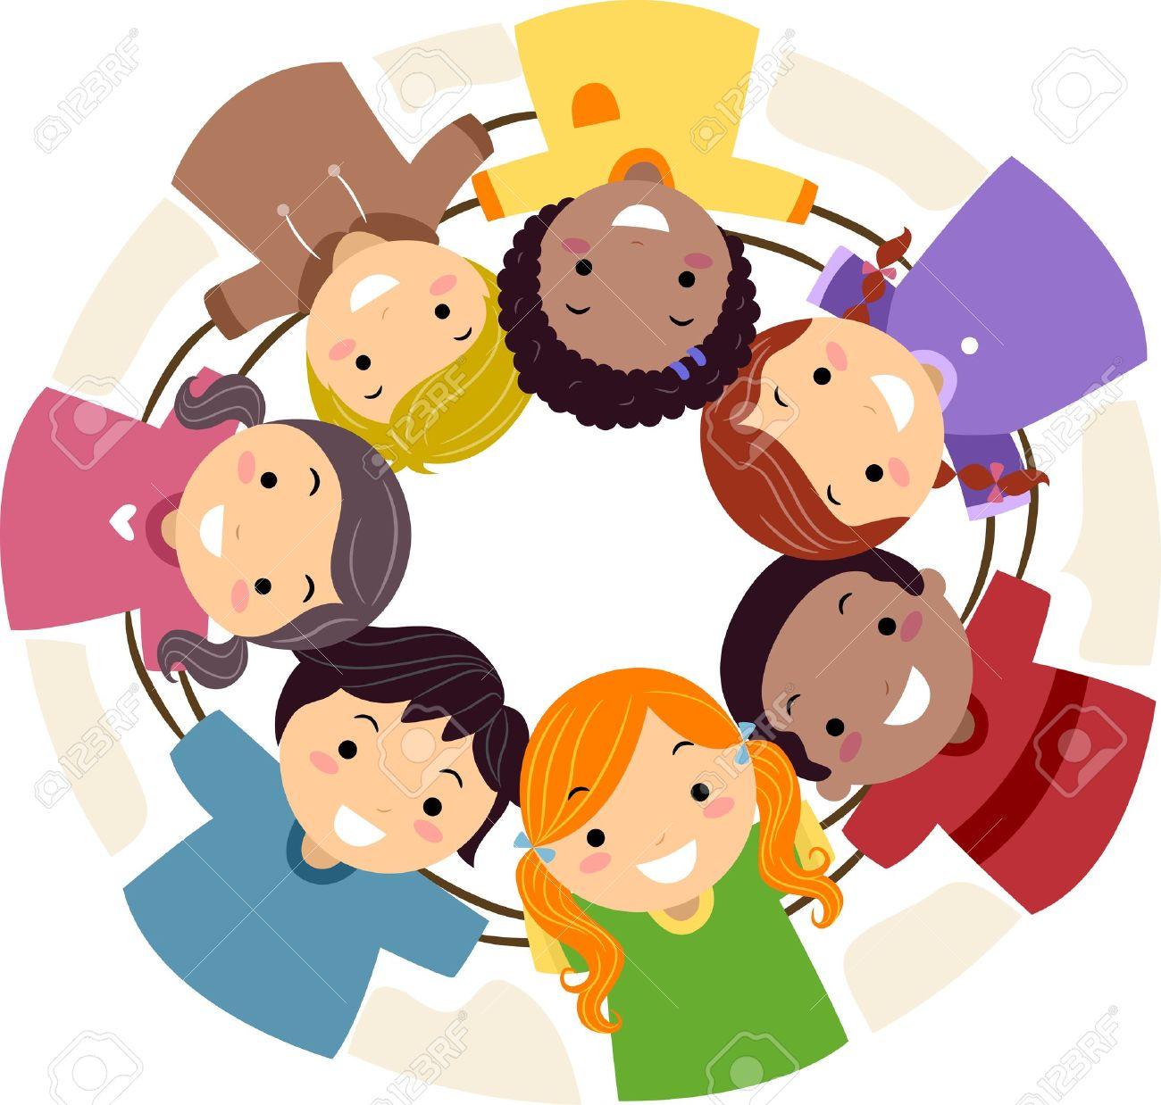

Our project this term is all about exploring friendship and what it means to understand others in our daily lives, within our local community and to be ‘friends of the earth’.

The launch for our learning will centre around our focus story about friendship, ‘On Sudden Hill’. Two boys with a cardboard box each spend time playing and creating. The children will work in teams to create their own imaginative cardboard boxes. What can they make? Next, the children will look closely at one another and draft a portrait of their friends. What do we look like? Do we look the same?

Following this immersion into the project we will start the Focus One by critiquing their portraits and producing a further draft with any improvements. The children will then be using description, adjectives and rhyme to develop friendship poems and be able to recite them by heart. Our Maths focus will see the children making friendship bracelets/necklaces whilst learning to count in twos, fives and tens and measuring their lengths in cm. We will return to our focus story, On Sudden Hill, to discuss the events, characters and their friendships, setting and illustrations. This will lead them onto creating their own story about friendship based on falling out and making up and they will use ICT to retell their stories dramatically.

Focus Two will see the children looking at what makes a good friend in the community. They will look at maps of the local area - identifying significant places and using directions to find and see these places in our community first-hand. During our walk around the community, the children will be seeking to help out those who need it. We will create tally charts to show who we can help. The children will also be learning about different religious stories about friendship.

Focus Three will centre around making connections with others around the world and caring for the Earth. The children will be writing letters to children living in another country and culture – sharing information safely and discussing ideas around recycling. They will consider the impact that recycling can have on the Earth, why it is so important and what they can do to help. The children will look to solve maths problems around recycling too.

**Immersive Environment**

To immerse the children into their learning, our classrooms will become a hub of friendship with a gallery of portraits, a growing tree of friendship and ‘emotional’ buckets for each child filled with uplifting and positive comments.

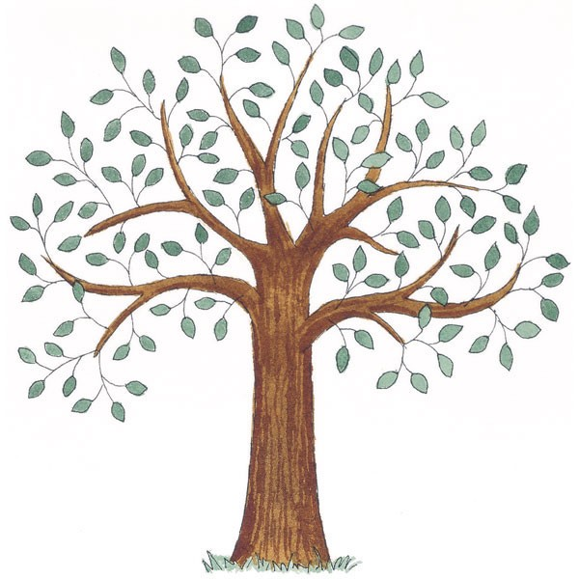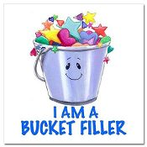

**Curriculum Opportunities**

**Writing**

Write stories and poems inspired by our focus text – On Sudden Hill.

Present information in the form of a letter and write labels, caption and lists.

**Reading**

Read and listen to a wide range of styles of text, including stories with familiar settings and poems.

Listen to and discuss a wide range of texts.

Discuss books including the setting, characters, events and illustrations.

**Maths**

Count and calculate in a range of practical contexts.

Using subtraction to solve problems.

Solving multiplication problems using repeated addition.

Explore numbers and place value up to at least 100.

Recognise, find and name halves and quarters of a quantity.

Explore the properties of shapes.

Use language to describe position, direction and movement.

**Science**

Identify and describe the basic structure of flowers and plants.

**Geography**

Ask and answer question about places.

Identify key features of a community.

Use maps to find the UK and other countries.

Use aerial images of the surrounding area.

**Art and Design**

Develop ideas about how to produce portraits.

Take inspiration from notable portrait artists and artwork.

Improve mastery of techniques in painting and drawing.

**Design and Technology**

Design products with a clear purpose.

Master cutting, shaping and joining techniques.

**P.E.**

Perform dances.

**R.E.**

Study the beliefs, festivals and celebrations of Christianity and other religions.

**Computing**

Connecting with others and understanding online risks.

Using applications to communicate ideas, work and messages.

**What makes a good friend?**

**Project Based Learning**

Year 1

Term 2

2016-2017

**Project Enhancements**

Experience

The aim of our class trip is for the children to see aspects of their community they may be unfamiliar with and to lend a helping hand to those who may need their help.

Visitors

Visitors will include volunteers in the community explaining what it means to be a volunteer and why they do it.

Class book

The 2 main books we will focus on:

‘On Sudden Hill’ by Linda Sarah and Benji Davies and ‘How Full Is Your Bucket?’ by Tom Rath and Mary Reckmeyer.

Creative Home Learning

Create a model of a ‘perfect’ friend. How would they be friendly to others? How would they be a friend to the community? How would they be a friend of the earth? This could be a poster, a video, a song or any other way this could be presented.

**How can you help?**

Are you a volunteer? Do you work in the local community? If you feel you can help us with our project this term we would love to hear from you.

Do you have any books about friendship you could share with your child?

The following website also has a host of information that your children might find interesting:

<http://www.cyh.com/HealthTopics/HealthTopicDetailsKids.aspx?p=335&id=1636&np=286>

**Project Timeline**

Focus 1 – What makes a good friend at school?

* Portraits of friends
* Friendship poems
* Friendship bracelets/necklaces
* Friendship stories

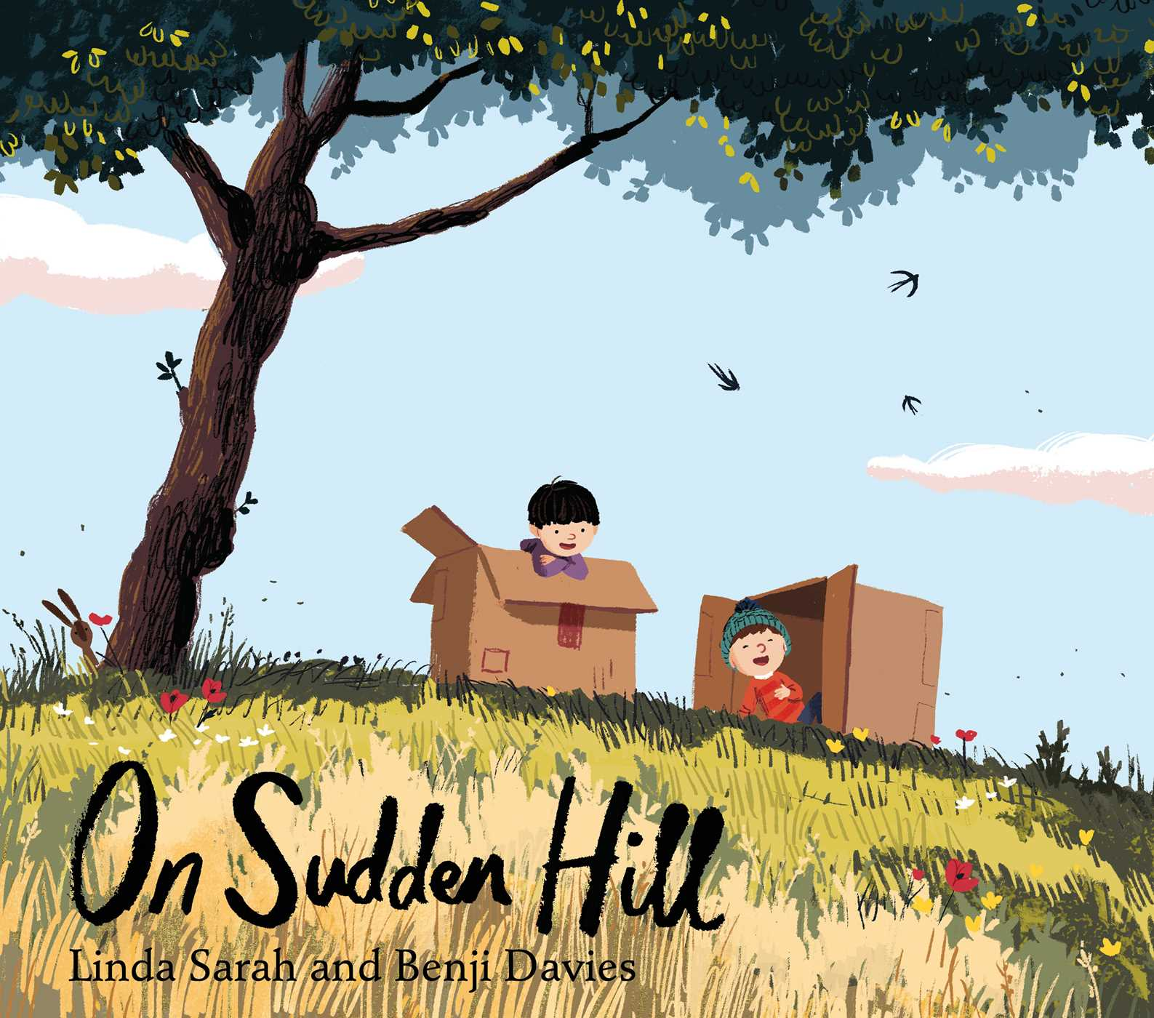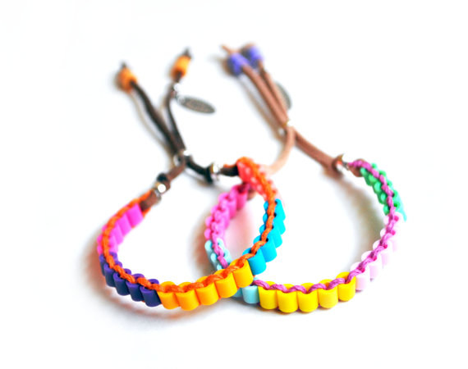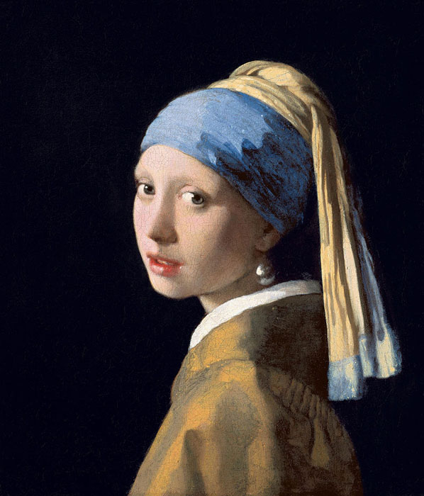

Focus 2 – What makes a good friend in the community?

* Labelling significant places on maps
* Using maps to find key places in the community
* Volunteering to help in the community

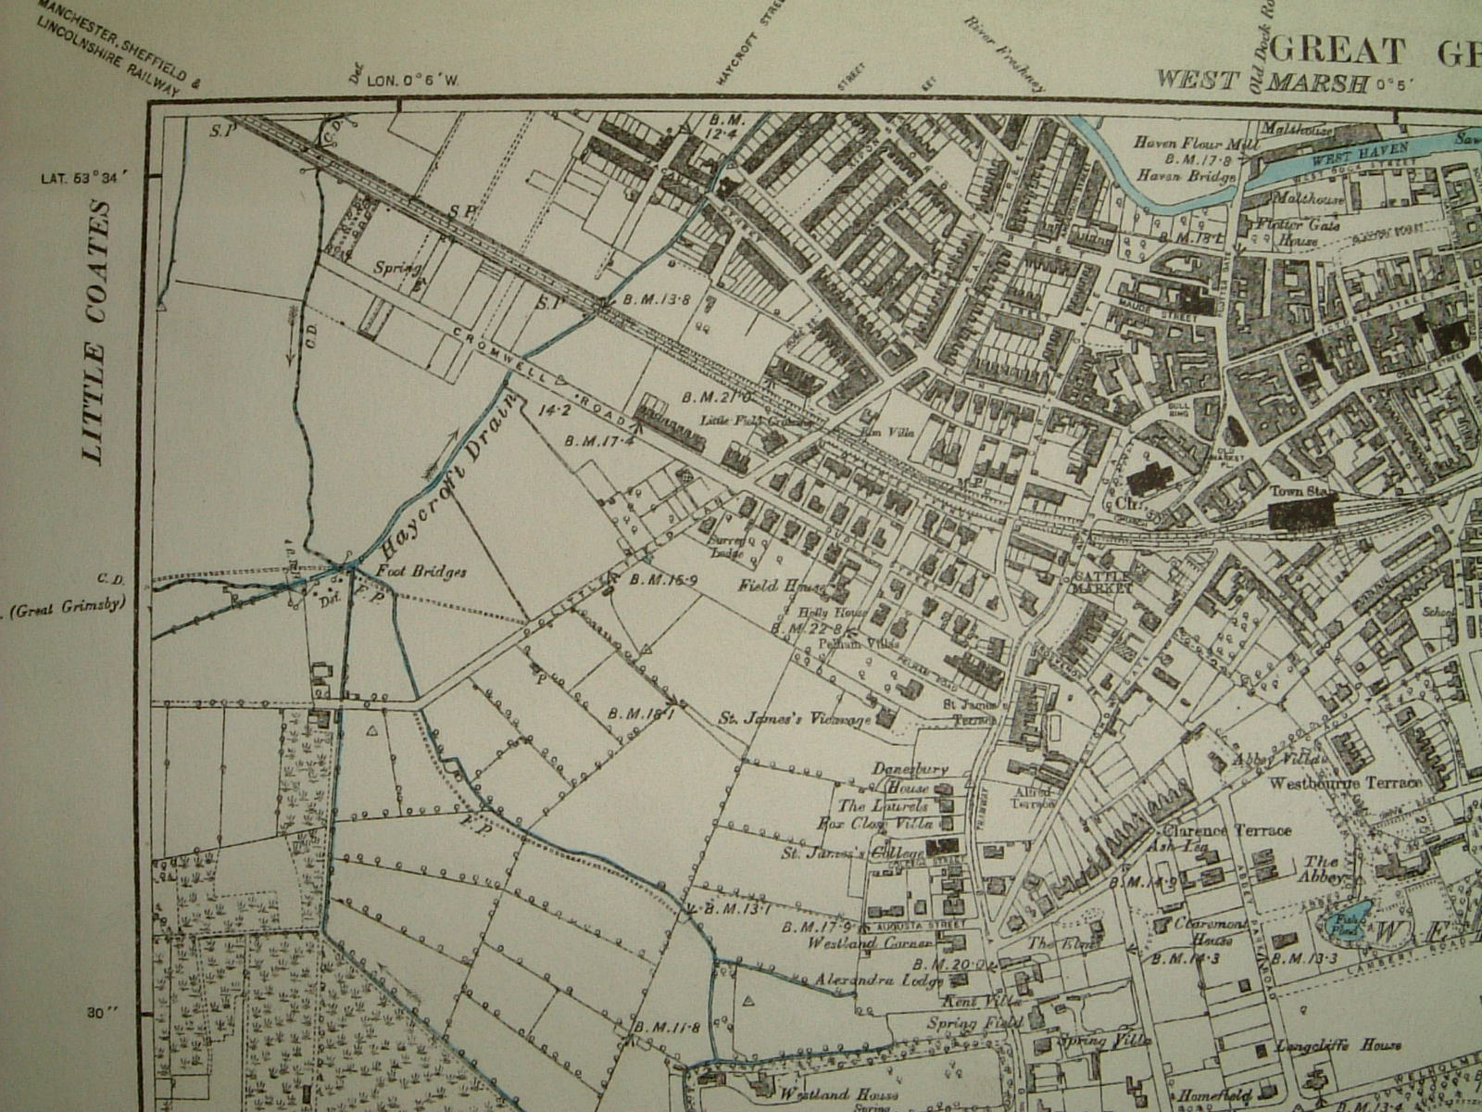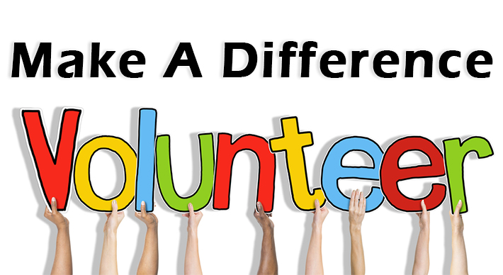

Focus 3 – What makes a good friend to the Earth?

* Communicating safely to friends around the world
* Providing information about themselves and recycling
* Solving problems involving recycling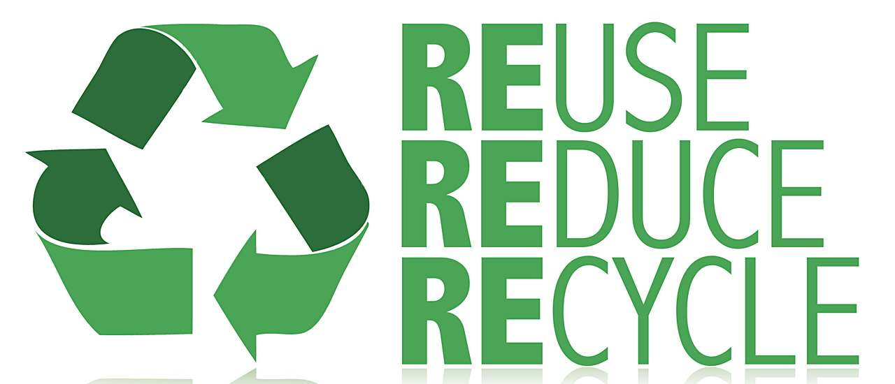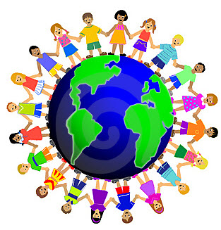

**Project Outcomes**

This project will involve the children using cross-curricular skills to help them answer the essential question of ‘What makes a good friend?’

Throughout the project, the children will be working towards creating and collecting things to go in their very own friendship box including portraits, bracelets, poems, stories and letters.

At the end of the project, as a symbol of friendship we will have benches placed in the KS1 playground that will be decorated by the children and made interactive so that other children can discover the true meaning of friendship.

The project exhibition will be held on Thursday 30th March 2017.