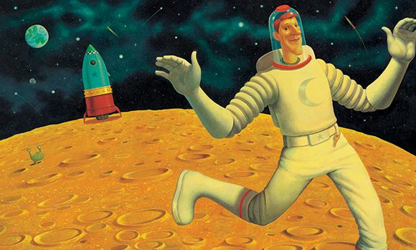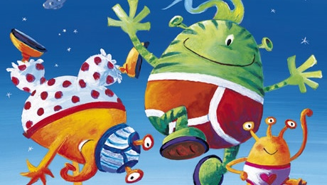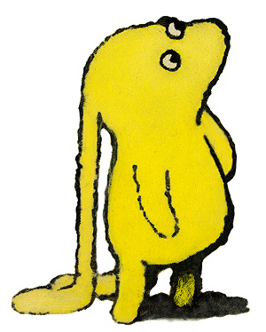

**Immersive Environment**

Our classroom will be transformed into different parts of space with:

Planets

Stars

Rockets and spaceships

Aliens hiding around the room

**What’s Beegus’ story?**

**Project Overview**

Our project this term is all about “What’s Beegus’ story?” We will read the story of Beegu and find out how she got here.

We will help to teach Beegu about the different things on Earth, looking at ourselves, investigating our similarities and differences. On a local walk we will be teaching Beegu about our local environment and what she might see. She will then tell us about her planet, which we will try to recreate for her. Beegu will then teach us all about her family, describing her family to us, allowing us to design and then make this family member for her using clay. By exploring different colours from her clues we will be able to find and mix the right colour for this family member. When Beegu becomes sad and longs for home, we will help her by investigating ways to design, make and then launch a rocket to send her home. Only then will we be able to explore all the different ways we helped her get home and from this retell her story, so she can explain all of this to her family.

The children will be hooked into their learning

when investigating a spaceship that has crashed in

our new classroom, meeting Beegu and discovering

more about her, ourselves and our new friends.

**Project Based Learning**

Reception/FS2

Term 1

2017/2018

**Curriculum Opportunities**

Personal, Social and Emotional Development

Discussing what makes a good friend

Working as a class to help send Beegu home

Communication and Language

Talking about similarities and differences between themselves and others

Speaking about likes and dislikes

Describing different planet textures

Retelling the story of Beegu

Physical Development

Developing our handwriting when writing labels and captions

Using our fine motor skills when making puppets and characters from the story

Literacy

Adding labels to our self portraits

Exploring character descriptions

Reading instructions ‘How to make a rocket’

Investigating story structure

Mathematics

Exploring 2D and 3D shapes in relation to planets

Adding patterns to our rockets

Counting down from 10 before blasting off

Ordering events from Beegu’s story

Understanding the World

Investigating where we live and what we can find in our local area

Discussing how our environment differs from other places and how it is the same

Expressive Arts and Design

Drawing a self portrait

Creating Beegu’s planet

Exploring mixing colours to find the correct colour of Beegu’s planet

Making a Beegu figurine out of clay

Designing our own rocket

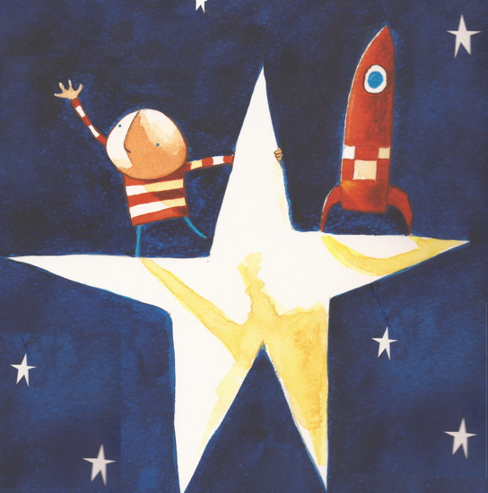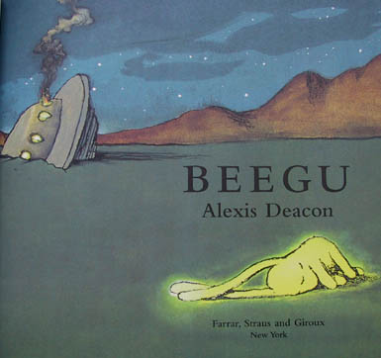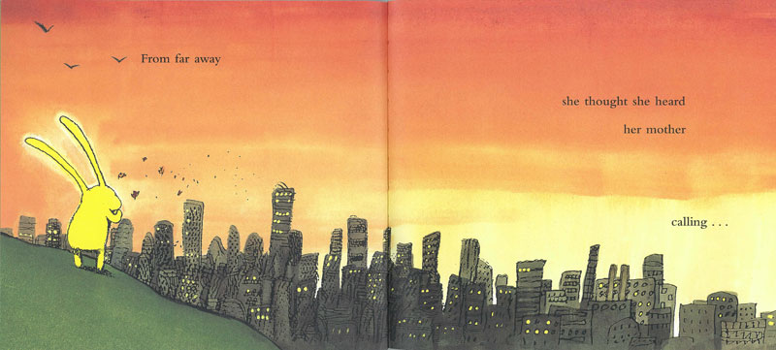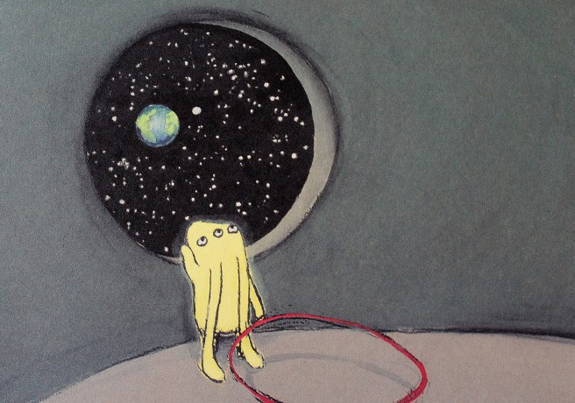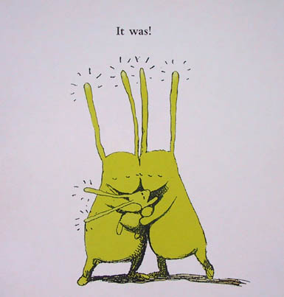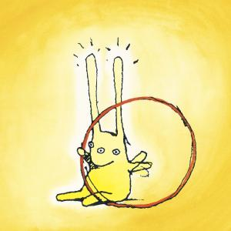

**Project Outcomes**

This project will involve the children using cross-curricular skills to help them answer the essential question of “What’s Beegus’ story?”

The final project will be a stay a play session in which we will be able to retell Beegus’ story, telling you how we helped her and how she finally got home. During the session you can re-enact the story together.

The exhibition will be held on **Monday 4th December**

Willow Class- 1.10-2.00

Cherry Class- 2.10-3.00

**Project Enhancements**

Visitors – a planetarium will come to visit us **Monday 25th September** in the morning, showing the children the different planets and constellations Beegu might see on her way home. **In order for this to happen can we please have £5 towards the costs of this fabulous experience.**

Visits - we will be going on a local walk to teach Beegu all about our local environment

Class books – Beegu, My Alien and Me, Man on the Moon, Rocket, Aliens love underpants, How to catch a Star

Creative Home Learning – Using the design your child has drawn, make their rocket at home.

**Project Timeline**

Focus 1

Who are we?

We will be teaching Beegu about us, about what we look like and what makes us unique

Focus 2

Where are we?

Investigating the local area to teach Beegu about where we live, then she will teach us about her planet

Focus 3

Who are Beegus’ family?

We will use her descriptions to desing and then make her mum using clay, then looking at colour mixing to find the right colour to paint her.

Focus 4

How will we get her home?

By finding out about how to design, make and then launch a rocket we will try to get her home.

Focus 5

Can we tell Beegus’ story?

Using all the things we have created with Beegu, we will explore all that we have done to help her and retell her story of how she got home.

**How can you help?**

If you feel you can help us with our project this term we would love to hear from you!

You can also help with the project by doing the following at home:

Talk about the similarities and differences between different environments

Investigating earth and other planets in our solar system

Talk about how stories are structured