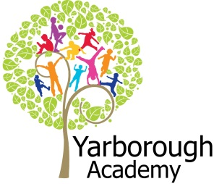

**Curriculum Opportunities**

**Writing**

-Write recounts

-Write stories, letters, scripts and fictional biographies inspired by reading across the curriculum.

-Write in a journalistic style.

-Write stories, letters, scripts and fictional biographies inspired by reading across the curriculum.

-Write poems that convey an image

-Write stories that contain mythical, legendary or historical characters or events.  
-Write stories of adventure.

**Reading**

-Learn poetry by heart.

-Read and listen to a wide range of styles of text, including fairy stories, myths and legends.

-Take part in conversations about books.

-Read and listen to whole books.

**Maths**

- Use and apply measures to increasingly complex contexts.

**Science**

- Examine the properties of materials using various tests.

-Rigorously apply mathematical knowledge across the curriculum, in particular in science, technology and computing.

-Work scientifically

**Art and Design**

- Use experiences, other subjects across the curriculum and ideas as inspiration for artwork.

- Improve mastery of techniques.

**D.T**

- To master practical skills.

**Computing**

-Select, use and combine a variety of software (including internet services) on a range of digital devices to accomplish given goals, including collecting, analysing, evaluating and presenting data and information.

-Select, use and combine a variety of software (including internet services) on a range of digital devices to accomplish given goals, including collecting, analysing, evaluating and presenting data and information. (Research ships.)

**Music**

- Use and understand the basics of the stave and other musical notations.

**Geography**

-Use the eight points of a compass, four-figure grid references, symbols and keys (including the use of Ordnance Survey maps) to build knowledge of the United Kingdom and the world.  
- Use maps, atlases, globes and digital/computer mapping to locate countries and describe features studied.

- Use a wide range of geographical sources in order to investigate places and patterns.

**History**

-A local history study.

**-**History of interest to pupils.

P.E. –

**Immersive Environment**

So as to inspire and immerse their learning, both Sycamore and Elder classrooms will become pirate ships! During the project launch we will be involving the classes in the design and creation of these.

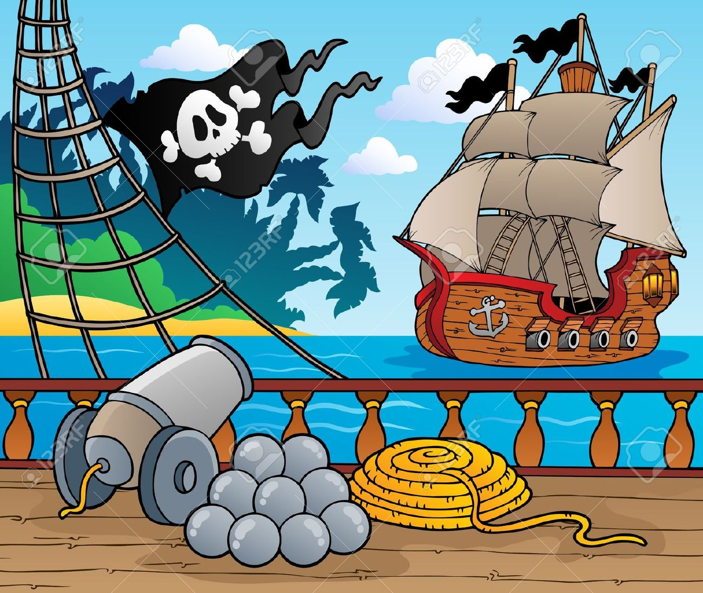

**Project Overview**

Our project this term is all about researching the real pirates who existed in the local and surrounding areas. The launch for our learning will entail a code which the children will have to crack, together with a collection of artefacts to be discussed and investigated. This will lead the children into knowing the focus of the project. We will then explore people’s perceptions of pirates through the medium of film, followed by a myth busting session by a local pirate expert. Finally, we will be immersing the children in their learning environment by involving them in its creation.

The very beginning of the new term will focus on a pirate experience day – where a special guest will be engaging the children in all things pirate, and showing them replicas of pirate weapons and artefacts. The children will be given tasks to do by our pirate and the experience will be as authentic as is possible.

Once we have explored what it is like to be a pirate, we will be looking at what motivated pirates and how beliefs about right and wrong affect people’s behaviour. Map work will also be a focus, with the children plotting a pirate route and describing the journey. We will also look at where the pirates came from.

In science, the properties of materials that would have been suitable for building a pirate ship will be investigated and a replica pirate ship will be made to scale.

Pirate entertainment will be identified and the children will be writing their own sea shanties, with the help of the local authority’s Music Hub.

To wrap all of their learning up, the children will be writing their own stories, as if it were the next one in the series of the class books we will be reading.

**Do We Walk in Pirates’ Footsteps?**

**(The Untold Story!)**

**Project Based Learning**

Year 4

Term 1

2016-2017

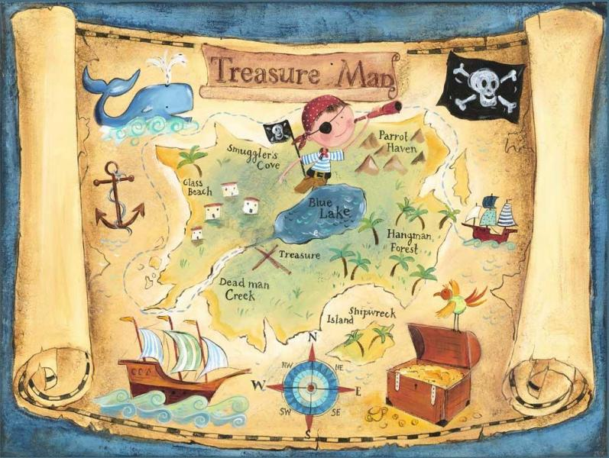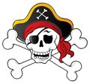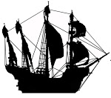

**Project Timeline**

Focus 1

What is it like to be a pirate?

Focus 2

What motivates a pirate?

Focus 3

Where did the pirates come from?

Focus 4

How did the pirates get here?

Focus 5

How did other people view pirates?

Focus 6

How did pirates entertain themselves?

Focus 7

Can we tell their story?

**Project Enhancements**

Experience

A pirate day experience, at Cleethorpes beach, on Tuesday 6th September (our first day back after the holidays) – held in conjunction with a pirate actor, to immerse the children in authentic activities and tasks.

Visitors

Helen Good – a local pirate historian.

Sue Baker from the Music Hub.

Class book

A range of books from the series Sam Silver (Undercover Pirate.)

Creative Home Learning

Over the term we will be asking you to help your child to create a pirate’s treasure chest – in a box.

Another activity will be to design some new pirate currency.

**Project Outcomes**

This project will involve the children using cross-curricular skills to help them answer the essential question of ‘Do We Walk in Pirates’ Footsteps? (The Untold Story.)’

Throughout the project, the children will be working towards researching real pirates, what motivated them, how they got here (and where from), how they entertained themselves and whether it was right or wrong to steal. We aim to provide a public exhibition to tell local people about this important, but little known piece of local history.

The final exhibition will be to hold a Pirate Exhibition at a local venue, to inform the general public of the real pirates that did exist in ours and surrounding areas. There is currently no such exhibition!

**How can you help?**

If you feel you can help us with our project this term we would love to hear from you.

In the meantime could we please ask you to read as many pirate stories with your child as you can.

It would also be beneficial to study some maps – looking at the East coast around our local area. What can the children notice about it?

The following website also has a host of information that your children might find interesting:

<http://www.thepirateking.com/historical/ship_roles.htm>