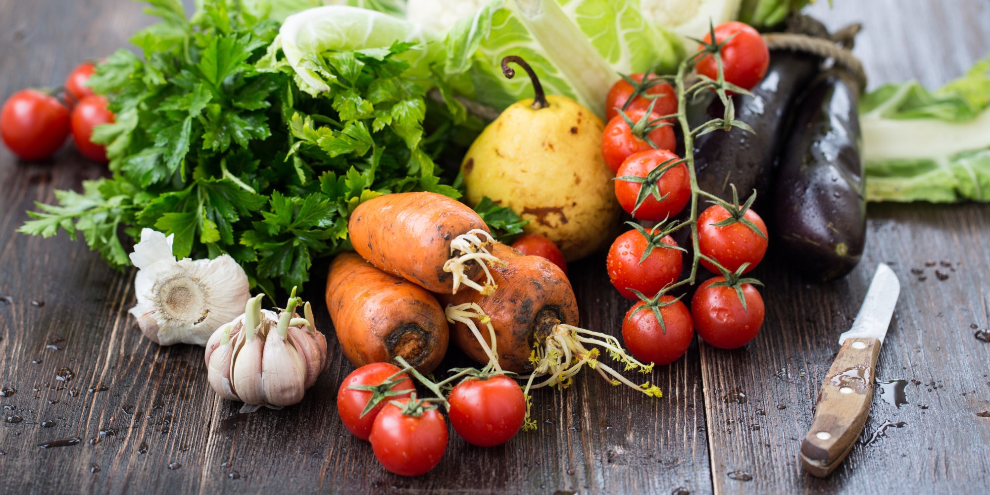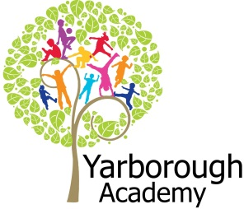

**Project Overview**

Our project this term is all about looking for the magic in growing fruit and vegetables. The children will be hooked into their learning by discovering a long beanstalk growing throughout the school – leading to a range of seeds. As scientists the children will set up an experiment to investigate optimum growing conditions. As mathematicians we will measure amounts of water required, as well as the growing heights of our plants. Our results will be displayed in charts and graphs. As writers we will be writing an explanation text about the magical lifecycle of a plant, as well as a cinquain poem about their growth. Further along, the children will write their own story about magical seeds coming to life, and use persuasive language for a vegetable talent show.

The artist Giuseppe Arcimboldo’s work will be studied, and we will also look at printing with vegetables. There will be an element of computing within this project – whereby the children will be designing and writing a programme to make fruit and vegetables come to life, incorporating a musical element. We will also be creating an animation to accompany our stories.

During this project we will be focussing on the planting and growing of potatoes which will be exhibited for judging at the Lincolnshire Show. Each of our classes will be holding a stall at the show, where a presentation of our crops will be made.

Although parents will be invited to attend the show, we will also be hosting a vegetable talent show at school.

**Project Based Learning**

Year 4

Term 3

2015-2016

**How Can Fruit and Vegetables Be Magical?**

**Immersive Environment**

Elder classroom will be focussing on the fields, tractors, scarecrow and mud element of growing fruits and vegetables.

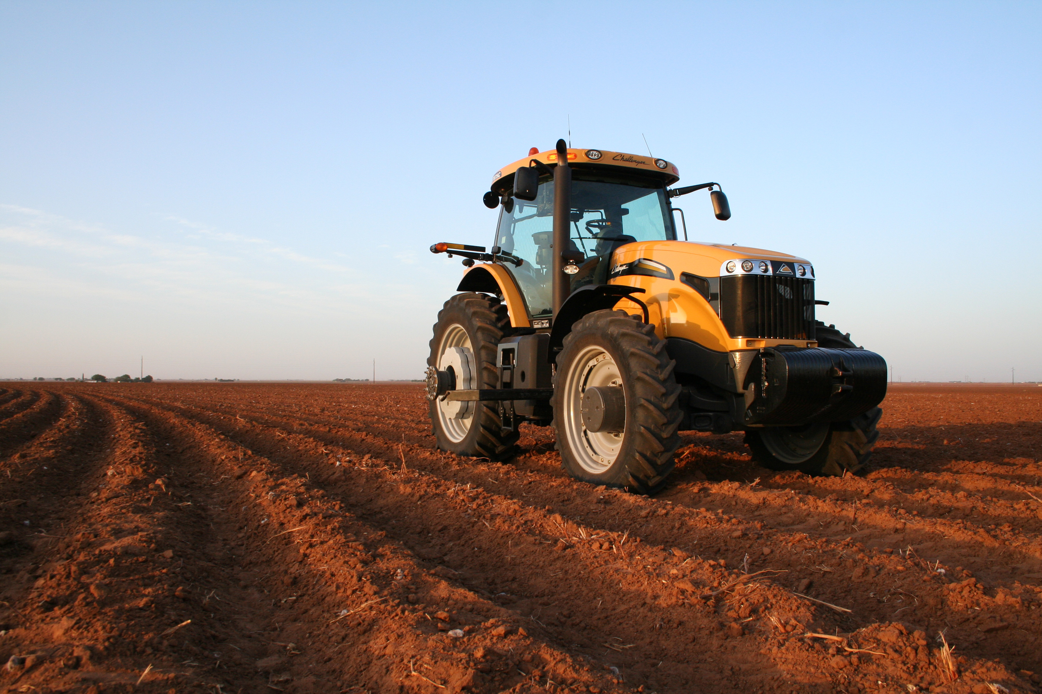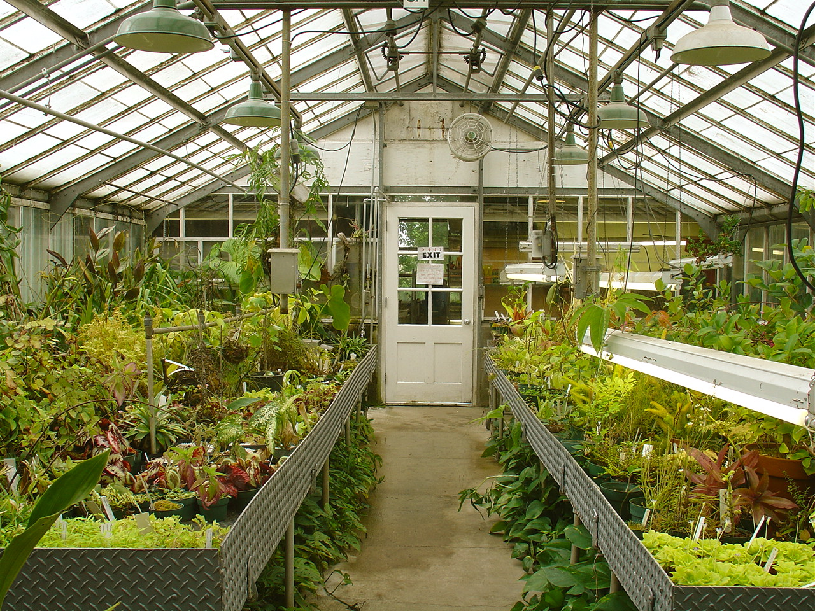

Alternatively, Sycamore class will become a greenhouse!

**Curriculum Opportunities**

Writing

Write explanations. Write stories set in places pupils have been.

Poetry – Writing cinquains.

Write persuasively

Write instructions

Reading

Listen to and discuss a wide range of texts. Read and listen to a wide range of styles of text, including fairy stories, myths and legends. Read and listen to whole books.

Maths

Use and apply measures in increasingly complex contexts. Gather organise and interrogate data

Maths – use and apply measure to increasingly complex contexts.

Science

Look at the function of flowering plants, requirements of growth, water transportation in plants, life cycles and seed dispersal.

Look at the life cycle of animals and plants.

Science – Look at the classification of plants, animals and micro-organisms.

Art and Design- Improve mastery of techniques

-Use experiences, other subjects across the curriculum and ideas as inspiration for artwork

-Learn about the great artists.

Use experiences, other subjects across the curriculum and ideas as inspiration for artwork.

D.T. – Understand seasonality and know where and how a variety of ingredients are grown.

- Prepare and cook a variety of predominantly savoury dishes using a range of cooking techniques.

Communication – Speak to small and larger audiences at frequent intervals.

Computing- Use sequence, selections and repetition in programs: work with variables and various forms of input and output:generate appropriate inputs and predicted outputs to test programs.

-Use logicalreasoning to explain how a simple algorithm works and todetect and correct errors in algorithms and programs.

-Select, use and combine a variety of software on a range of digital devices to accomplish givengoals.

Design and write programs that accomplish specific goals, including controlling or simulating physical systems: solve problems by decomposing them into smaller parts.

Music – Play and perform in soloand ensemble contexts, using voice and playing instruments with increasing accuracy, control and expression.

-Improvise andcompose music using inter-related dimensions of music separately and in combinations.

History - History of interest to pupils.

RE. – Study the beliefs, festivals and celebrations of Christianity.

P.E. – Perform dances.

Take part in gymnastic activities

**Project Outcomes**

This project will involve the children using cross-curricular skills to help them answer the essential question of ‘How can fruit and vegetables be magical?’

Throughout the project, the children will be working towards showing the magic that can arise from both growing fruit and vegetables, as well as utilising them.

The final exhibition will be planting and growing vegetables (with a special focus on potatoes) to display at the Lincolnshire Show – for judging.

**Project Enhancements**

Trip

The Lincolnshire Show – 22nd and 23rd June 2016. Your child will be attending one of these dates.

A visit to a local allotment.

Visitors

Farming mentors – sponsors of the Lincolnshire Show.

Class book

Farmer Will Allen and the Growing Table by Jacqueline Briggs Martin and Eric-Shabazz Larkin

Creative Home Learning

Over the term we will be asking you to help your child investigate vegetables that can magically re-grow themselves, as well as to create a greenhouse in a bottle!

**How can you help?**

If you feel you can help us with our project this term we would love to hear from you.

Useful websites:

<http://gyop.potato.org.uk>

[www.schools.potato.org.uk](http://www.schools.potato.org.uk)

[www.face-online.org.uk](http://www.face-online.org.uk)

<http://apps.rhs.org.uk/schoolgardening/teachershome/resources/gardentypes/foodgrowing/default.aspa>

<http://www.schoolfoodmatters.com/growing.html>

**Project Timeline**

Focus 1

**The Magic of Growing**

– planting seeds under optimum growing conditions.

Focus 2

**Making Magic**

– designing a computer programme to create musical fruit or vegetables.

Focus 3

**Allotment Magic**

– visiting a local allotment. Writing a story about magical seeds and creating an animation to accompany it.

Focus 4

**Spud Magic**

-asking questions of a farmer, exploring the history of the Irish potato famine and investigating different uses for potatoes.

Focus 5

**Creative Magic**

- studying the work of the artist Giuseppe Arcimboldo.

