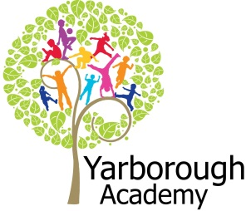

**Project Overview**

 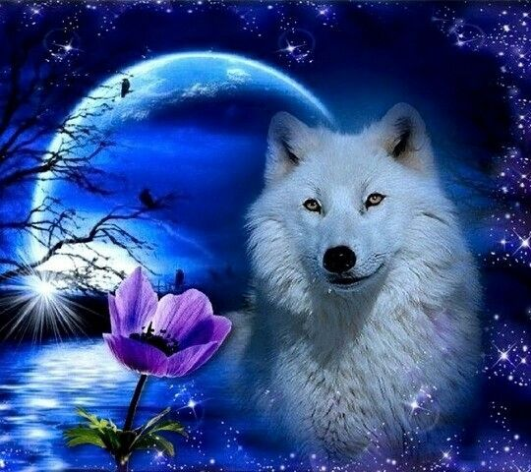

Our project this term is all about exploring how wolves have been perceived through story telling and how they have always been seen as the ‘bad guys’.

The launch for our learning will centre around a story depicting a character who the reader feels sorry for. There will be a letter on the cupboard door, letting the children know that the character from this story won’t come out until they understand his/her feelings. The character will be revealed! (It’s a wolf!) The children will then carry out some freeze frame emotions and hot seat the wolf.

Following this immersion into the project we will start the first focus by having a story telling carousel of a wide range of different stories featuring wolves – where we will see different ways in which wolves are portrayed. There will be character analysis activities, followed by immersion into The True Story of Little Red Riding Hood, culminating in writing a prequel to The Three Little Pigs.

Focus two will be studying the facts about wolves. Habitats, the food chain, life cycles, classification of wolves and their lifestyles will be covered. The final outcome will be to produce a non-chronological factual report about wolves – to be handed out at our exhibition.

Focus three will be where we find the beauty of wolves and show these through the medium of art. Our hook for this focus will be an art gallery experience. The children will take part in workshops held by students from the local art college – experimenting with a range of different art forms, such as photography, sketches, collage and oils.

The overall aim of this project is to look at how wolves are always portrayed as the ‘baddy’ – whereas in reality, they are beautiful creatures. We will be fund raising in order to adopt our very own wolves!

**Immersive Environment**

To immerse the children into their learning, our classrooms will become woodland habitats – where wolves would live.

During the launch days, the children will be helping us to create this environment . 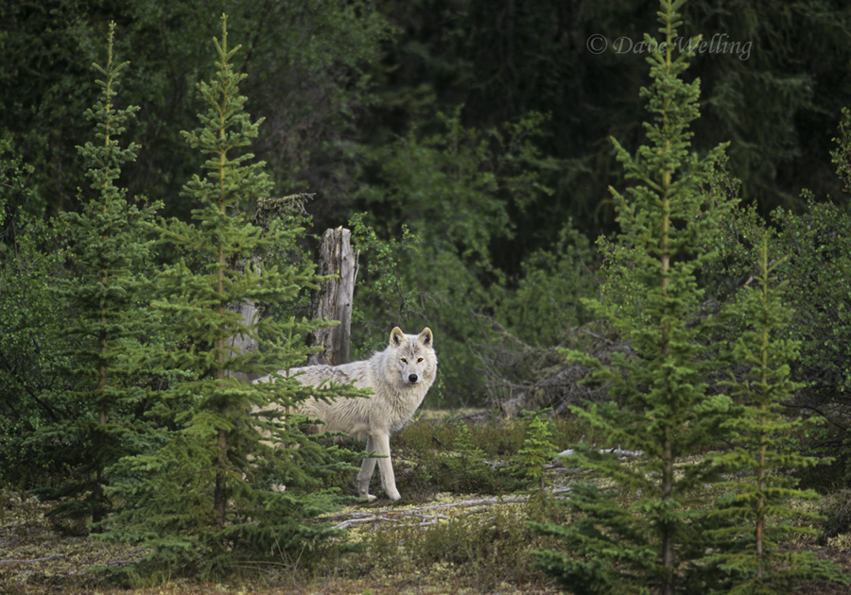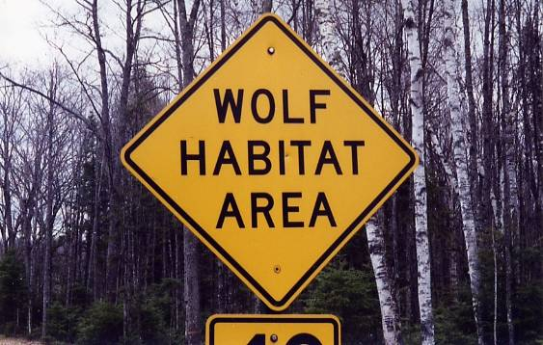

**Curriculum Opportunities**

**Writing**

Write stories, letters, scripts and fictional biographies inspired by reading across the curriculum.

Write non-chronological reports.

**Reading**

Read and listen to a wide range of styles of text, including fairy stories, myths and legends.

Listen to and discuss a wide range of texts.

Increase familiarity with a wide range of books, including myths and legends, traditional stories, modern fiction, classic British fiction and books from other cultures.

Take part in conversations about books.

Read and listen to whole books.

**Maths**

Gather, organise and interrogate data.

Deepen conceptual understanding of mathematics by frequent repetition and extension of

key concepts in a range of engaging and purposeful contexts.

**Science**

Look at resemblance in offspring.

Look at changes in animals over time.

Look at adaptation to environments.

Look at differences in offspring.

Look at adaptation and evolution.

Look at classification keys.

Look at the life cycle of animals and plants.

Look at classification of plants, animals and micro-organisms

Look at nutrition, transportation of water and nutrients in the body, and the muscle and

skeleton system of humans and animals.

**Art and Design**

Use experiences, other subjects across the curriculum and ideas as inspiration for artwork. Develop and share ideas in a sketchbook and in finished products.

Improve mastery of techniques.

**Music**

Listen with attention to detail and recall sounds with increasing aural memory.

Appreciate and understand a wide range of high-quality live and recorded music from

different traditions and from great musicians and composers.

**P.E.**

Perform dances.

**R.E.**

Study the beliefs, festivals and celebrations of Christianity

**Myth busters:   
How Have Words Wounded Wolves?**

**Project Based Learning**

Year 4

Term 2

2016-2017

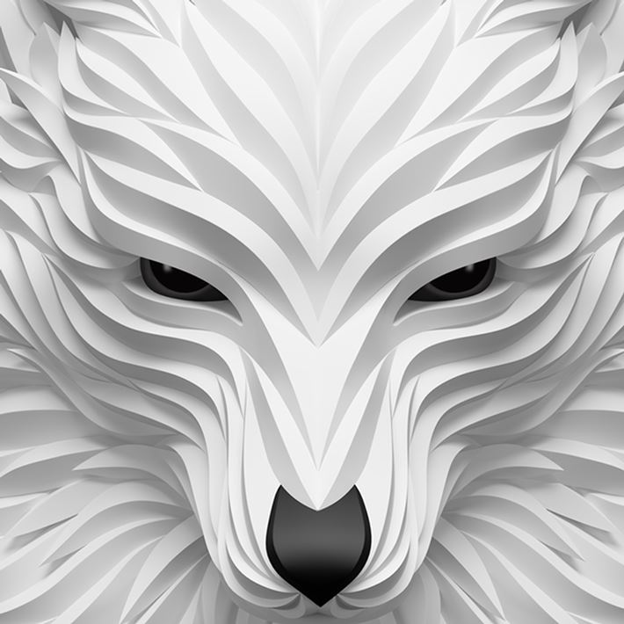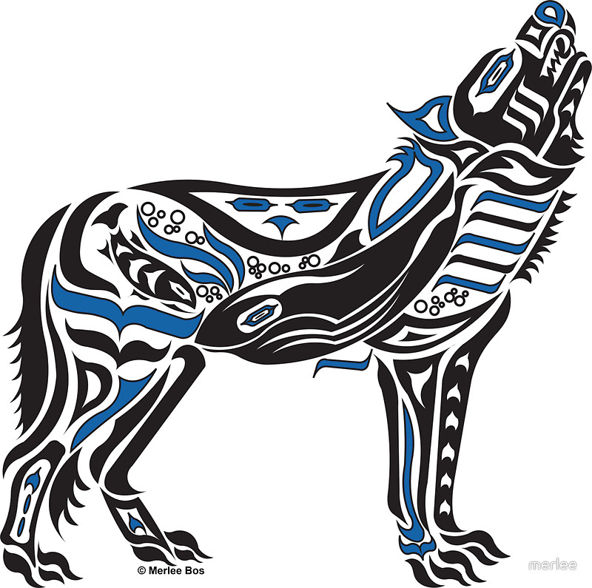

**Project Enhancements**

Experience

The aim of our class trip is for the children to see real wolves in their natural habitat and also to learn about them from experts who look after them. We will be going to Woodside Wildlife Park on Monday 6th February 2016.

Visitors

Visitors will include students from the local art college, who will demonstrate a range of different mediums of art to the children.

Class book

The 2 main books we will be studying are:

The True Story of Little Red Riding Hood, by Agnese Baruzzi and Sandro Natalini

Wolves, by Emily Gravett.

Creative Home Learning

We will be asking you to create a wolf mask or head with your child – to add to our immersive environment.

Another mini project will be to make a wolf den.

To help with studying where wolves live, we will ask you to research the habitats in different countries where wolves live.

**How can you help?**

If you feel you can help us with our project this term we would love to hear from you – perhaps resources to help us create wolf habitats for our immersive environments.

In the meantime could we please ask you to read as many stories with wolves in them as you can, identifying what it is that portrays them in a bad light.

The following website also has a host of information that your children might find interesting:

<http://www.fun-facts.org.uk/animals/animals-wolf.htm>

**Project Timeline**

Focus 1

Myth

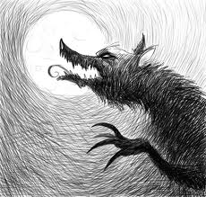

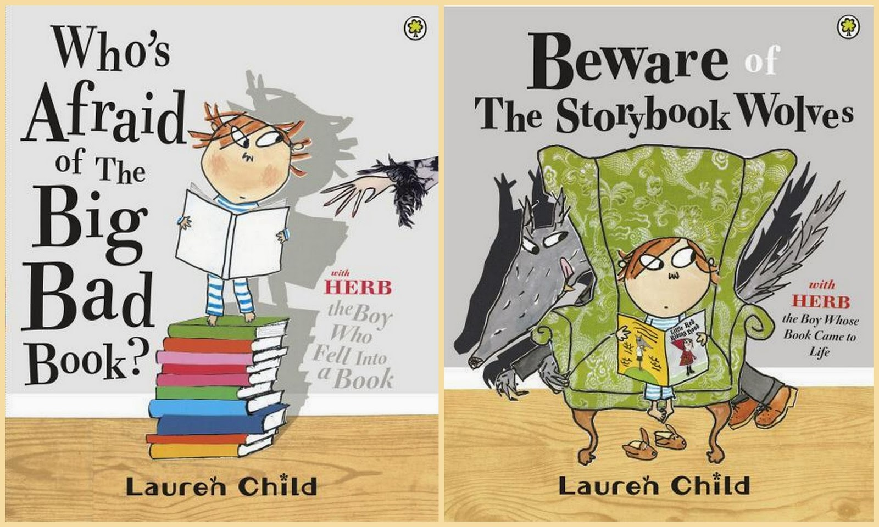

Focus 2

Truth

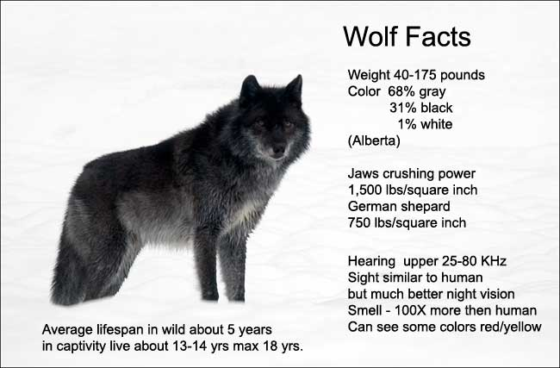

Focus 3

Beauty

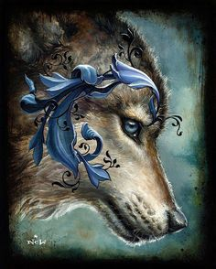

**Project Outcomes**

This project will involve the children using cross-curricular skills to help them answer the essential question of How Have Words Wounded Wolves?

Throughout the project, the children will be exploring ways in which wolves are portrayed in stories. This will be done through reading lots of different stories and analysing the characters and how they are stereotyped (Myth.) A prequel to a famous story will then be written from a different perspective – that of the wolf.

Following on from this, the real facts about wolves will be studied. (Truth.) A non-chronological report will be written from the facts found.

To bring it all together, we will use a variety of art mediums to exhibit the beauty of these animals.