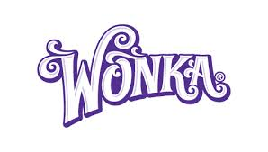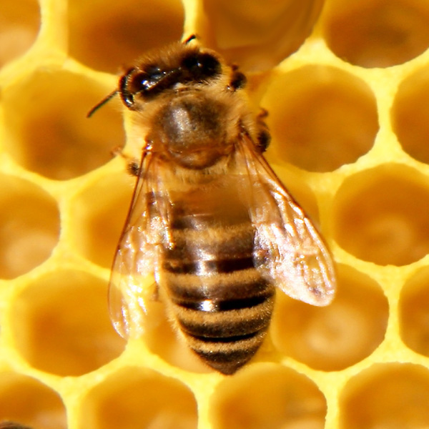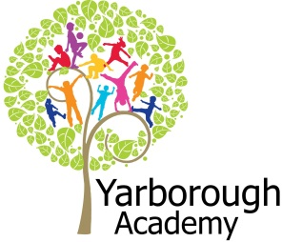

**Project Overview**

This term our project will be exploring the creative and imagination of Willy Wonka and his inventions in his chocolate factory. We will investigate the technology and machinery that he uses in his factory and explore how similar technology is used in the real world today. We will then bring all of that information together to create a blueprint, using our own imagination, to solve a problem for the local community.

We will start by launching into our Novel, Charlie and the Chocolate Factory, and immerse ourselves in the world of the chocolate factory. We’ll look at the unique character of the inventor and the world of pure imagination he inhabits.

We will then journey through the book and investigate the various rooms within the chocolate factory. We will start at the chocolate waterfall and investigate why Wonka constantly stirs his chocolate. We will then explore in more depth what his invention has led to in scientific fields by investigating the mixing of substances, which leads to reversible or irreversible changes.

We will then call off at the Invention Room, where we will investigate the complex machine that produces the everlasting gobstopper. We will look in detail at how it works, creating explanation texts, before looking at how his invention has led to factories using similar machinery in the world today.

After that, we will move through the factory to the Nut Room and investigate how Wonka uses squirrels to help sort nuts. His idea of having something non-human work to separate good and bad products is used in industry around the world. We will look at how AI in modern industry is used to replace human jobs and we will create a version of AI in the classroom.

We will then move to the TV Room and investigate how Wonka’s invention of transporting people to another dimension. We will look at how modern technology is making that possible through augmented and virtual reality. We will create our own virtual reality recording and express this as a piece of artwork.

Finally, we will bring all of these ideas together and create an imaginary blueprint for a piece of technology, based on Wonka’s imagination, to help the local community.

The whole purpose of this project is to investigate how an idea can come from somebody’s imagination, all the way through to a reality and how people can use that idea to solve issues and problems.

**Immersive Environment**

Hawthorn and Birch classrooms will have the same theme, but will be slightly different.

Hawthorn classroom will be immersed in the various areas of Wonka’s chocolate factory, whilst Birch classroom will transform into a factory!

**How can we use Wonka’s imagination to innovate?**



**Curriculum Opportunities**

**Writing**

- Write plays  
- Write explanations  
- Write stories of adventure

**Mathematics**- Rigorously apply mathematical knowledge across the curriculum, in particular in science, technology and computing  
- Describe position, direction and movement in increasingly precise ways  
- Count and calculate in increasingly complex contexts, including those that cannot be experienced first hand  
- Use and apply measures to increasingly complex contexts

**Reading**  
- Take part in conversations about books  
-  Listen to and discuss a wide range of texts  
- Take part in conversations about books  
- Increase familiarity with traditional stories

**Science**- Examine the properties of materials using various tests  
- Look at solubility and recovering dissolved substances

**Art**- Use experiences and ideas as inspiration for artwork

**Computing**  
-Design and write programs that accomplish specific goals

**Music**- Listen with attention to detail and recall sounds with increasing aural memory

**R.E**- Study the beliefs, festivals and celebrations of Christianity.

**P.E**  
- Perform dances

P.E.

- Perform dances.

**Project Based Learning**

Year 5

Term 3

2016-2017

**Project Timeline**

Focus 1

Wonka’s chocolate waterfall

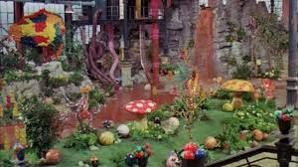

Focus 2

Wonka’s invention room

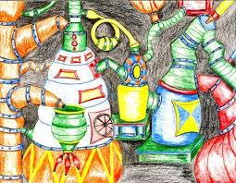

Focus 3

Wonka’s Nut room

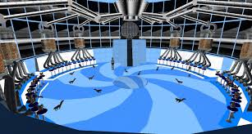

Focus 4

Wonka’s TV room

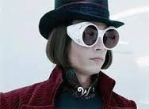

Focus 5

Design our blueprints

**Project Enhancements**

Trip

A visit to the Museum of Technology and Science, Manchester.6th June 2017

Visitors

20-21 Visual Art Centre to help children create their virtual reality concept art. Date TBC

Class book

Charlie and the Chocolate Factory by Roald Dahl.

Creative Home Learning

For Focus 2, we will be asking children to create their own invention room for something they want to invent.

**Project Outcomes**

This project will hopefully raise awareness that all great ideas have humble beginnings and children should not shy away from being ambitious, in spite of the perception of others.

Throughout the project, the children will be working towards understanding that great inventions once seemed impossible, but only by working together and building upon current and existing inventions, inventors were able to realise their dreams.

The final exhibition will be a pitch at Saint Michael’s Church on Monday 10th July from 2pm to the local community to choose a blueprint of a piece of technology, which has the sole aim of helping the elderly, frail or housebound. Children will need to convince the local community that their blueprint is the one that will make a big difference to their lives.

**How can you help?**

If you feel you can help us with our project this term we would love to hear from you.

In the meantime could we please ask you to consider what technology you’d love to invent for your house or local area. Also, talk to your children about what life might be like without inventions and technology.

The following websites have information that your children might find interesting:

<http://www.bbc.co.uk/education/clips/z6k4d2p>

<http://www.uptoten.com/kids/kidsgames-mixedbag-inventionstimeline.html>