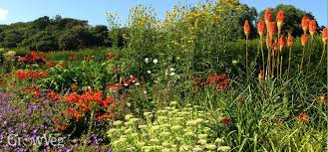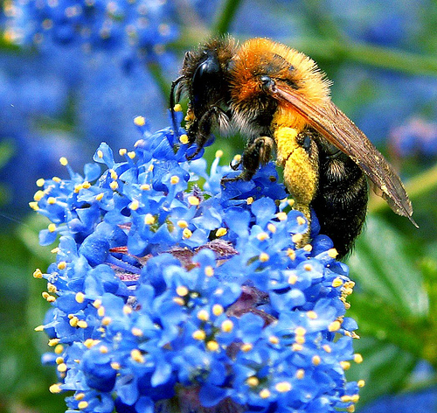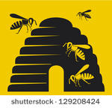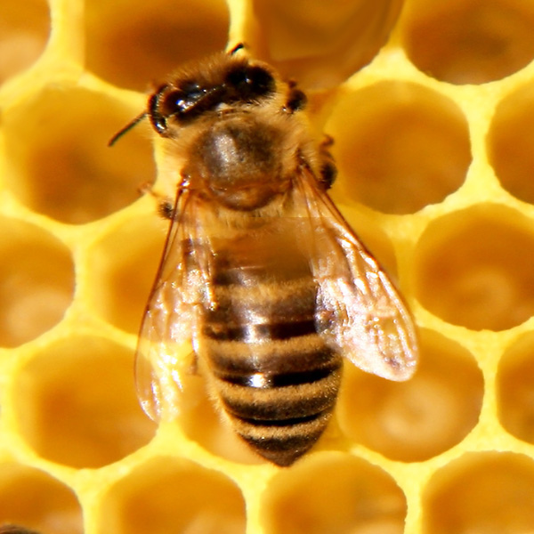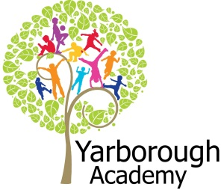

**Project Overview**

This term our project will be exploring the importance of the British Bee to our eco-system. The launch for our learning will be made up of an Imagineering experience – exploring what the world would look like without bees.

We will then watch the Bee Movie and hone in on particular facts we glean from this film, which will lead the children into knowing the focus of the project. Other activities for our launch will include creating our new learning environment.

Once the children have realised that bees are important, we will be studying the class novel (Bee & Me by Alison Jay), looking in depth at the types of flowers that attract bees, comparing habitats, pollination and bee population.

In science, we will be investigating the parts of flowers and also working scientifically to experiment with growth conditions and water transportation.

RE. and Art will combine to produce spiritual quotes from the Buddhist belief that all creatures are important – which will be added to bee art work. We will also be having a visitor from The Ropewalk Gallery who will help us to create some bee-themed, outdoor art work to be placed at school.

This project’s writing will incorporate a story of extinction from a bee’s point of view (using our class novel as inspiration), an explanation text about the importance of bees (to be displayed at our exhibition) and a persuasive text (in the form of a leaflet to hand out to members of the public.)

The whole purpose of this project is to investigate how we can preserve bees in our country - what conditions and plants we should take into account. We will be presenting our findings in the shape of our own design and creation of a bee-friendly garden. This will be entered into the Great Garden Challenge at the Lincolnshire Show in June. How exciting! We will then be relocating this garden to an area in school, which we will be inviting parents/carers to the grand opening of.

**Immersive Environment**

Elder and Sycamore classrooms will have the same theme, but will be slightly different.

Sycamore classroom will become a bee garden, whilst Elder classroom will transform into a beehive!

**How can we fight the plight of the British Bee?**



**Curriculum Opportunities**

**Writing**

- Write stories, letters, scripts and fictional biographies inspired by reading across the curriculum.

- Write persuasively.

- Write explanations.

**Reading**

- Read and listen to a wide range of styles of text, including fairy stories, myths and legends.

- Listen to and discuss a wide range of texts.

- Take part in conversations about books.

- Read and listen to whole books.

**Maths**

**-** Count and calculate in increasingly complex contexts, including those that cannot be experienced first hand.

- Gather, organise and interrogate data.

- Use and apply measures to increasingly complex contexts.

**Science**

- Look at the function of parts of flowering plants, requirements of growth, water

transportation in plants, life cycles and seed dispersal.

- Look at classification of plants, animals and micro-organisms.

- Look at adaptation to environments.

**Art and Design**

- Use experiences, other subjects across the curriculum and ideas as inspiration for artwork.

**D.T**

- understand and apply the principles of a healthy and varied diet.

**Computing**

- Select, use and combine a variety of software (including internet services) on a range of digital devices to accomplish given goals, including collecting, analysing, evaluating and presenting data and information.

**Music**

- Listen with attention to detail and recall sounds with increasing aural memory.

**Geography**

- Use a wide range of geographical sources in order to investigate places and patterns.

**P.E.**

- Perform dances.

**Project Based Learning**

Year 4

Term 3

2016-2017

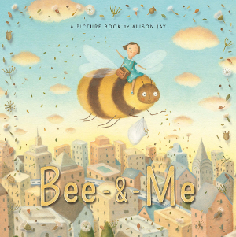

**Project Timeline**

Focus 1

Bee Aware

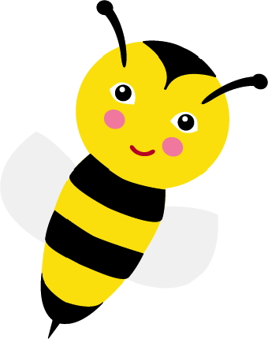

Focus 2

Bee Botanical

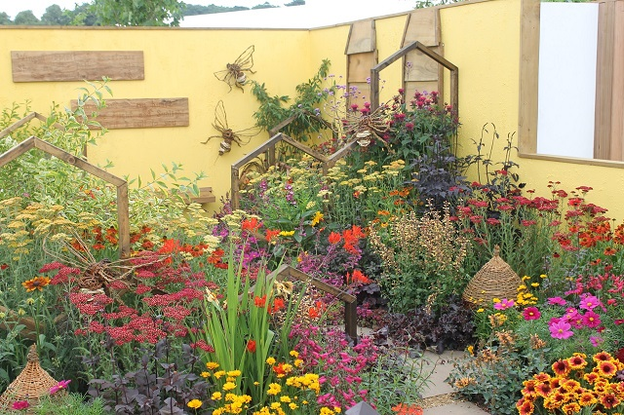

Focus 3

Be Convincing



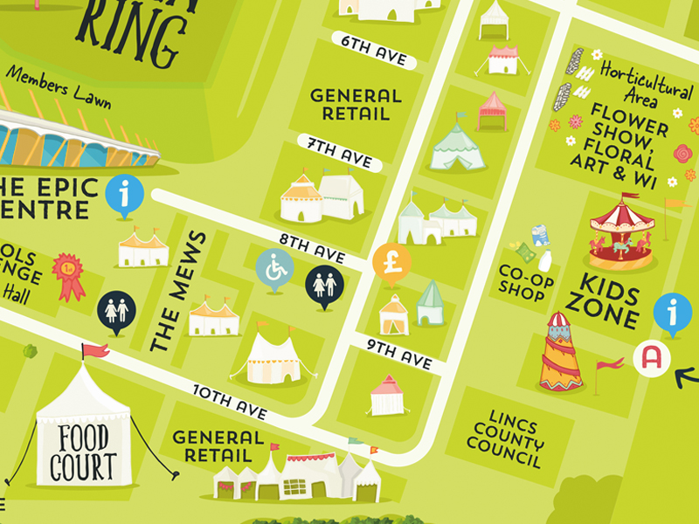

**Project Enhancements**

Experience

Exhibiting our garden design for judging at The Lincolnshire Show in June 2017.

Visitors

Ropewalk Gallery – workshops to create artwork for our bee-friendly garden.

Year 6 pupils from Scartho Junior School – giving information about their bee-keeping skills.

Local bee keeper

Class book

Bee & Me by Alison Jay

Creative Home Learning

For Focus 2 we will be asking the children to make a model flower, with labels for all of the parts.

**Project Outcomes**

This project will hopefully raise awareness of the plight of bees, encouraging people to plant flowers and plants that bees so desperately need to continue existing.

Throughout the project, the children will be working towards knowing why the existence of bees is so important as well as understanding how we can create environments that will support their sustainability.

The final exhibition will be creating a bee-friendly garden, to be shown and judged at the Lincolnshire Show. This garden will then be transplanted into an area in school. Information leaflets will be handed out to members of the public at the show and also to parents and VIPs who will be invited to the grand opening of our garden at school.

**How can you help?**

If you feel you can help us with our project this term we would love to hear from you.

In the meantime could we please ask you to consider what plants you could grow in your garden that would be bee-friendly. Also, talk to your children about what life might be like without bees.

The following websites have information that your children might find interesting:

<http://www.ngkids.co.uk/animals/Honey-Bees>

<http://www.funkidslive.com/learn/environment/b-for-plan-bee/>