Calculation Policy
2017

This policy has been designed to teach children through the use of concrete, pictorial and abstract methods. This calculation policy should be used to support children to develop a deep understanding of number and calculation.

Using the concrete-pictorial-abstract approach:
Children develop an understanding of a mathematical concept through the three steps (or representation) of concrete-pictorial-abstract approach. Reinforcement is achieved by going back and forth between these representations.

Concrete representation The enactive stage - a pupil is first introduced to an idea or a skill by acting it out with real objects. This is a 'hands on' component using real objects and it is the foundation for conceptual understanding.

Pictorial representation The iconic stage - a pupil has sufficiently understood the hands-on experiences performed and can now relate them to representations, such as a diagram or picture of the problem.

Abstract representation The symbolic stage - a pupil is now capable of representing problems by using mathematical notation, for example: 12 ÷ 2 = 6 .

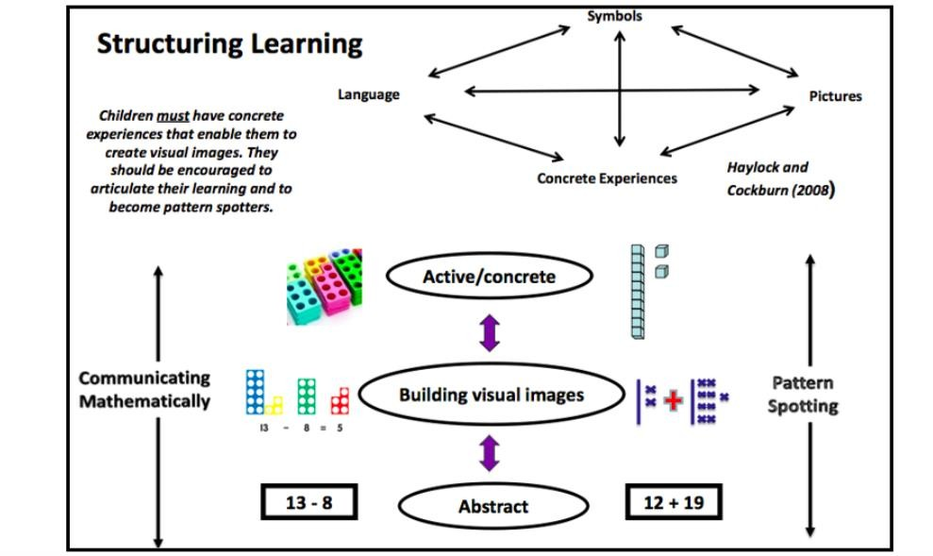

Guidance

This is document provides guidance and examples for key objectives for each year group but is not to be followed as a complete planning aid as not all objectives are exemplified.
Reception

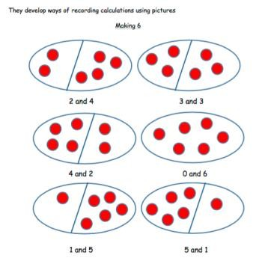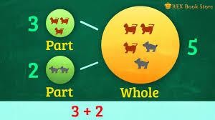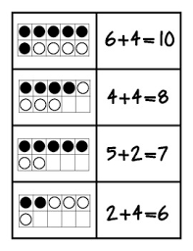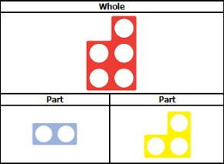Addition

Explore part part whole relationship

Using the ten frame to support addition of single digits – counting all/combining two groups

Solving problems using concrete and pictorial images.
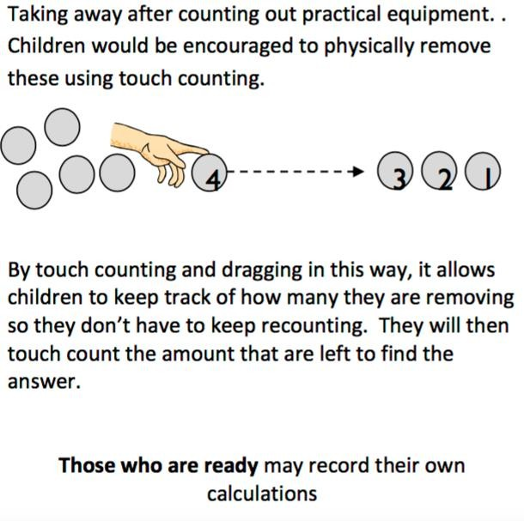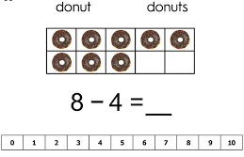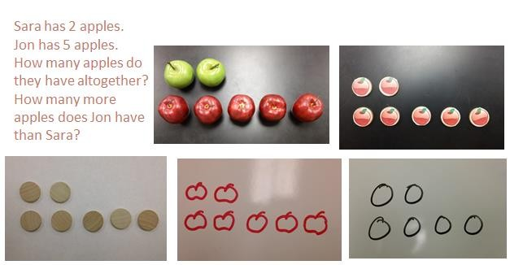
Subtraction
Using the ten frame to support subtraction by taking away
• 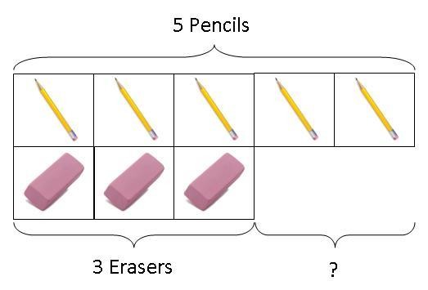Peter has 5 pencils and 3 erasers. How
many more pencils than erasers does he have? Solving problems using concrete and pictorial images.
Multiplication

Division

Year 1

Addition

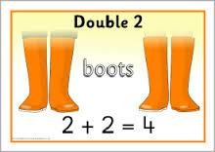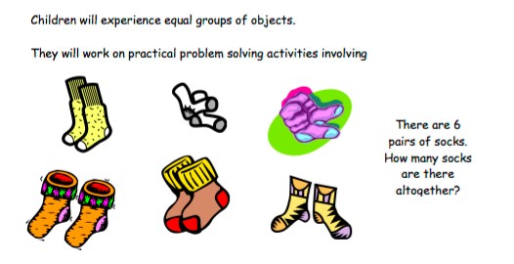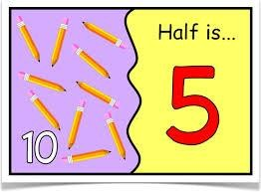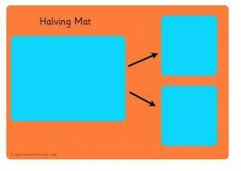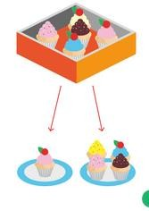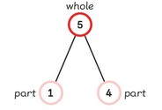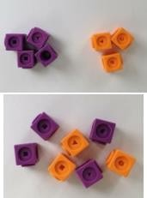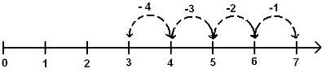Joining two groups and then recounting all objects using one-to-one Correspondence
(lots of practice making
10 and numbers to 10 e.g. 6 + 4 = 10 or 3 + 5 =
8)
3 + 4 = 7

Learn number bonds to  20 and demonstrate related facts  Teach addition and subtraction alongside each other as pupils need to see the  relationship between the facts. | 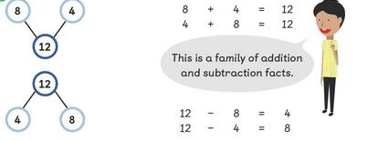
Add and subtract one  digit numbers and two digit numbers to 20, including zero | 8+1=9
Bridging 10  Use ten frames, Singapore bars, egg boxes and number lines to practice.  Chn should start with the larger number and add the smaller number seeing what makes ten and what is left over. | 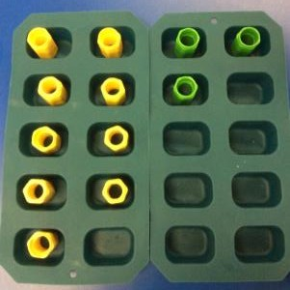  6 + 6 = 12 Make 9 in one and 3 in the other. Take one from  the 3 to make the 9 into a ten….10+2 = 12
Subtraction
Taking away should  begin with physical objects: objects, cubes, Dienes etc | 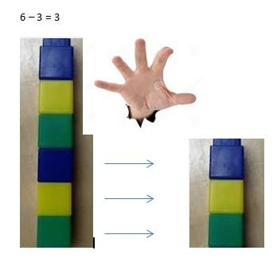

Subtraction by counting
back
Subtracting a single digit
number from a single digit number and a single digit from a two digit by crossing out pictures
Subtracting using the  part part whole  (include problem solving with missing digits).  ? - 5 = 2 | 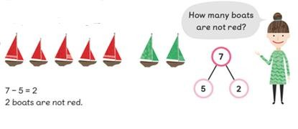
Subtraction by  subtracting from 10  Children subtract from  10 and not from ones | 14 – 8 = ?

When subtracting using  Dienes children should be taught to regroup a ten rod for 10 ones and then subtract from those ones | 20 – 4 = 16
Subtracting multiples of  10  Using the vocabulary of  1 ten, 2 tens etc alongside 10, 20, 30 Is very important here as pupils need to  understand that it is a 10 not a 1 that is being taken away | 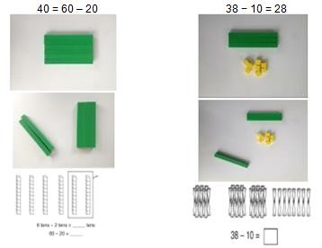
Multiplication
Counting in multiples of  2, 5 and 10 from zero  Children should count  the number of groups on their fingers as they are skip counting. | 2 4 6 8  4 groups of 2 = 8

When moving to  pictorial/written calculations the vocabulary is important | This image represents two groups of 4 or 4 twice
Solving multiplication problems using repeated addition | 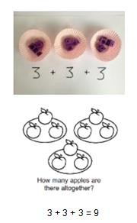
Division
Pupils should be taught  to divide through working practically and the sharing should be shown below the whole to familiarize children with the concept of the whole.  The language of whole and part part should be used. | 10 ÷ 2 = 5  8 ÷ 4 = 2
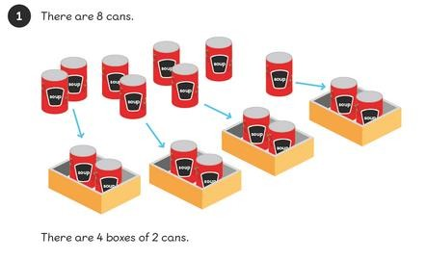Year 2

Addition

Using concrete objects and pictorial
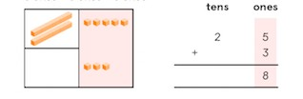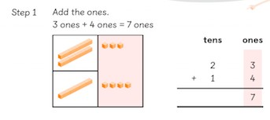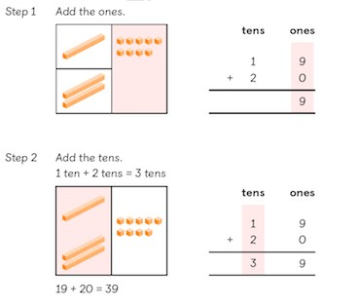
representations to
add a 2 digit number with a 1 digit number.
Using concrete objects and pictorial representations to add a 2 digit number and 10s number.

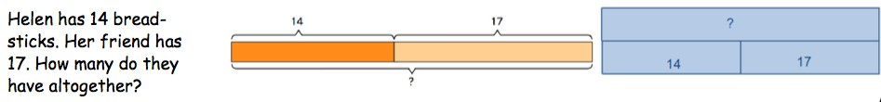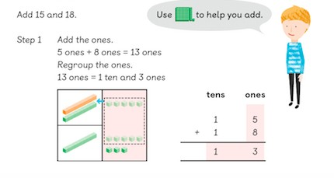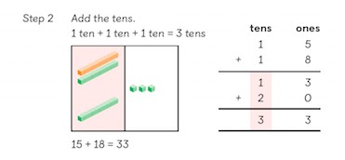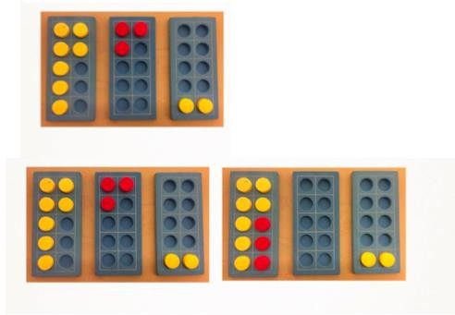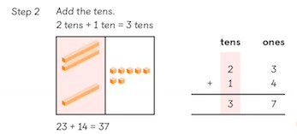
Using concrete  objects and pictorial representations to add a 2 2 digit numbers. | Adding with renaming
Using concrete  objects and pictorial representations to add a 3 single digit numbers. | 7+3+2 = leads to 10 + 2 =
Using the bar to find
missing digits.
It is important for children to use the bar in this way to encourage the use of it to aid with
problem solving.

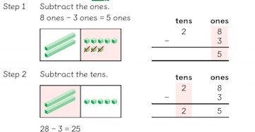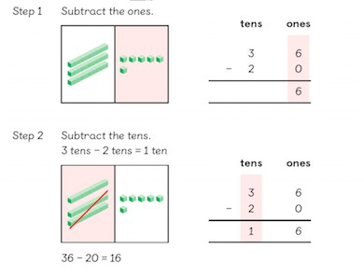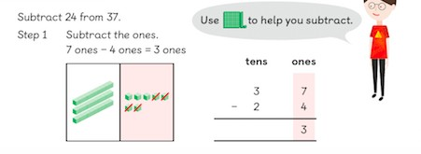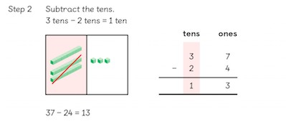
Subtraction
Using concrete
objects and pictorial representations to subtract a 1 digit number from 2 digit number.
Using concrete
objects and pictorial representations to subtract a 10s number from 2 digit number.
Using concrete objects and pictorial representations to subtract a 2 digit number from 2 digit number.
Recognise and use  the inverse relationship between addition and subtraction | Use this to check calculations and  ? 76 solve missing number problems.  23 53 23 ?
Multiplication

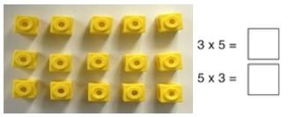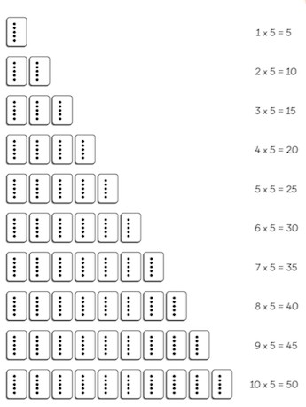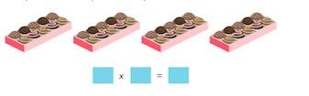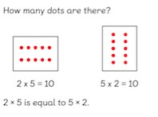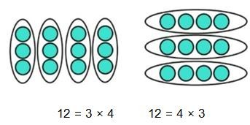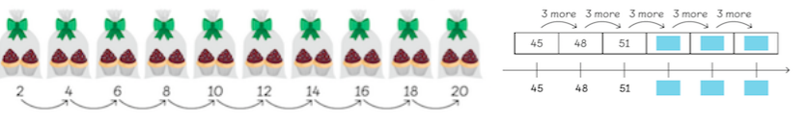
Skip counting in
multiples
of 2, 3, 5, 10 from
0
Recall and use
multiplication facts for the multiplication tables 2, 5 and 10.
I can use
multiplication (x) and
equal (=) sign when writing out my times tables.
Multiplication is
commutative

Pupils should understand that an array can represent different equations and that, as multiplication is
commutative, the order of the multiplication does not affect the answer.
Solve multiplication
problems in context using arrays and repeated addition
Division

Recall and use division facts for the multiplication tables  2, 5 and 10. | 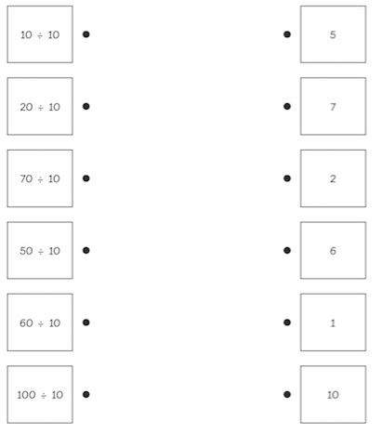
Solve division
problems in context
using concrete objects by sharing
Solve division
problems in context using arrays
I can solve
division as grouping.

I can use the inverse.

This should be taught alongside both multiplication and division.

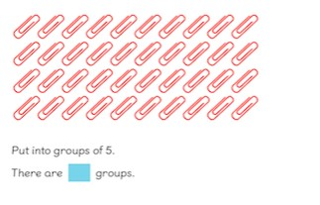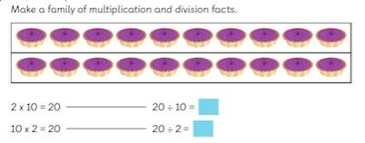Year 3

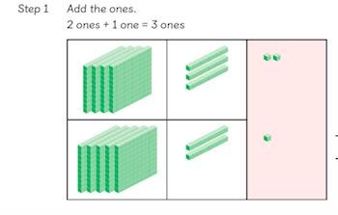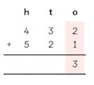Addition

Add two three digit numbers.

Children need to use equipment first to support their understanding of place value.

Children to word gradually to three digit + three digit starting without carrying and gradually moving towards carrying.
432 + 521 =
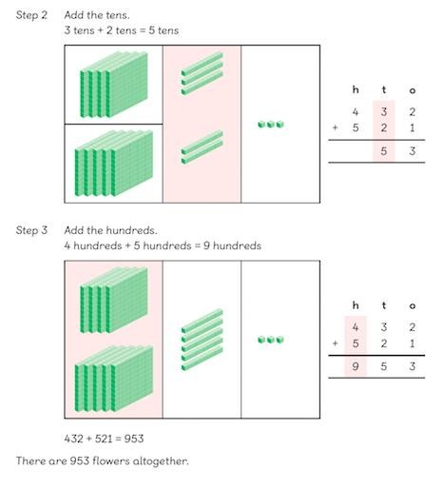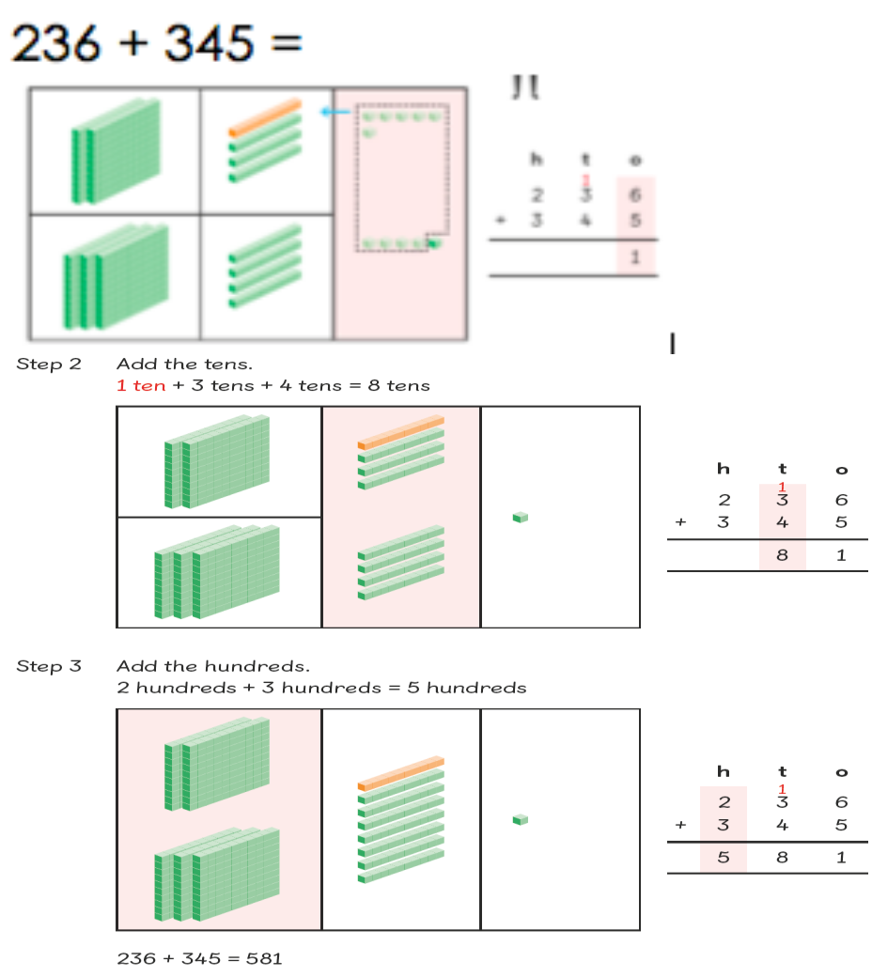
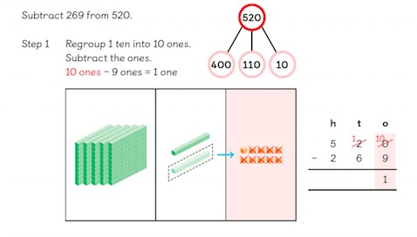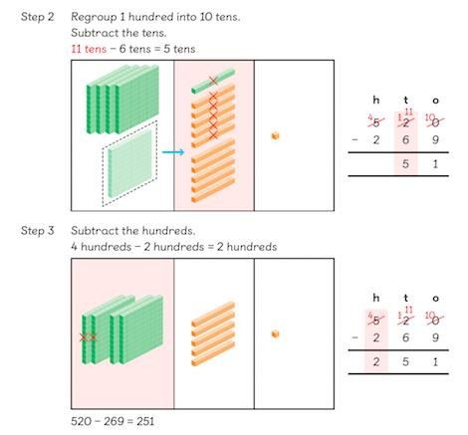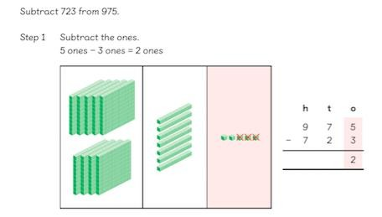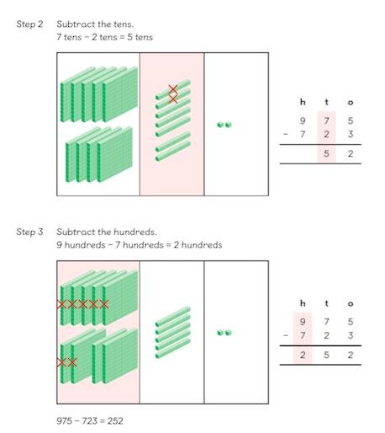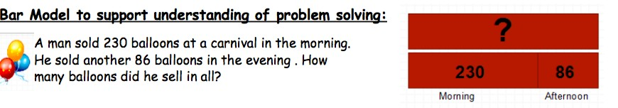
Using the bar to
find missing digits. It is important for children to use the bar in this way to encourage the use of it to aid with problem solving.
Subtraction
Subtract up to 3  digits from 3 digits.  Very important for children to use dienes equipment along with a place value chart to support. | Only when secure with the method should exchanging be introduced.

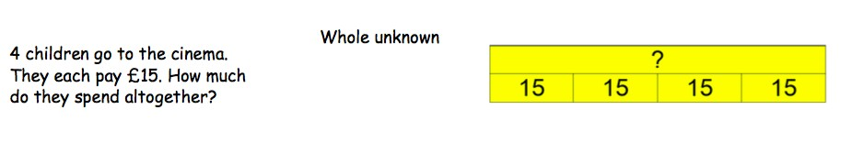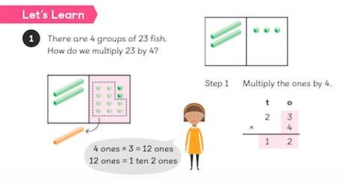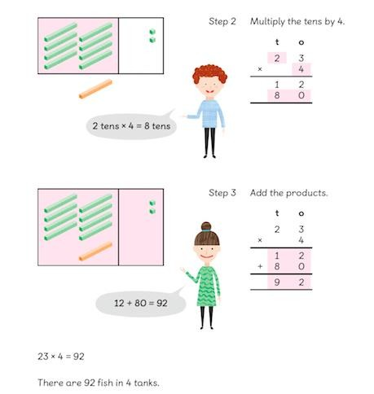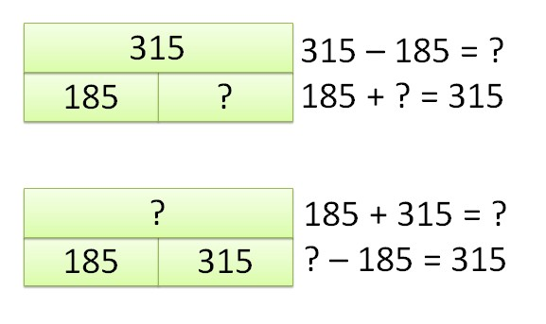
Using the bar to
find missing digits.

It is important for children to use the bar in this way to encourage the use of it to aid with problem solving.
Multiplication
Children should be
able to recall the 2,
5, 10, 3, 4 and 8 times tables.

Multiple a two digit number by a one digit.
Using the bar to
solve multiplication problems.

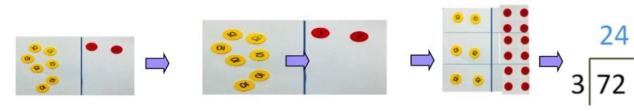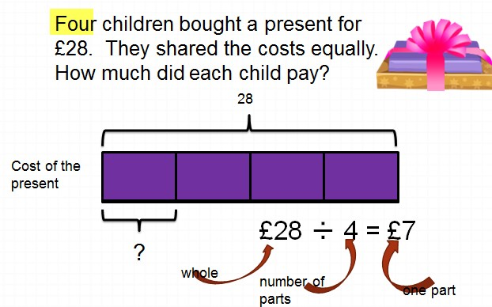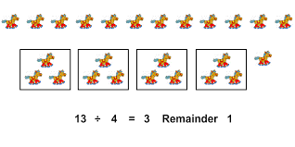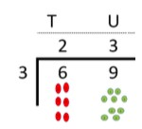
Division
Dividing by  grouping undrestanding the concept of remainders. | Start with using the real objects-or objects that represent the calculation.
Dividing using short division.  Once children are secure with division as grouping and demonstrate this using number lines, arrays etc., short division for larger  2-digit numbers should be introduced, initially with carefully selected examples requiring no calculating of remainders at all. Start by  introducing the  layout of short division by comparing it to an array. | Remind children of correct place value, that 69 is equal to 60 and 9, but in short division, pose:  · How many 3’s in 6? = 2, and record it above the 6 tens.  · How many 3’s in 9? = 3, and record it above the 9 ones.  Once children demonstrate a full understanding of remainders, and also the short division method taught, they can be taught how to use the method when remainders occur within the calculation (e.g. 72÷3), and be taught to ‘carry’ the remainder onto the next digit.
Using the bar to
aid the solving of division problems.

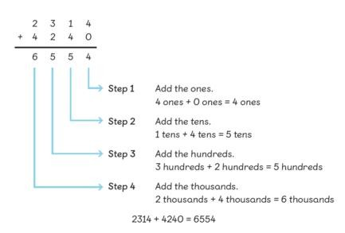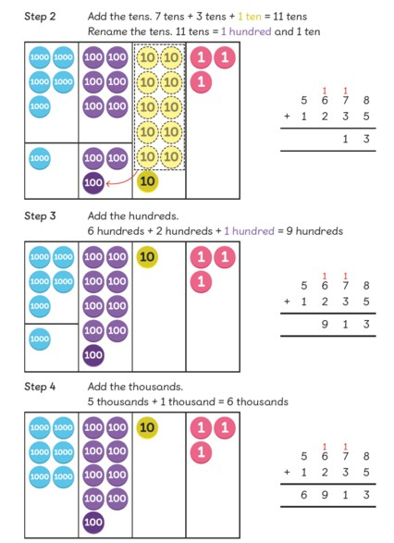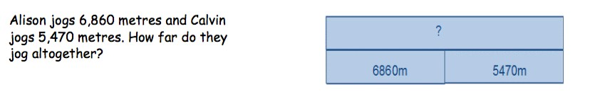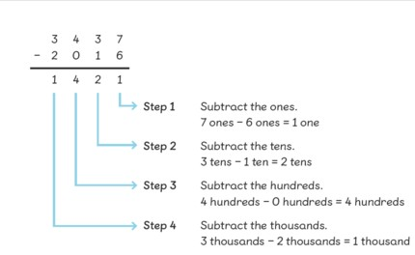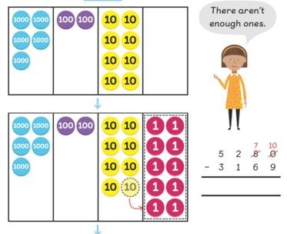Year 4

Addition
Adding numbers
with up to 4 digits.

Again this should start with the children using dienes to support them with lots of
discussion about the value of each digit.
Using the bar to find  missing digits.  It is important for children to use the bar in this way to encourage the use of it to aid with problem solving. | This is not a form of getting the correct answer but helping to guide children to the  correct operation.
Subtraction
To subtract with
numbers up to four digits including exchanging when children are secure.

Again children need to use dienes to support their learning.

Using the bar to find
missing digits.

It is important for children to use the bar in this way to encourage the use of it to aid with problem solving.
Multiplication
Children to know all
times tables to 12 x
12.

Ladder method to be used with children multiplying both two and three digits by a one digit number.
Multiplying using  the bar. | 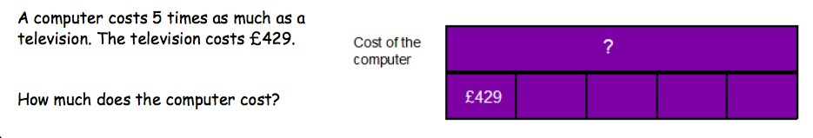

Division
Dividing up to three digit numbers by a one digit number using short division.

Only when the children are secure with dividing a two digit number should they move onto a 3 digit number.
Dividing using the
bar.

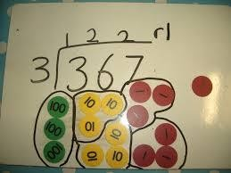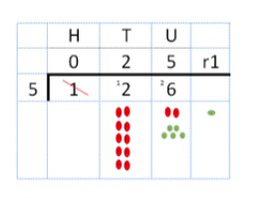Year 5

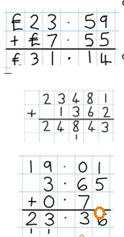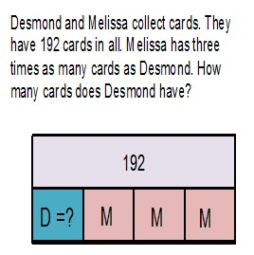Addition

Adding numbers with more than 4 digits including decimals

Using place value charts are key to this as well as place value counters to help with the decimals.
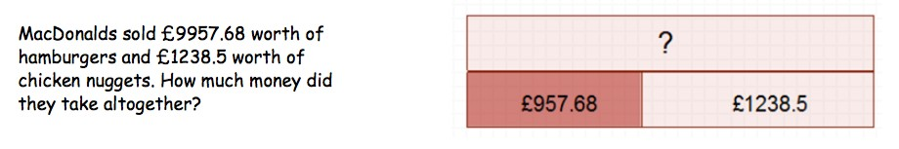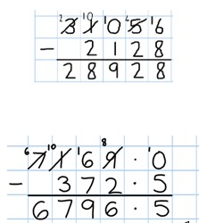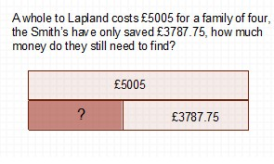
Using the bar to find missing digits.  It is important for children to use the bar in this way to encourage the use of it to aid with problem solving. | This is not a form of getting the correct answer but helping to guide children to the correct operation.
Subtraction
Subtract with at least four digit numbers including two decimal places.  Include money, measures and decimals ensuring that children do this practically before the abstract. | Subtract with decimal values, including mixtures of integers and decimals, aligning the decimal point.  Approxima te, Calculate, Check .
Using the bar to find
missing digits.

It is important for children to use the bar in this way to encourage the use of it to aid with problem solving.
Multiplication
Multiplying up to four  digit numbers by two digits using long multiplication.  Children need to be taught to approximate first, e.g. for 72 x 38, they will use rounding:  72 x 38 is approximately  70 x 40 = 2800, and use the approximation to check the | 56  X 27 Approximate, Calculate,  Check .  392 (56x7)  1120 (56x20)  1512  · Explain that first we are multiplying the top number by 7 starting with the units. (any carrying needs to be done underneath the numbers).

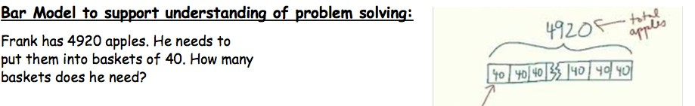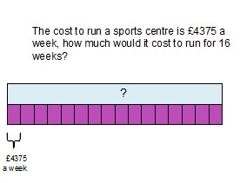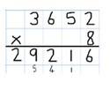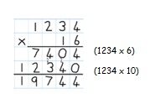
reasonableness of their  answer. | · Now explain that we need to put a 0 underneath—explain that this is because  we are multiplying the number by 20.. (2 tens) which is the same as multiplying  10 and 2.  · Now add the 2 numbers together to give you the answer.  · This will need lots of modeling to show the children.
Using the bar to support
multiplication.
Division
Diving with up to four  digit numbers by one digit including numbers where remainders are left. | 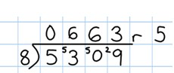  Short division with remainders: Now that pupils are introduced to examples that give rise to remainder answers, division needs to have a real life problem solving context, where pupils consider the meaning of the remainder and how to express it, ie. as a fraction, a decimal, or as a rounded number or value , depending upon the context of the problem.
Using the bar to support
division problems.

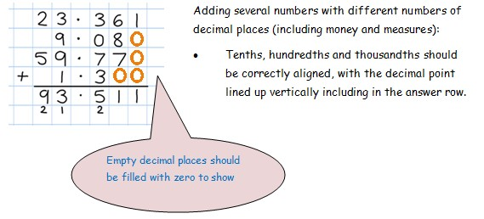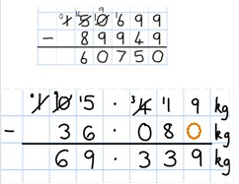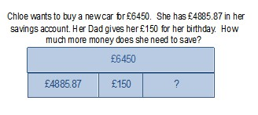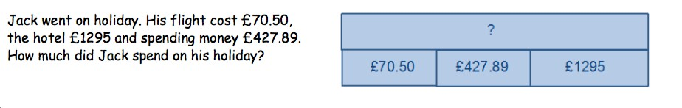Year 6

Addition
Adding several
numbers with up to three decimal places.
Adding using the
bar.
Subtraction
Subtracting with  increasingly large and more complex numbers and decimal values. | Very important to use in a range of contexts-  measures and money.
Using the bar for
subtraction.

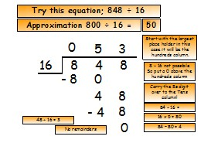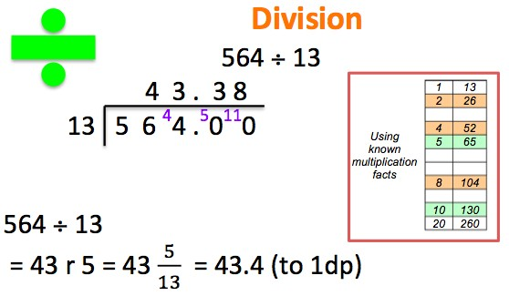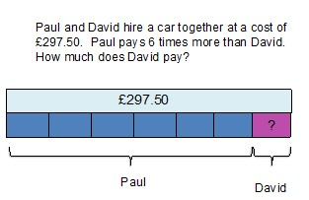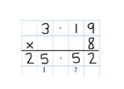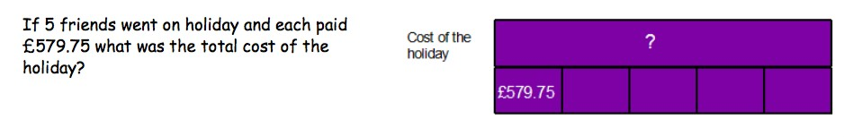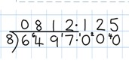
Multiplication
Short and long  multiplication with up to two decimal places. | Approximate, Calculate, Check .
Using the bar to
help with multiplication.
Division
Divide at least 4  digits by both single-digit and  2-digit numbers  (including decimal numbers and quantities) | Short division with remainders: Pupils should continue to use this method, but with numbers to at least 4 digits, and understand how to express remainders as fractions, decimals, whole number remainders, or  rounded numbers. Real life problem solving contexts need to be the starting point, where pupils have to consider the most appropriate way to express the remainder.
Long division this
is for when
dividing by two digit numbers.
Using the bar to
help divide.

