
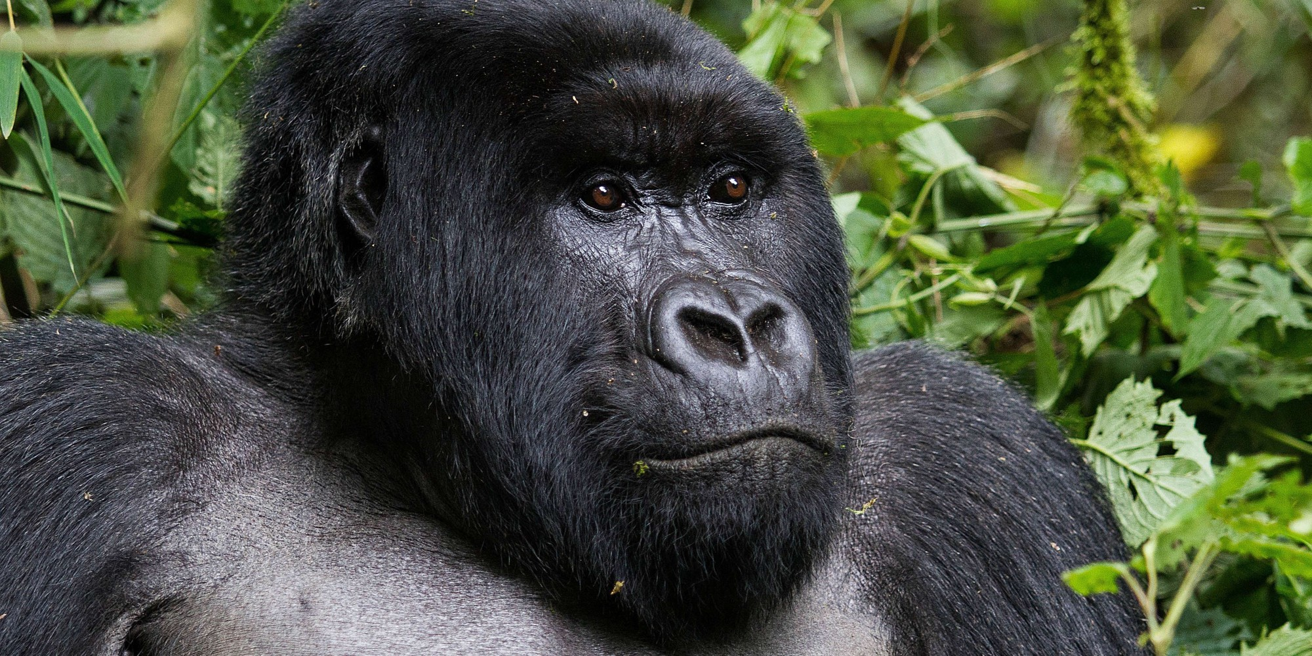
Project Based Learning
Year 6
Term 2
2016-2017
How can we help prevent the next mass extinction?

Project Overview
Almost every day we hear on the news about species of animals that are becoming increasingly rare, or scientists warning of the consequences of global warming… but what is really going on in the world today? And how will it affect all our lives in the future? For instance, it is predicted that by 2020 there will be no wild elephants left.
In the past, there have been periods of mass extinction when many animal species have been wiped out. We are currently in danger of history repeating itself- however with your help it is preventable. We will be exploring strategies and ways of limiting damage to our planet and helping to avoid the next mass extinction.
We will begin by examining evidence from the past regarding extinction and the scientific reasons behind it. We will then be exploring current issues such as global warming and deforestation- studying the impact of these on living things.
Finally we will decide what we can do to help in our own local environment. We aim to be top of the class by #ShapingOurFuture on climate change.

Curriculum Opportunities

Writing
Write a fiction text from the point of view of an animal whose home has been invaded.
Write in a journalistic to inform readers of the next mass extinction.
Write an explanation text how a specific animal has become extinct, for example the Dodo.
Discuss the issue of global warming.
Write a non-chronological report of how to decrease our carbon footprint.

Reading
Read a wide range of non-fiction texts related global warming and other environmental issues.
Listen to and discuss and wide range of texts
Read and listen to whole books
Take part in discussions related to the class book

Maths
Handle data relating to endangered species.
Depict deforestation using area and perimeter skills
Use percentage, ration and proportion skills for breeding programmes.

Science
Study the process of evolution in living things.
Investigate how animals are adapted to particular environments.
Examine the lifecycles of different animals
Explore food webs and food chains.

Art and Design
Design a rainforest.
Design and create a wildlife haven.

Communication
Engage in meaningful discussions regarding the project in all areas of the curriculum
Listen to and learn a wide range of subject specific vocabulary
Practise and rehearse sentences and stories, gaining feedback on the overall effect
Debate issues and formulate well-constructed points

Geography
Investigate the impact of humans on the environment.
Find geographical features of the world
Describing how locations around the world are changing and explain the reasons for this change.

Computing-
Create an interactive wildlife haven linked to our findings

RE.
Discuss shared beliefs across religions

PHSE
Examine many issues related to respect, opinions, conflict and belief
Immersive Environment
We will be creating a variety of threatened environments, including the tropical rainforest. We will include animals that are on the endangered species list such as giraffes, elephants and polar bears.

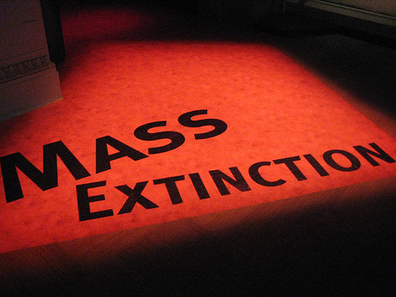
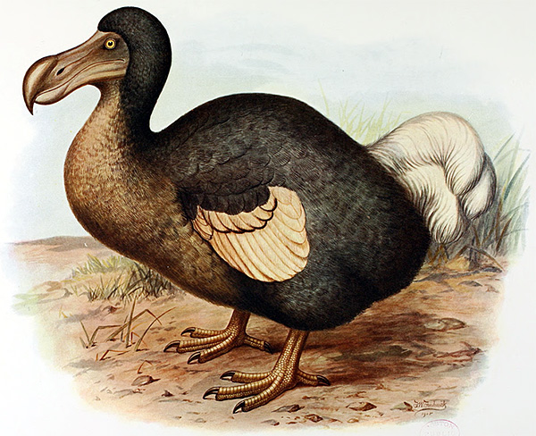
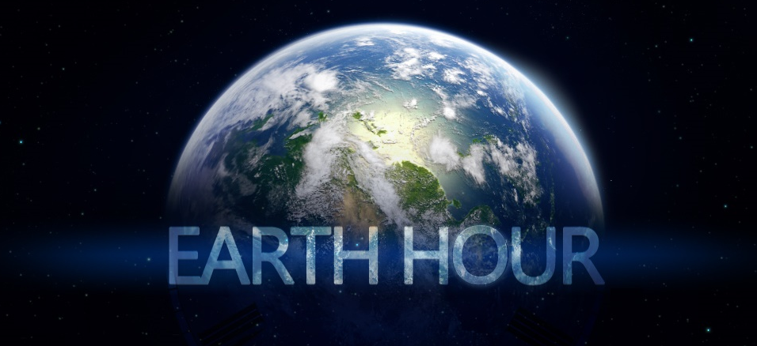
Project Timeline
Focus 1
Have mass extinctions happened in the past?

Focus 2
What species are currently endangered?

Focus 3
What’s already in place to prevent this?

Focus 4
Is mankind responsible for extinctions?

Focus 5
How can we help prevent this?

Project Outcomes
This project will involve the children using cross-curricular skills to help them answer the essential question of “How can we help prevent the next mass extinction?”
Throughout the project, the children will be exploring ways in which we can all help save our environment.

During the project, pupils will take into consideration the needs and requirements of wildlife that we want to encourage into our wildlife haven. At the end of the project the pupils will then create a haven for local wildlife.

Project Enhancements

Trip
Our trip is to the Yorkshire Wildlife Park on Tuesday 24th January to examine the essential work already in place to avoid particular species becoming extinct in the wild.

Class Book
Rabbits by John Marsden and Shaun Tan

Creative home learning
Your home learning task is to create an environment inhabited by at least five different species of animal. This could be inside a box of some description and include a suitable habitat for all the creatures. ie a desert inhabited by Bactrian camel, Cairo spiny mouse, African wild dog, Cobra and a Chuckwalla. (You have to be specific!)
OR
Create an ark including all the animals that you would like to protect.
(Feel free to do both if you wish- this is an extended project)

How can you help?
Participate in “Earth Hour” on Saturday March 25th, from 8.30pm to 9.30pm. More details at www.earthhour.org or @earthhour on Twitter.
You could also research species that are on the endangered list, statistics and facts welcome.

Useful websites:
www.wwf.org.uk
www.yorshirewildlifepark.com
www.greenpeace.org.uk

