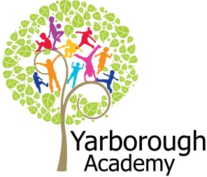
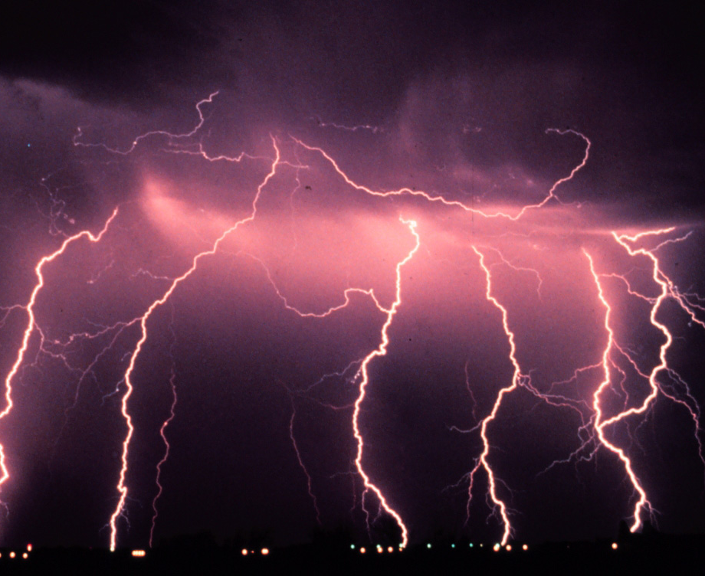
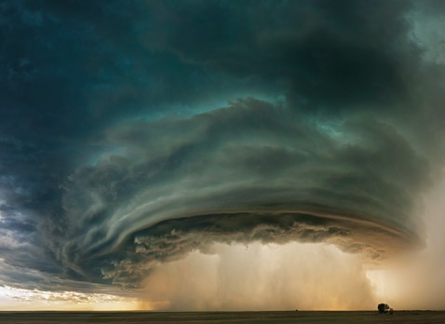
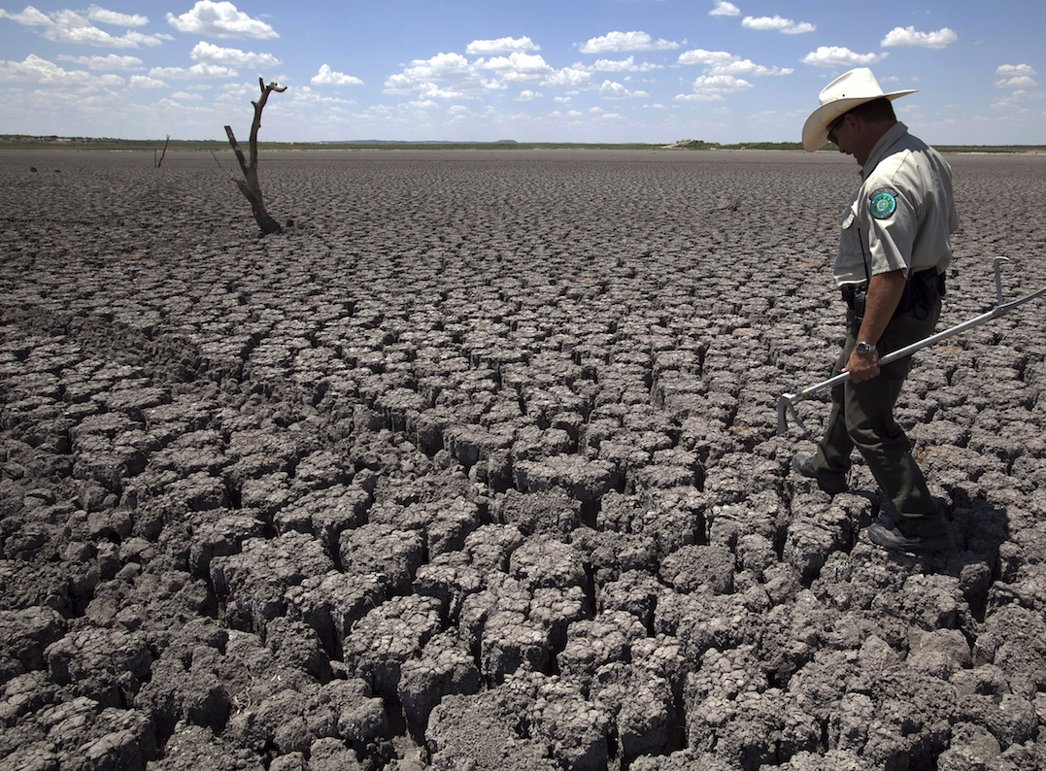
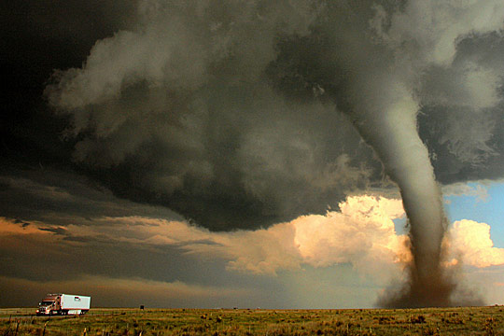
Project Based Learning
Year 3
Term 2
2016-2017
Extreme weather: Are you prepared?
Project Overview
Our project this term is all about looking at how we can be prepared to face extreme weather. The children will be hooked into their learning through watching Cloudy with a Chance of Meatballs and experiencing what might happen during a flood. They will also be working on decorating the classrooms with tornadoes, clouds and rain. As researchers, the children will discover the devastating effects of extreme weather and how the water cycle works. As mathematicians, they will gather and analyse data from terrible floods, storms and temperature extremes. They will also look at maps to research where in the world these events occur.

As readers and writers, they will be creating suspenseful stories about what it would be like to lose your home to flooding. Further along, the children will be reporters, writing their own newspaper reports about a devastating storm. They will then use the skills of a scientist to investigate what effects extreme heat has on plants and animals and create a scientific report about it.

Finally, the children will make their own Bear Grylls inspired videos about how to stay warm in very cold temperatures. All the hard work will be put together in a Year 3 book about extreme weather that will be sold and the profits will go to charities supporting those whose lives have been affected by flooding.

Curriculum Opportunities

Writing
- Write stories of mystery and suspense
- Write in a journalistic style.
- Write formally
- Write haiku
Reading
- Read and listen to a wide range of styles of text, including fairy stories, myths and legends.
- Listen to and discuss a wide range of texts.
- Read and listen to whole books
Maths
- Gather, organise and interrogate data.
- Use and apply measures to increasingly complex contexts.
- Use the properties of shapes and angles in increasingly complex and practical contexts, including in construction and engineering contexts.
Science-
- Look at adaptation to environments
- Look at the requirements of growth and water transportation in plants
Geography -
- Locate the world’s countries, with a focus on Europe and countries of particular interest to pupils.
- Describe and understand key aspects of rivers and the water cycle.
D.T. –
- Generate design ideas
- Make design product
- Evaluate prototypes
Communication –
- Speak to small and larger audiences at frequent intervals
History –
- History of interest to pupils
Computing-
- Select, use and combine a variety of software (including internet services) on a range of digital devices to accomplish given goals, including collecting, analysing, evaluating and presenting data and information.
Music –
- Improvise and compose music
RE. –
- Study other religions of interest to pupils
P.E.-
- Perform dances
PHSE-
- Discuss and learn techniques to improve in the eight areas of ‘success’.

Immersive Environment
Our classroom will have a weather theme, inspired by:

- Pictures of storms
- Hot weather and deserts
- Tornadoes
- Snow and frost
- Floods
- Weather report boards

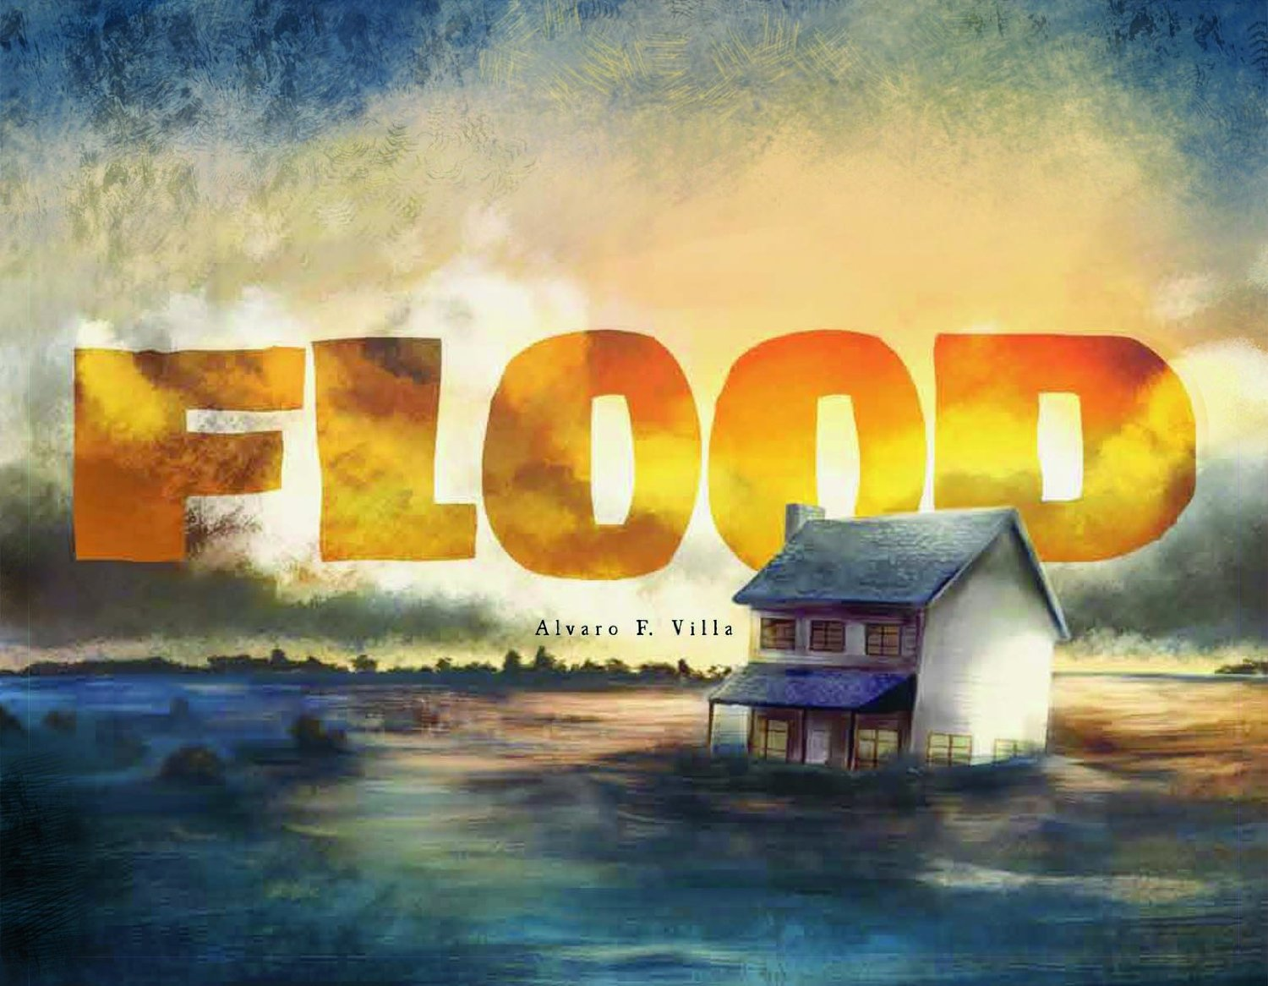

Project Timeline
Focus 1 – How do people cope with severe flooding?
In this focus, we will be looking closely at where flooding might happen. Next, the children will look at how the water cycle works and why we might get too much rain. We will see what we can learn about Noah and the Ark in Christianity. We will write suspense stories about flooding.
Focus 2 – How can people protect themselves from storms?
In this focus, we will be creating a 3D village using shapes. Then we can investigate what impact a hurricane would have. Then the children will write a compelling newspaper article about it.
Focus 3 – How does extreme heat affect the environment?
In this focus, we will be researching how plants and animals cope with extreme heat. This will involve looking at animals that have successfully adapted to live in hot places, and experimenting to find out what plants need to survive.
Focus 4 – What can we do to keep warm when it’s cold?
In this focus, we will explain how to cope with sub-zero temperatures. Therefore, we will need to investigate the best ways to keep warm and how to be prepared. We’ll watch Bear Grylls survival videos to inspire us and discover some of the coldest places on Earth.

Project Outcomes
This project will involve the children using cross-curricular skills to help them answer the essential question of ‘Extreme weather: Are you prepared?’

Throughout the project, the children will be working towards creating a book to educate and prepare people for extreme weather events.

The final exhibition will be a book sale selling copies of our book. Representatives from the National Flood Forum will be attending. Our exhibition will be on Tuesday 28th March.

Project Enhancements

How can you help?
If you feel you could help us with this project, we would love to hear from you.

Here are some really useful websites that will help you get informed about weather:

- https://www.ready.gov/kids/know-the-facts
- http://kidsahead.com/subjects/5-extreme-weather
- http://www.metoffice.gov.uk/learning/weather-for-kids/extreme-weather

Trip

We will be visiting a village that was severely affected by floods to ask locals about the scale of the damage and how long it took to repair.

Visitors

We will be having a visit from Margaret Deller to tell us more about extreme weather in stories from the Bible.

Class book

Flood by Alvaro Villa
Hurricane by David Wiesner

Creative Home Learning

Create extreme weather in a box

