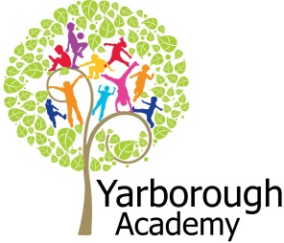
Project Based Learning
Year 2
Term 2
2016-2017
What is and could be out there?
Project Overview
Our project this term is all about looking at what is in space and what could be out there. The children will be launched into their learning through an immersive experience in the classroom. The classroom will be blacked out and star projectors and music will be used to create an atmosphere. The children will then be given a variety of media to use to initially answer the essential question in anyway they choose. They will also be working on decorating the classrooms with stars, planets and spaceships.

As researchers, the children will discover what planets are out there and use their maths skills to discover their positions. They will consider what other planet could be out there and create their own. This will be represented through artwork using the artist Robert McCall for inspiration.

As scientists the children will investigate some information from ‘Bob- The Man on the Moon’. He believes he has a factual speech for his tourists about the Sun, Moon and the Stars. They will explore whether his facts are true through a variety of activities and as writers they will produce a factual guide to the Sun, Moon and Stars.

As researchers and historians the children will then discover astronauts from the past and present. They will investigate famous space missions with the support of our Year 6 experts. As scientists the children will discover what is needed for a space mission and consider the basic pull of gravity. A timeline of major space events will then be created.

As readers and writers the children will then be immersed into the possibility of other life being out there. They will look at the experiences of a character called ‘Beegu’ who has crash-landed on our planet. They will then use this to write a narrative diary as they crash land onto the planet they created at the beginning of the project. This will be presented as a video diary.

Finally, the children will put together an electronic guide to what is and could be out there. The children will share this with Cleethorpes observatory who hope to publish it on their website.

Curriculum Opportunities

Writing
Write labels
Write non-chronological reports
Present information
Write narrative diaries
Write nonsense and humorous poems and limericks

Reading
Use the class and school libraries
Discuss books
Listen to a range of texts

Maths
Use and apply mathematics in everyday activities across the curriculum
Handle data in practical contexts
Explore numbers and place value up to at least 100.

Art
Use experiences and ideas as the inspiration for artwork.
Share ideas using drawing, painting and sculpture.
Explore a variety of techniques.
Learn about the work of a range of artists, artisans and designers.

Science- Light- look at sources and reflection
Earth and Space- observe seasonal changes
Forces – describe basic movements

Communication – Listen to and learn a wide range of subject specific vocabulary
Debate issues and formulate well constructed points
Through reading identify vocabulary that enriches and enlivens stories
Listen to and tell stories often so as to internalise the structure

History – The lives of significant individuals in Britain’s past who have contributed to our nations achievements.
Significant historical events, people and places in their own locality.

Computing- Organise, store, manipulate and retrieve data in a range of digital formats.

PHSE-
Discuss and learn techniques to improve in the eight areas of ‘success’.
Study role models who have achieved success

Immersive Environment
Our classroom will have space theme, inspired by:
Black material, stars, planets, rockets and spaceships.

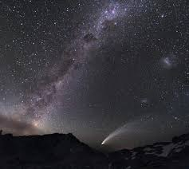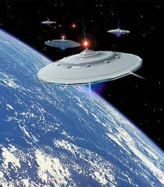
Project Timeline
Focus 1 – Planets
In this focus, we will be researching planets, working out their positions and creating mnemonics to remember the positions. Then we will create other planets and represent these through pieces of art.
Focus 2 – Moon, Sun and Stars
In this focus, we will be investigating light sources and looking at how the position of constellations of stars are used to tell the seasons apart. We will then be creating a factual guide to the Sun, Moon and Stars.
Focus 3 – Space Missions
In this focus, we will be researching astronauts from the past and present. We will be looking at famous space missions and what equipment is needed. The children will investigate the pull of gravity and the impact of this on a space mission. A timeline of major space events will then be created.
Focus 4 – Other Life
In this focus, we will be exploring the life of ‘Beegu’ who has crash-landed on the planet Earth. We will discover his experiences and use these to consider what it would be like for us if we crash-landed on another planet. This will result in the children writing and recording a diary.

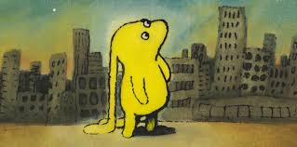
Project Outcomes
This project will involve the children using cross-curricular skills to help them answer the essential question of ‘What is and could be out there?’

Throughout the project, the children will be working towards creating an electronic guide for the Cleethorpes Observatory to publish on their website.

The final exhibition will be an immersive experience in which the children share their guides with parents and experts from Cleethorpes Observatory. This will take place on the afternoon of Wednesday 29th March

Project Enhancements

How can you help?
If you feel you could help us with this project, we would love to hear from you.

Here are some really useful websites that will help you get informed about space:
http://www.spacekids.co.uk/learn/
http://www.sciencekids.co.nz/sciencefacts/space.html
http://www.planetsforkids.org/
http://space-facts.com/

Trip

We will be visiting Cleethorpes Observatory on Wednesday 4th January.

Visitors

We will be having a visit from an expert from Cleethorpes Observatory. The Spacelincs Planetarium will be visiting as part of our exhibition.

Class book

Beegu by Alexis Deacon
Man on the Moon by Simon Bartram

Creative Home Learning

Model spaceships for Beegu to fly home in.

