
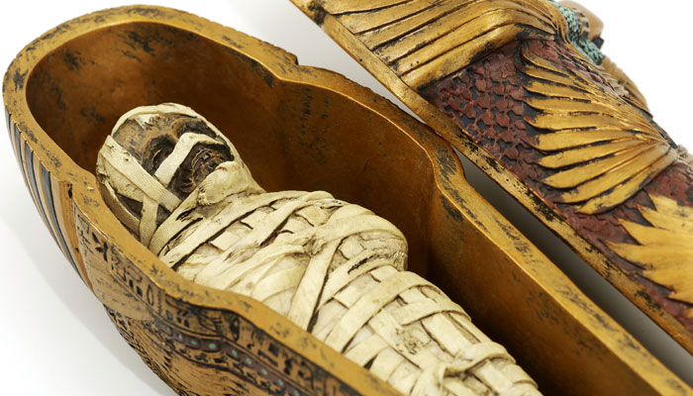
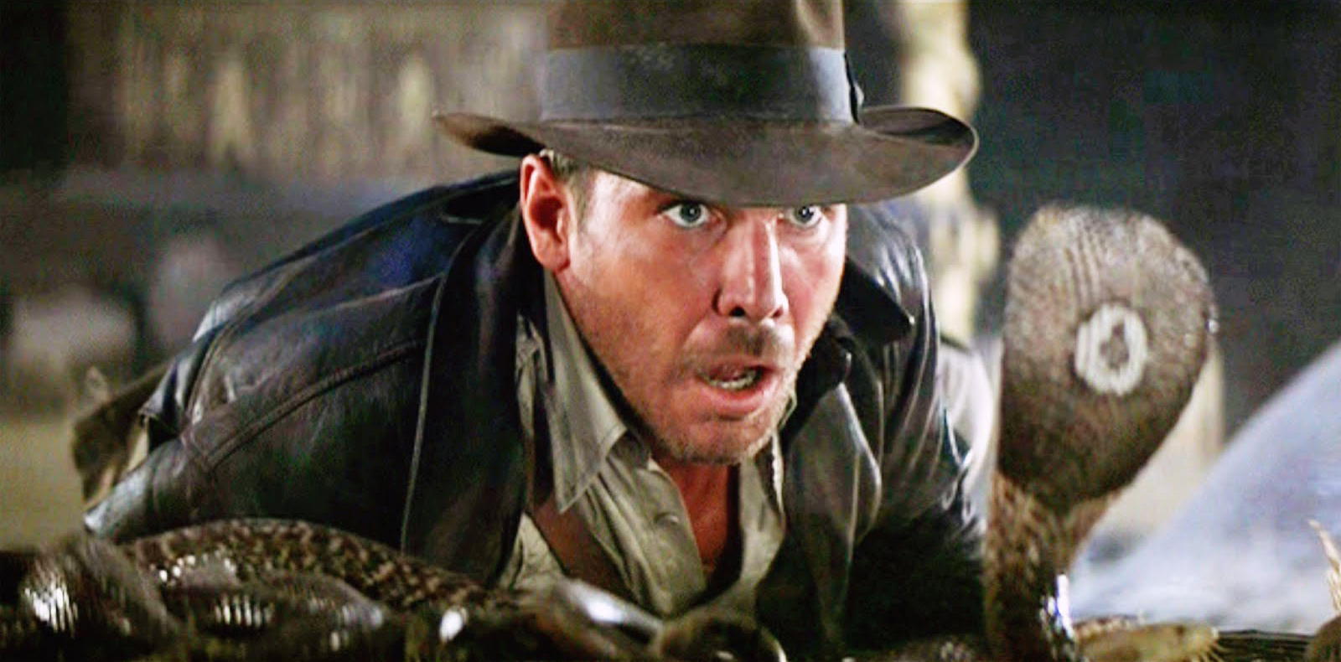
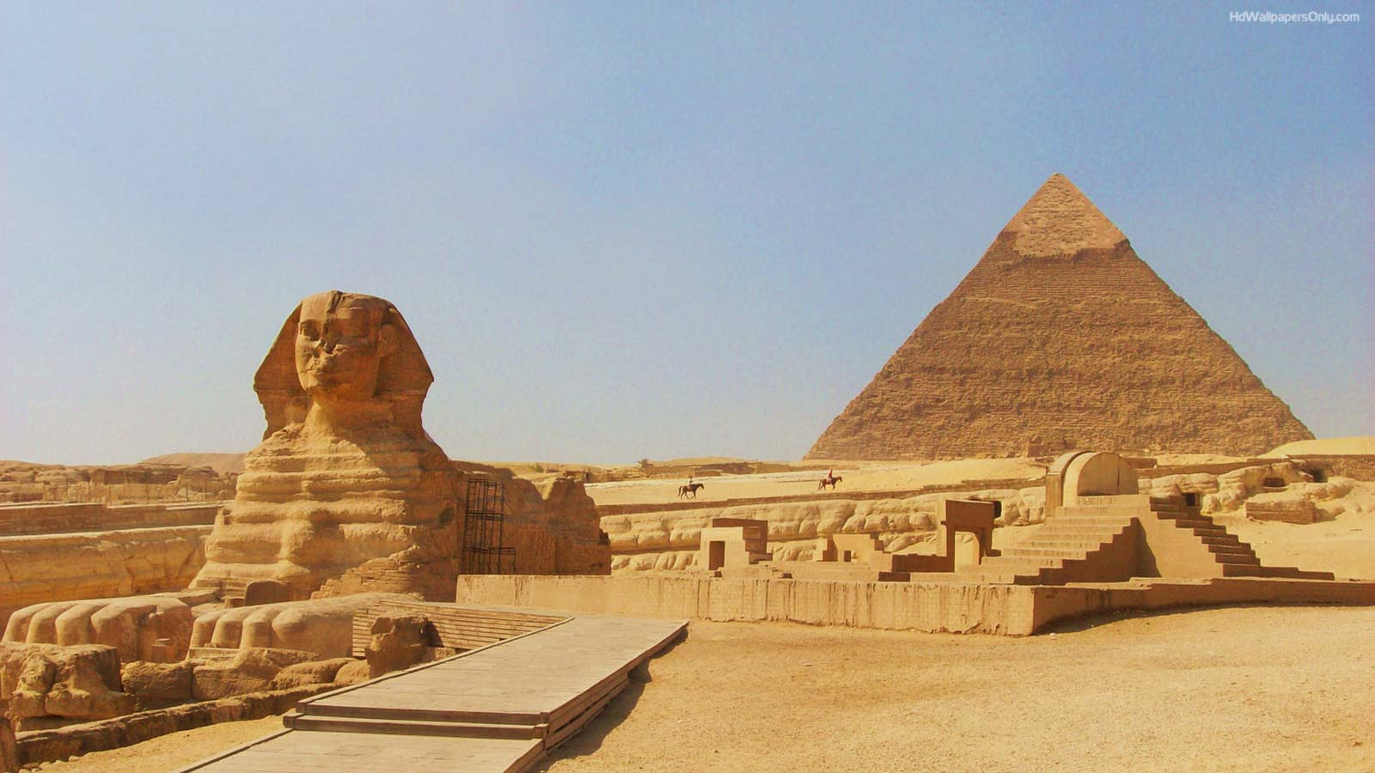
Project Based Learning
Year 6
Term 1
2016-2017
Ancient Egyptians: fabulous or foolish?

Project Overview
Have you ever wondered about the ancient Egyptians and just how clever they may have been? Fancy being a tomb raider and discovering priceless treasure? Do you want to find out about the gruesome task of removing body organs from a decaying, smelly dead body and preparing it for the next world? What about those gods with animal heads on a human body? Ever wanted to decipher hieroglyphic codes to understand hidden messages?

During the Autumn Term we will be investigating the essential question ‘Ancient Egyptians: fabulous or foolish?’ and deciding for ourselves just how clever or ‘daft’ the ancient Egyptians were.
We will begin by researching who they were and the background of their daily lives.
We will then be making mummies using the methods that the Ancient Egyptians used - investigating the miracle that is the human body (so we can remove the correct parts!). Obviously we need to make canopic jars to store the ‘removed’ body parts.
We will discover what it would be like to be a tomb raider just like Harrison Ford and try to survive the many traps and pitfalls to reach the treasure!
Children will participate in a maths challenge to create an ‘Ikea’ style flat pack pyramid using their shape skills for a Pharaoh to take on holiday, amongst other maths challenges! At the end of it all pupils will be museum curators and justify their views of the ancient Egyptians to adults! Wow!

Curriculum Opportunities

Writing
Write an adventure story as ‘tomb raiders’
Write a non-chronological report about life and times of ancient Egypt
Write an explanation text how mummies were made.
Write a discussion text with evidence gathered to answer the question: Ancient Egyptians fabulous or foolish?

Reading
Read a wide range of non-fiction texts related to ancient Egypt
Listen to and discuss and wide range of texts
Read and listen to whole books
Take part in discussions related to the class book

Maths
Use algebra and hieroglyphics in code-breaking
Use a variety of weight and measure to create water clocks.
Design 3D flat pack pyramids for a travelling pharaoh

Science-
Forces and pulleys related to moving stone
Exploring the human body including the digestive and circulatory system
Investigating how the organs of the human body work

Art and Design-
Design and use hieroglyphics
Study tomb art and create a classroom environment

Communication –
Engage in meaningful discussions regarding the project in all areas of the curriculum
Listen to and learn a wide range of subject specific vocabulary
Practise and rehearse sentences and stories, gaining feedback on the overall effect
Debate issues and formulate well-constructed points

Geography –
Use maps, atlases and digital resources to locate countries and continents of the world
Find geographical features of the world
Describe and understand key aspects of physical geography

Computing-
Coding to create a pyramid raider game

RE.
Examine the beliefs of the ancient Egyptians
Look at their god systems
Compare creation stories from different cultures

PHSE -
Examine prejudice and how different groups of people are treated
Immersive Environment
Be prepared to enter the unfound tomb of a lost king or queen of ancient Egypt…if you can break the code to find and open it!
We will have mummies (not mummys) in the classroom as well as other exciting artefacts.

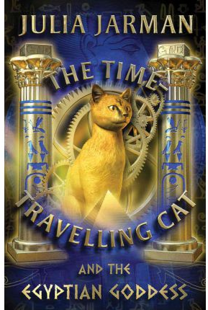
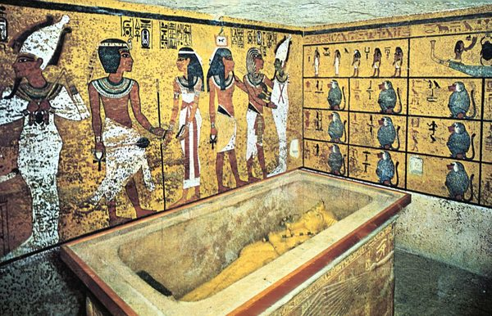
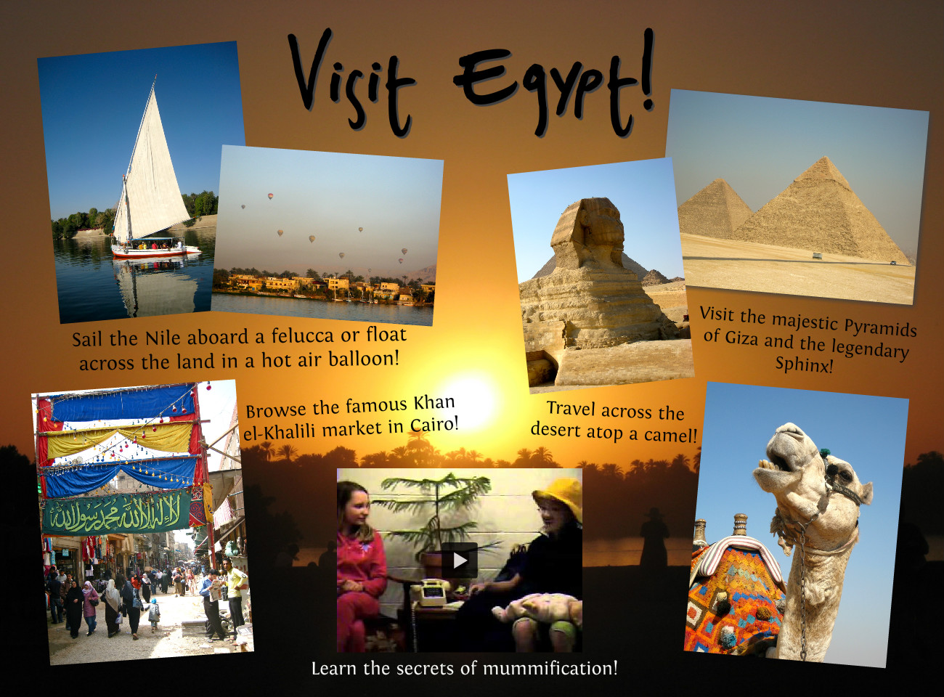
Project Timeline

Focus 1
Who were the ancient Egyptians?

Focus 2
How do we know about the ancient Egyptians?

Focus 3
What was their legacy?

Focus 4
Can you find evidence to support fabulous or foolish?

Project Outcomes
This project will involve the children using cross-curricular skills to help them answer the essential question of “Ancient Egyptians: Fabulous or foolish” and decide for themselves just how clever (or daft) the Egyptians were.
Throughout the project, the children will be working towards creating exhibits and information for the final exhibition.

At the end of the project the pupils will become curators of their own museum in the school hall, explaining whether artefacts prove that the Ancient Egyptians were indeed fabulous or foolish. This will be on Friday 25rd November in the afternoon- you are all warmly invited to attend what will be a marvellous event!

Project Enhancements

Trip
Our trip is to the Manchester Museum on Tuesday 20th September to explore the Egyptians galleries. Also included is a workshop to examine historical skills such as using first hand evidence to deduce information about the lives of the ancient Egyptians.

Class Book
The Time-travelling Cat & the Egyptian Goddess by Julia Jarman

Visitors
Hopefully a visit from an expert to explain about the life of Moses.
We are hoping to Skype a school in Cairo to discuss with them their thoughts on the Ancient Egyptians and any legacy that they have left for today’s Egyptians.

Creative home learning
Design and create a tomb for modern times. What features of modern day life would you need in the next life?

How can you help?
If you feel you can help us with our project this term we would love to hear from you! Have you visited Egypt? Have you any Egyptian artefacts that you are willing to share with the pupils?
Please can your child bring in an empty Pringles carton (other makes are available) by the end of September so we can create something gruesome.
Why not research about the ancient Egyptians in the holidays? Perhaps create a holiday brochure…but for ancient Egypt?

