
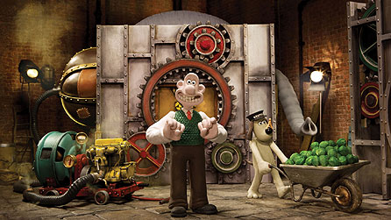
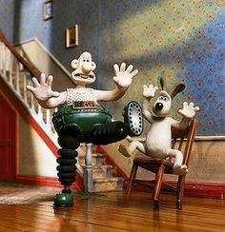
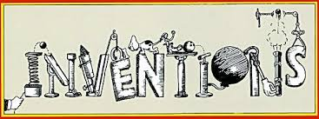
Project Based Learning
Year 3
Term 1
2016-2017
How can we be amazing inventors?
Project Overview
Our project this term is all about looking at how we can be creative and imaginative inventors. The children will be hooked into their learning through watching Wallace and Gromit: A Close Shave and creating their own amazing inventions from junk. They will also be working on inventions that were initially mistakes such as silly putty, which was created as a replacement for rubber in WWII. As researchers, the children will discover what amazing inventions have changed our world as well as what inventions we might need these days. As mathematicians, they will gather and analyse data from electronic questionnaires given to parents and members of the public. They will also work out the cost of materials.

As designers, they will come up with their own ideas for a life-changing invention. As scientists, the children will be looking at how we can use electricity in our inventions as well as the physics of how things work. As readers and writers, they will be creating stories about their inventions. Further along, the children will write their own explanations of their inventions and create newspaper reports about them.

Finally, the children will be making their invention prototypes. There will be lots of interesting opportunities to develop children’s computing skills within this project. For example, creating a sales pitch video for their invention and making e-books.

Curriculum Opportunities

Writing
- Write explanations
- Write cinquain poems
- Write stories set in places pupils have been.
Reading
- Listen to and discuss a wide range of books
- Learn a wide range of poetry by heart.
- Learn poetry by heart.
- Read and listen to whole books.
Maths
- Gather, organise and interrogate data.
- Use and apply measures to increasingly complex contexts.
Science-
- Look at appliances, circuits, lamps, switches, insulators and conductors.
- Look at circuits, the effect of the voltage in cells and the resistance and conductivity of materials.
D.T. –
- Generate design ideas
- Make design product
- Evaluate prototypes
Communication –
- Speak to small and larger audiences at frequent intervals
History –
- History of interest to pupils
Computing-
- Select, use and combine a variety of software (including internet services) on a range of digital devices to accomplish given goals, including collecting, analysing, evaluating and presenting data and information.
Music –
- Develop an understanding of the history of music.
RE. –
- Study other religions of interest to pupils
P.E.-
- Play competitive games, modified where appropriate, such as football, netball, rounders, cricket, hockey, basketball, badminton and tennis, and apply basic principles suitable for attacking and defending.
PHSE-
- Discuss and learn techniques to improve in the eight areas of ‘success’.

Immersive Environment
Our classroom will have an inventors workshop theme, with:

- Pictures of inventions
- Wallace and Gromit characters and inventions
- Cogs and pulleys
- Large machinery
- Conveyor belts
- Inventors hall of fame

Project Timeline
Focus 1 – Inspiring inventors
In this focus, we will be looking closely at the history of inventions. We will be looking at how inventions changed the world including the telephone, light bulb and the television. We will see how religion inspired inventions. We will be creating our own inventors hall of fame.
Focus 2 – What do you want?
In this focus, we will be looking at planning and creating our own questionnaires online, and gathering data from these from parents and members of the public. We will create bar charts from our data and use this to inform our design ideas for focus three.
Focus 3 – What does it look like?
In this focus, we will be focusing on the design element of our invention. We will be learning about how electricity works, as well as reading stories about Wallace and Gromits’ inventions. We will also be writing out own stories about our inventions.
Focus 4 – How does it work?
In this focus, we will explain how our invention works by creating an eBook explanation text. We will also look at the physics behind some inventions.

Focus 5 – How can it be made?

In the final focus, we will be making and evaluating our product. We will be using measuring in maths to support this. We will also create a sales video to try and persuade someone to invest in our product.

Project Outcomes
This project will involve the children using cross-curricular skills to help them answer the essential question of ‘How can we be amazing inventors?’

Throughout the project, the children will be working towards creating their own invention to make life easier for parents.

The final exhibition will be an inventor’s fair showcasing the brilliant inventions the children have designed and made. This will include a vote to find the most imaginative idea and design.

Project Enhancements

How can you help?
If you feel you could help us with this project, we would love to hear from you.

Here are some really useful websites that will help you get inspired into inventions:

- http://www.bbc.co.uk/education/clips/z6k4d2p
- http://inventors.about.com/od/astartinventions/a/FamousInvention.htm
- http://www.livescience.com/topics/invention

If you want to create your own invention over the holidays, we would love to see them in September.

Trip

We will be visiting the National Media Museum in Bradford, on Thursday 22nd September, to look at the inventions in media including the television. We will also be looking at the animation of Wallace and Gromit, and watching an Imax movie on 3D robots.

Visitors

We will be having a visit from a local designer to give us advice on how to design and create our inventions

Class book

A day with Wilbur Robinson
Until I met Dudley

Creative Home Learning

Mini invention products linked to Wallace and Gromit

