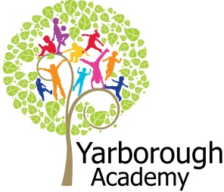
Project Based Learning
Year 2
Term 4
2016-2017
How Can Fairy Tale Characters Live Together?
Project Overview
Our project this term is all about looking at how different fairy tale characters can live together effectively in a community. The children will be hooked into their learning through dressing up, role play, watching Shrek and visits from fairy tale characters. As designers and makers the children will discover different structures and materials before designing their own. As mathematicians they will look at different 2d and 3d shapes and measures to plan, build and evaluate the effectiveness of their fairy tale village. As scientists the children will be looking at how we can use electricity to light the village at night. As readers and writers they will be developing character and setting descriptions as well as creating persuasive posters to encourage other characters to live in their new community. Further along, the children will write their own alternative ending to a fairy tale story to show how two characters could potentially get along.

Traditional fairy tale stories will be discovered in depth. The author Roald Dahl will be studied to incorporate an alternative ending to a traditional fairy tale as well as discovering how he used rhythm and rhyme to make his writing exciting. There will be lots of interesting opportunities to develop childrens computing skills within this project. For example develop computer plans of villages and structures and using the apps Explain Everything, Morfo and Aurasma.

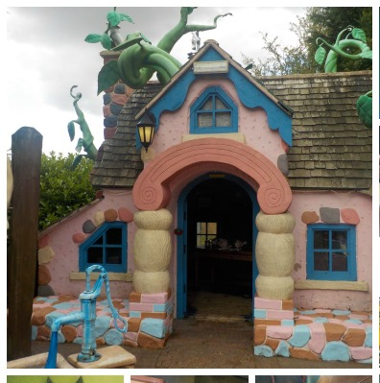

Curriculum Opportunities

Writing
Write stories and plays that use the language of fairy tales and traditional tales
Write labels
Write instructions
Write lists
Reading
Listen to a range of texts
Listen to traditional tales
Become familiar with a wide range of texts of different lengths
Discuss books
Maths
Explore the properties of shape
Use language to describe position, direction and movements
Science-
Work scientifically
Electricity - Look at sources.
Electricity - Look at appliances and circuits.
Art and Design-
Use experiences and ideas as the inspiration for artwork.
D.T. -
Build structures, exploring how they can be made stronger, stiffer and more stable.
Select from and use a range of tools and equipment to perform practical tasks such as cutting, shaping, joining and finishing.
Evaluate their ideas and products against design criteria.
Communication -
Practise and rehearse sentenced and stories, gaining feedback on the overall effect and use of standard English.
Engage in meaningful discussions in all areas of the curriculum
Geography –
Use basic geographical vocabulary to refer to and describe key physical and human features of locations
Use simple compass directions.
Use aerial photographs
Use fieldwork and observational skills
Computing-
Organise, store, manipulate and retrieve data in a range of digital formats.
Music –
Use their voices expressively by singing songs and speaking chants and rhymes.
RE. –
Study the main stories of Christianity.
P.E.-
Participate in team games, developing simple tactics for attacking and defending.
PHSE-
Discuss and learn techniques to improve the eight areas of success

Immersive Environment
Our classroom will have a fairy tale theme featuring characters and settings from stories such as:

- 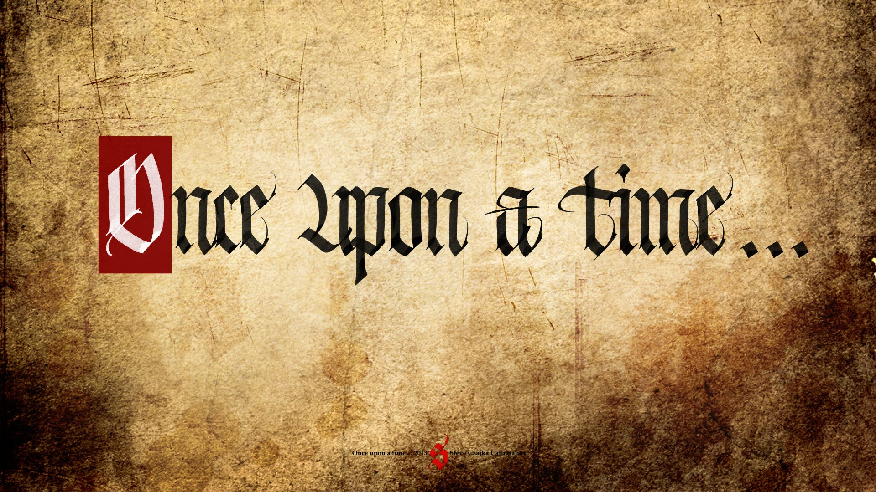
- Three Little Pigs
- Goldilocks and the Three
Bears
- Red Riding Hood
- Rapunzel

Project Timeline
Focus 1
Who belongs in a fairy tale?
– Recorded character descriptions using talking postcards.

Focus 2
What is a fairy tale setting?
- Writing a setting description based on trip to Sundown

Focus 3
Can we build a fairy tale structure?
– Creating and building their own fairy tale building.

Focus 4
What is a community?
- Creating a toolkit of what a community needs using findings from walks in the local area.

Focus 5
Location, location, location
- The children to create their own fairy tale model village.
Focus 6
Writing an alternative fairy tale
- The children to use ideas from the author Roald Dahl (Revolting Rhymes) to create an alternative fairy tale ending.
Focus 7
Can we build a fairy tale village?
- The opening and unveiling ceremony of the fairy tale village in the KS1 playground.

Project Outcomes
This project will involve the children using cross-curricular skills to help them answer the essential question of ‘How can fairy tale characters live together?’

Throughout the project, the children will be working towards creating their own real life fairy tale village as a permanent feature in the KS1 playground.

The final exhibition will be the opening and unveiling ceremony of the children’s fairy tale village which will include re-enacting fairy tale stories. This will take place on the afternoon of Monday 28th November

Project Enhancements


How can you help?
If you feel you can help us with our project this term we would love to hear from you. We are aiming to get four sheds for the playground which we can convert into a fairy tale village. If you know of anyone who could donate a second hand shed in good condition or get us a new shed at a discounted price please let us know. In addition if have any outdoor paint which you could donate to our project, or finally, have any time in which you could help us create this wonderland we would be very grateful.

Useful websites:
http://www.storynory.com/archives/fairy-tales/
http://www.lancsngfl.ac.uk/curriculum/literacy/lit_site/html/fiction/fairytale2/fairytale.htm
http://www.classicfairytales.com/

Trip
Sundown Adventureland – Wednesday 14th September

A walk to discover features, structures and buildings in the local community.

Visitors
Lego town planners
Important community members

Class book
Classic fairy tale books, Roald Dahl Revolting Rhymes.

Creative Home Learning
Over the term we will be asking you to help your child investigate fairy tale characters and the types of buildings in which they live as well as creating a fairy tale setting in a box!

