Assessment policy
Yarborough Academy
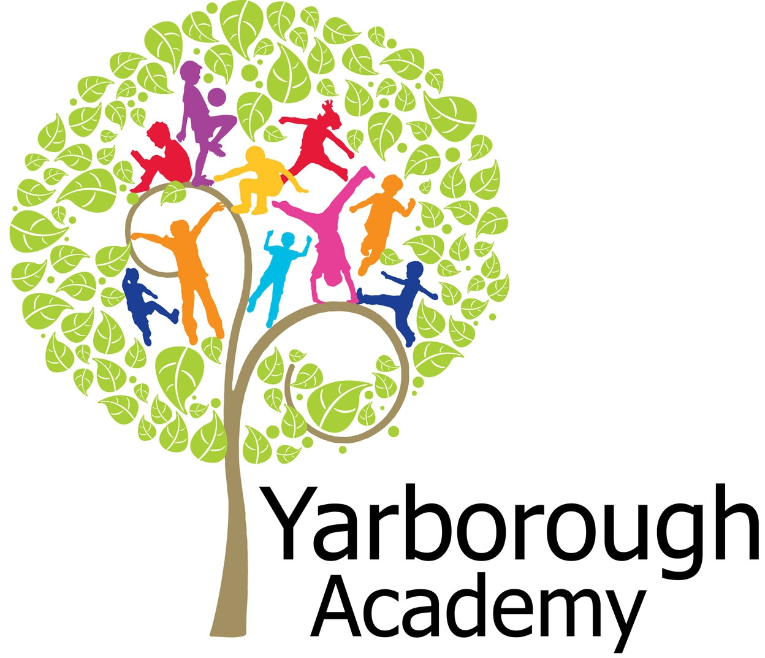

Approved by: | Governing Body | Date: March 2018
Last reviewed on: | March 2018 Written by: Mrs R Moss
Next review due by: | September 2019

Aims
The main purpose of this policy for assessment, recording and reporting is to develop effective, efficient, consistent methods through which a child’s progress is monitored and used to inform decisions about future curriculum developments for that child. Effective recording systems throughout the school will be an aid to consistency and continuity. Reports, based on records, will give accurate and meaningful information. The policy will also ensure that statutory requirements are fulfilled.
This policy aims to:
- Provide clear guidelines on our approach to formative and summative assessment
- Establish a consistent and coherent approach to recording summative assessment outcomes and reporting to parents
- Clearly set out how and when assessment practice will be monitored and evaluated

2. Principles of assessment
1. Assessment is at the heart of teaching and learning.
- Assessment provides evidence to guide teaching and learning.
- Assessment provides the opportunity for students to demonstrate and review their progress.

2. Assessment is fair.
- Assessment is inclusive of all abilities.
- Assessment is free from bias towards factors that are not relevant to what the assessment intends to address.

3. Assessment is honest.
- Assessment outcomes are used in ways that minimise undesirable effects.
- Assessment outcomes are conveyed in an open, honest and transparent way to assist pupils with their learning.
- Assessment judgements are moderated by experienced professionals to ensure their accuracy.

4. Assessment is ambitious.
- Assessment places achievement in context against nationally standardised criteria and expected standards.
- Assessment embodies, through objective criteria, a pathway of progress and development for every child.
- Assessment objectives set high expectations for learners.

5. Assessment is appropriate.
- The purpose of any assessment process should be clearly stated.
- Conclusions regarding pupil achievement are valid when the assessment method is appropriate (to age, to the task and to the desired feedback information).
- Assessment should draw on a wide range of evidence to provide a complete picture of student achievement.
- Assessment should demand no more procedures or records than are practically required to allow pupils, their parents and teachers to plan future learning.

6. Assessment is consistent.
- Judgements are formed according to common principles.
- The results are readily understandable by third parties.
- A school’s results are capable of comparison with other schools, both locally and nationally.

7. Assessment outcomes provide meaningful and understandable information for:
- pupils in developing their learning;
- parents in supporting children with their learning;
- teachers in planning teaching and learning;
- school leaders and governors in planning and allocating resources; and E. government and agents of government.

8. Assessment feedback should inspire greater effort and a belief that, through hard work and practice, more can be achieved.

4. Assessment approaches
At Yarborough Academy we see assessment as an integral part of teaching and learning, and it is inextricably linked to our curriculum.
We use three broad overarching forms of assessment: day-to-day in-school formative assessment, in-school summative assessment and nationally standardised summative assessment.

4.1 In-school formative assessment
Effective in-school formative assessment enables:
- Teachers to identify how pupils are performing on a continuing basis and to use this information to provide appropriate support or extension, evaluate teaching and plan future lessons
- Pupils to measure their knowledge and understanding against essential learning objectives, and identify areas in which they need to improve
- Parents to gain a broad picture of where their child’s strengths and weaknesses lie, and what they need to do to improve

4.2 In-school summative assessment
Effective in-school summative assessment enables:
- School leaders to monitor the performance of pupil cohorts, identify where interventions may be required, and work with teachers to ensure pupils are supported to achieve sufficient progress and attainment
- Teachers to evaluate learning at the end of a unit or period and the impact of their own teaching
- Pupils to understand how well they have learned and understood a topic or course of work taught over a period of time. It should be used to provide feedback on how they can improve
- Parents to stay informed about the achievement, progress and wider outcomes of their child across a period
4.3 Nationally standardised summative assessment
Nationally standardised summative assessment enables:
- School leaders to monitor the performance of pupil cohorts, identify where interventions may be required, and work with teachers to ensure pupils are supported to achieve sufficient progress and attainment
- Teachers to understand national expectations and assess their own performance in the broader national context
- Pupils and parents to understand how pupils are performing in comparison to pupils nationally

Nationally standardised summative assessments include:
- Early Years Foundation Stage (EYFS) profile at the end of reception
- Phonics screening check in year 1
- National Curriculum tests and teacher assessments at the end of Key Stage 1 (year 2) and Key Stage 2 (year 6)

At Yarborough Academy, all teachers assess the children on a daily basis to ascertain pupils’ understanding and identify where there are any gaps. This helps to inform the teacher of what to focus on in future lessons and prompts them to use fluid groupings to improve pupils’ understanding and ensure that the needs of each child are met. It helps the teacher to monitor progress and provide motivation for the children. At Yarborough Academy, we have a growth mind-set and avoid ideas of fixed ability through fluid groupings/responsive teaching, and emphasise the opportunity for all pupils to succeed using the Secrets of Success.
We use the results from the end of the Foundation stage to allow pupils’ progress to be measured across both Key Stage 1 and 2. Additional summative assessments (PUMA –Progress in Understanding Maths Assessment and PIRA – Progress in reading assessment) are used to track the pupils’ progress at the end of the Autumn, Spring and Summer term to enable teachers to measure the pupils’ attainment against the National Curriculum expectations. Pupils will be statutorily assessed at the end of EYFS, Key Stage One and Two, which provides a summative end of Key Stage attainment result and allows the school’s performance to be measured against other schools nationally.
Knowledge and skills in relation to the end of Key Stage expectations are developed by:
- assessing pupils at the end of the reception year to find out if they have met the good level of development
- tracking progress from our Foundation Stage entry data using the Depth of Learning Index
- making end of term judgements on the Depth of Learning Index basic 1, basic 2, advancing 1, advancing 2, deep 1 and deep 2 as markers of progress towards the end of Key Stage expectations with advancing 2 being the expected standard at the end of Milestone 1, Milestone 2 and Milestone 3
- using end of term assessments as a measure to track progress and attainment of pupils towards the end of Key Stage expectations
- using the Essential Learning Objectives as a method of tracking progress within and across subjects
- planning work for children who are falling behind or with special educational needs using either the Pebbles or working on the previous milestone dependent on their level of need.
- setting targets for the pupils in each academic year based on their success and what they need to improve using the Trello app as a method to communicate the targets between the teacher and pupils.

Depth Of Learning
The Depth of Learning website is used for data tracking and its subsequent analysis provides SLT, governors and external stakeholders with critical insights into progress of key groups/ individuals and effectiveness of teaching and learning strategies. Using this information, targets are set for children at the end of each academic year for the following academic year using the lines of good progress.
Termly Summative Assessment Tests
We use termly PUMA (Progress in Understanding Maths Assessment) and PIRA (Progress in Understanding Reading Assessment) tests which produces a standardised score for each child. All data from these tests are entered onto the Marks website (Rising Stars Assessment Online). Teachers use this information to support their Depth of Learning basic, advancing or deep judgements as well as using the gap analysis information to further support groups of children. Children complete these termly tests from the Spring Term in Reception onwards.

5. Collecting and using data
At Yarborough Academy formative assessments are made frequently by entering them live on the Depth of Learning website in the tracking section or by making teacher notes and adding the assessments at a later date. At the end of each term staff use this key indicator assessment to make a best fit judgements for the pupils depth of learning for every ELO within reading, writing and maths. The depth of learning website then uses this information to give individual pupils a depth of learning score for subjects which assessments have been entered. At the end of every term pupils complete the PUMA and PIRA tests which give individuals a standardised score. This information is compared with Depth of Learning Score to ensure that assessments are accurate. By the end of the year, every ELO in Science and PE are also assessed.
The Depth of Learning data is used in many ways such as:
- teachers to evaluate the progress their pupils have made in the last term / year etc
- SENCO to track the progress of children who have additional needs.
- Lead teachers to track the progress pupils are making in different subjects and to identify trends in key groups of pupils
- SLT to monitor attainment and progress across the school. To analyse the information in depth and provide key points of development to staff, governors and other stakeholders so that progress can be maintained or fast tracked in future terms.
Although teachers are expected to assess pupils on an ongoing basis they are given time within staff meeting to moderate, input and analyse data. This hopefully enables the process to be manageable.

6. Reporting to parents
At Yarborough Academy parents receive a termly coverage report which outlines the learning opportunities for the term completed. This report also lets the parents know what their child’s current targets are for reading, writing and maths. Parents are also able to meet with teachers termly for a parent consultation to discuss their child’s attainment, progress and next steps.
As well as the termly coverage reports, Parents also receive an end of year report which explains what their child is achieving in each subject as well as what their areas for development are. It also explains to them if their child is on track to reach their end of key stage expectations linked to their personal starting points.
In addition to this all pupils receive a report informing parents of statutory assessment results such as good level of development, phonics screening check, end of key stage 1 and key stage 2 results.

7. Inclusion
The principles of this assessment policy apply to all pupils, including those with special educational needs or disabilities.
Assessment will be used diagnostically to contribute to the early and accurate identification of pupils’ special educational needs and any requirements for support and intervention.
We will use meaningful ways of measuring all aspects of progress, including communication, social skills, physical development, resilience and independence. We will have the same high expectations of all pupils. However, this should account for the amount of effort the pupil puts in as well as the outcomes achieved.
For pupils working below the national expected level of attainment, our assessment arrangements will consider progress relative to pupil starting points, and take this into account alongside the nature of pupils’ learning difficulties.

8. Training

Teachers at Yarborough Academy are kept up to date with current assessment practices in various ways. We believe that it is important to train staff in new developments so that they can keep up to date with best practice in assessment for both formative and summative purposes.

- Assessment staff meetings are planned to keep staff up to date with developments and good practice in assessment by members of the SLT.
- Lesson studies based around assessment provide an opportunity for staff to share good practice and ideas.
- Members of the SLT attend Chris Quigley Education training linked to assessment and the Depth of Learning to ensure that the latest updates are disseminated
- The assessment lead teacher attends all local authority statutory assessment training and disseminates this information to the rest of the staff.
- Members of the SLT provide coaching opportunities for staff that need support with assessment procedures and making judgements
- Training opportunities are accessed by all staff who work in the statutory assessment year groups – EYFS, Y1, Y2 and Y6.

9. Roles and responsibilities
9.1 Governors
Governors are responsible for:
- Being familiar with statutory assessment systems as well as how the school’s own system of non-statutory assessment captures the attainment and progress of all pupils
- Holding school leaders to account for improving pupil and staff performance by rigorously analysing assessment data
9.2 Headteacher
The headteacher is responsible for:
- Ensuring that the policy is adhered to
- Monitoring standards in core and foundation subjects
- Analysing pupil progress and attainment, including individual pupils and specific groups
- Prioritising key actions to address underachievement
- Reporting to governors on all key aspects of pupil progress and attainment, including current standards and trends over previous years
9.3 Teachers
Teachers are responsible for following the assessment procedures outlined in this policy

10. Monitoring
This policy will be reviewed yearly by Rachael Moss. At every review, the policy will be shared with the governing board.
All teaching staff are expected to read and follow this policy. The SLT are responsible for ensuring that the policy is followed.
Rachael Moss will monitor the effectiveness of assessment practices across the school, through:
moderation, teaching and learning evaluations, book scrutiny’s, pupil progress meetings. Lesson studies, monitoring of Trello for target setting.

11. Links with other policies
This assessment policy is linked to:
- English Policy
- Maths Policy
- Early Years Foundation Stage policy and procedures
- Marking and Feedback Policy

