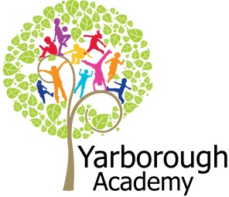


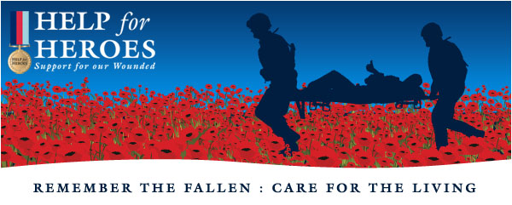
Project Based Learning
Year 6
Term 1
2017-2018
Do all heroes fly?

Project Overview
So what makes a hero anyhow? Do all superheroes fly? How can we fly in a metaphorical sense in our studies and lives? What does it mean to be successful?
In this project we will be investigating all about superheroes in comic books- including all the superhero powers that they possess. We will look at various gadgets that help them in their crime fighting exploits- POW! We will also investigate the science of flight and how it is all achieved. Can a human fly?
We will then look at historical heroes including myths and legends- creating our own legend about a chosen character-BOP!
But what about modern day heroes? We will look at heroes around us and include the helping themes that run through many religions, such as Sikhism.
Finally we will create our own hero character, which will be brought to life by designing a computer game about them. Also the pupils will be writing a book about their adventures which will be…published as a professional book! The authors (Y6 pupils) will then read their books to KS1 pupils, before selling them at a book launch at a Bookshop in Grimsby (to be announced later…). The money from the book sale will be given to the Help the Heroes charity to help them in their valuable cause.

Curriculum Opportunities
Writing
Write an adventure story as ‘Super Heroes’
Write a non-chronological report
Write a legend

Reading
Read a wide range of non-fiction texts related to super heroes
Listen to and discuss and wide range of texts
Read and listen to whole books
Take part in discussions related to the class book

Maths
Data analysis on costumer feed back
Grid references to explore flight patterns
Use scale to draw flight patterns

Science-
Identify the effect of drag forces, such as air resistance, water resistance and friction that act between moving surfaces
Plan enquiries, including recognising and controlling variables where necessary

Art and Design-
Use a variety of techniques to add interesting effects (e.g. reflections, shadows, direction of sunlight)
Use a choice of techniques to depict movement, perspective, shadows and reflection
Choose a style of drawing suitable for the work (e.g. realistic or impressionistic)

Communication –
Engage in meaningful discussions regarding the project in all areas of the curriculum
Listen to and learn a wide range of subject specific vocabulary
Practise and rehearse sentences and stories, gaining feedback on the overall effect
Debate issues and formulate well-constructed points

Geography-
Use maps, atlases and digital resources to locate countries and continents of the world
Find geographical features of the world

Computing-
Coding to create a Super Hero raider game

RE-
Explain how some teachings and beliefs are shared between religions
Explain how religious beliefs shape the lives of individuals and communities

PHSE-
Finding out what it takes to be a successful individual
To find out ways to push past doubts and fears, or a drop in motivation, even in challenging circumstances
Show effort and commitment in refining and adjusting work

Immersive Environment
Chestnut class will be transformed into the Leonardo da Vinci Room of flight design. We will also have caped crusaders and historical heroes that we will be studying.
Walnut class are flying high, with a classroom themed around the sky and flying, with a dusting of super hero magic too! They will have all things that can fly on display as well as inventions based on the class novel of ‘FArTHER’. There will also be an area for the pupils to work…which will be ‘On the cloud’ of course.
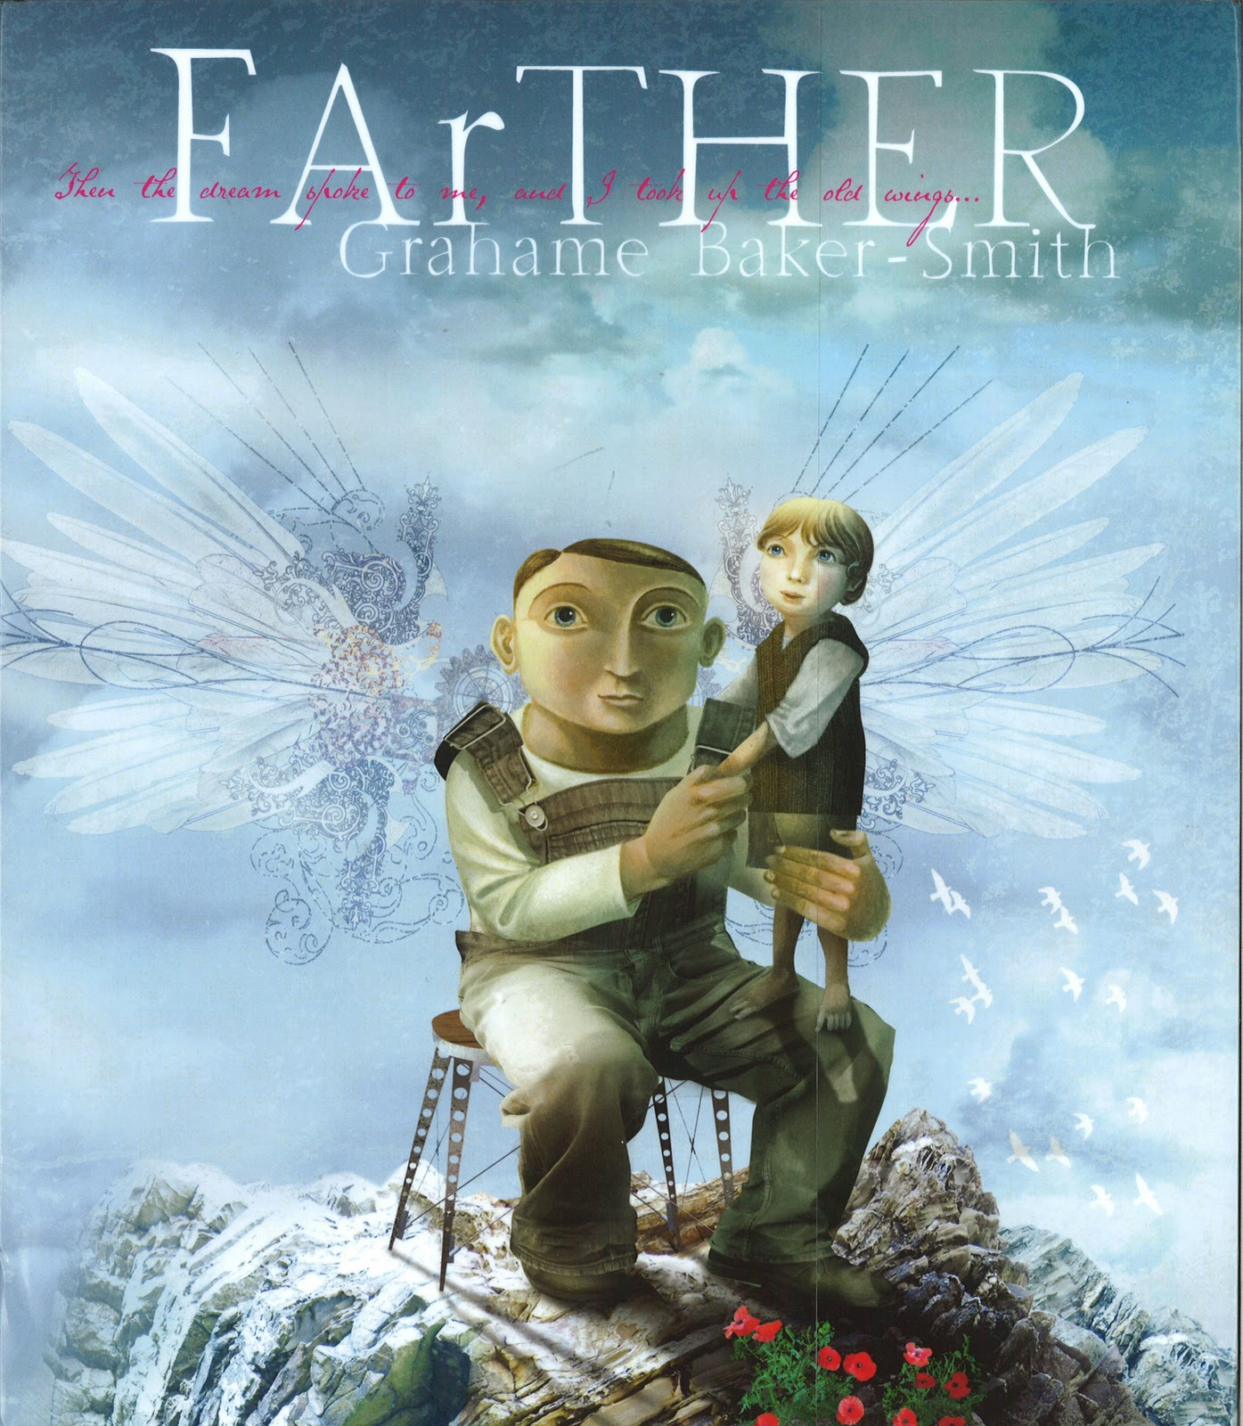
Project Timeline
Focus 1
Caped Crusaders
Focus 2
Historical Heroes
Focus 3
Modern Day Heroes
Focus 4
Our Hero

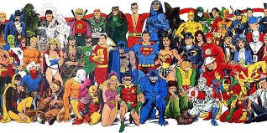
Project Outcomes
Our final aim is for each pupil to publish a book, which describes the adventures of a super hero designed by themselves. This will be based on research into what different audiences prefer to read about, for example, younger and older children.
This book will be then be launched at a bookshop in Grimsby (details to follow), with the money raised donated to the charity ‘Help the Heroes’.

Project Enhancements
Novel Study
FArTHER by Grahame Baker-Smith
This book was inspired by Grahames’ experience of being a son and then having a son of his own. ‘It is a mesmerising story of dreams and determination, relationships, aspiration and legacy’.
Visitors
We will be having a workshop on cartoonism and how to draw comic strip accurate super heroes characters.
Trip
We are intending to visit a Sikh Gurdwara to investigate the Sikh theme of service to the community.
Creative home learning
To create a 3D flying machine in the style of steam-punk. Let your imagination run wild.
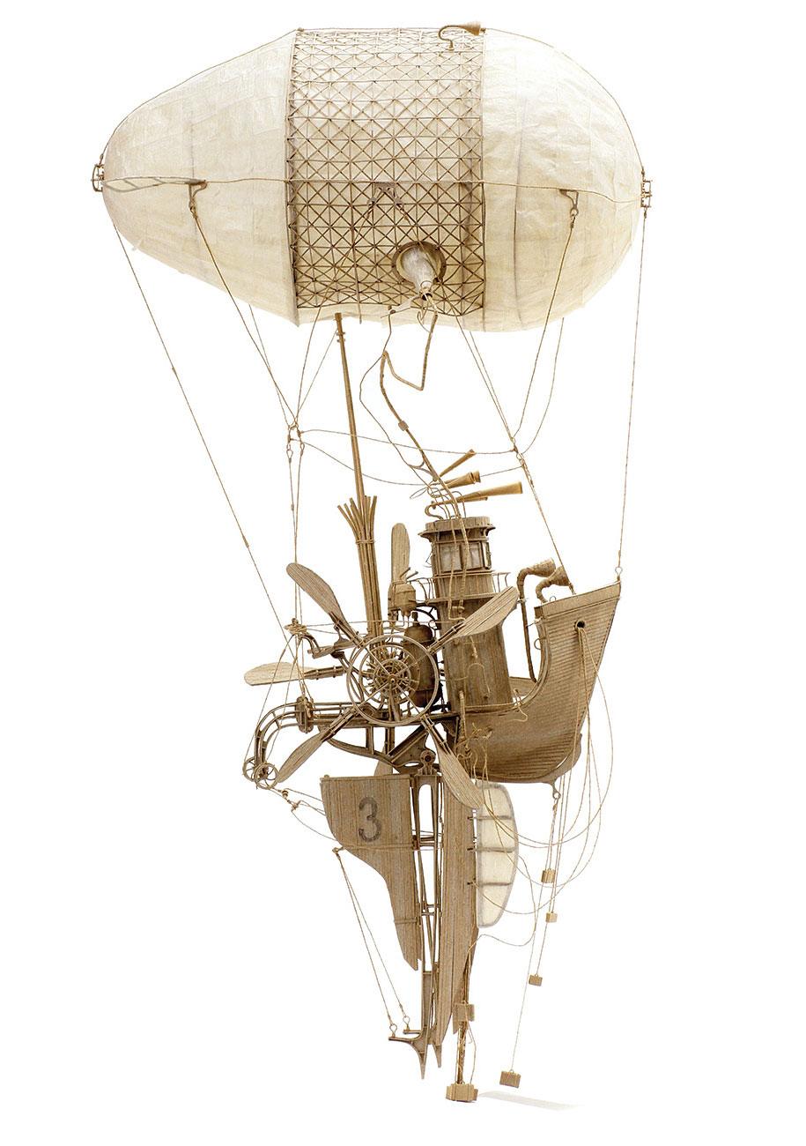

How can you help?
If you feel you can help us with our project this term we would love to hear from you! Are you a local hero or a volunteer and would be willing to give a talk to the pupils?
Please help your child with research into the creative home learning by investigating flying machines through history and creating designs, then constructing the finished model. Please note that homework runs over the course of a half term, so should be of a high standard to show the research, pleasure and enjoyment put into this task.
Also, why not look at all things flying- it’s a fascinating subject!

Synopsis: A son remembers his father-his dreams of being able to fly as well as spending time together until one day the war takes him away forever.
Novel Study
FArTHER
By Grahame Baker-Smith

