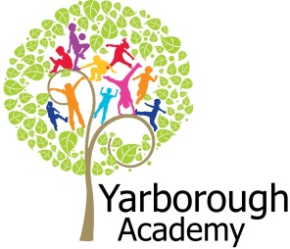

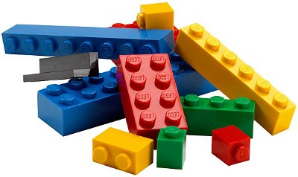

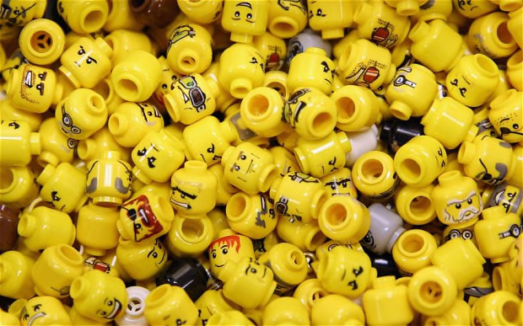
Project Based Learning
Year 3
Term 1
2017-2018
What is awesome about our town? (Everything is awesome!)
Project Overview
Our project this term is all about looking at what makes Grimsby an awesome place to live. It will have a Lego theme running through. The children will be hooked into their learning through watching the Lego movie. They will also be working on decorating the classrooms with colourful Lego models. As researchers, the children will discover more about the history of Grimsby including Grim the Viking in order to create a landmark out of Lego.They will also look at maps and globes to research famous landmarks around the world. As mathematicians, they will use data handling to support science when studying gravity. They will also be using our skills in computing to create a stop motion animation of a Viking invasion with their own composed music.

As readers and writers, they will be creating stories of adventure, using the novel ‘In the attic’ by Hiawyn Oram as our inspiration. Further along, the children will be writing a non-chronological report about landmarks in Grimsby and its surrounding villages. They will also be trying to convince Lego to produce their new design by writing persuasively to them.

All of the children’s work will come together when they submit their designs and writing to the official Lego website, where moderators will review their ideas. Our exhibition will be a grand unveiling of an art project, using all of the children’s input. There will also be workshops to work with your children to create their landmarks.

Curriculum Opportunities
Writing .
• Write persuasively.
•Write non chronological reports.
•Write stories of adventure.
Reading
•Listen to and discuss a wide range of texts.
• Read and listen to whole books.
Maths
• Add and subtract.
• Gather, organise and interrogate data.
• Describe position, direction and movement.
Science-
• Examine the properties of materials using various tests.
• Look at the effect of gravity and drag forces.
Geography -
• Locate the world’s countries, with a focus on Europe and countries of particular interest to pupils.
• Use maps, atlases, globes and digital/computer mapping to locate countries and describe features studied.
Art and Design –
•Use experiences, other subjects across the curriculum and ideas as inspiration for artwork.
• Improve mastery of techniques.
• Learn about the great artists, architects and designers in history.
D.T. –
• Generate design ideas.
• Make design product.
• Evaluate prototypes.
Communication –
• Speak to small and larger audiences at frequent intervals.
• Listen to and learn a wide range of subject specific vocabulary.
History –
• A local history study.
Computing-
• Design and write programs that accomplish specific goals, including controlling or simulating physical systems; solve problems by decomposing them into smaller parts.
Music -
• Improvise and compose music.
RE. –
• Study three of the major six religions not studied in depth in order to gain a
brief outline.
• Study other religions of interest to pupils.
P.E.-
• Take part in outdoor and adventurous activity challenges both individually and
within a team.
PHSE-
• Discuss and learn techniques to improve in the eight areas of ‘success’.

Immersive Environment
Our classroom will have a Lego theme, inspired by:

- Lego
- In the attic book

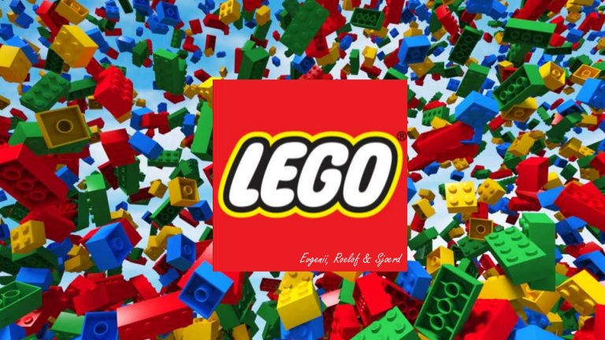
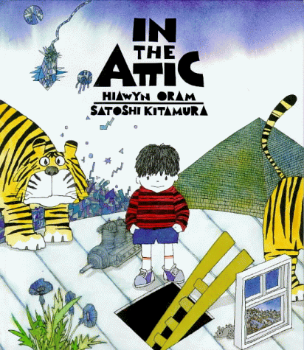
Project Timeline
Focus 1 – Imagination
In this focus, we will be looking at the novel ‘In the Attic’ by Hiawyn Oram. We will be looking at landmarks around the world paying particular interests to landmarks in Grimsby. We will be studying religious buildings too.
Focus 2 – Inspiration
In this focus, the children will learn about the Vikings and how this links to Grimsby. We will be composing our own music to create suspense during an invasion. We will use computing to create a stop motion animation using Lego.
Focus 3 – Innovation
In this focus, we will be building model landmarks. We will be writing persuasively to Lego to inspire them to create our designs.
Focus 4 – Creation
In this focus, we will investigate the materials suitable for a Lego brick. We will also be using our art skills when creating perfect drawings of the local landmarks ready to upload. We will be writing non-chronological reports to go along side this artwork.

Project Outcomes
This project will involve the children using cross-curricular skills to help them answer the essential question of ‘What is awesome about out town? (Everything is awesome!)’

Throughout the project, the children will be working towards designing their own landmark Lego set and uploading it to the Lego website.

The final exhibition will be a grand unveiling of an art project. Our exhibition will be on Thursday 30th November at 2:30pm in the hall.

Project Enhancements

How can you help?
If you feel you could help us with this project, we would love to hear from you.

Here are some really useful website that will help you get informed about Lego:

https://www.lego.com/en-gb

How about visiting different landmarks in the area over the holidays. You can also help us by collecting cardboard boxes of different sizes over the summer holidays and bringing them in at the start of term.

Thank you

Trip

We will be visiting Lego Land Discovery Centre Manchester on Tuesday 10th October 2017 from 8:30am – 5:30pm

Visitors

We are hoping to invite a local artist into school to help with our artwork. More details to follow.

Class book

In the Attic by Hiawyn Oram and
Illustrated by Satoshi Kitamura

Creative Home Learning

Creating a book about what is in your attic

