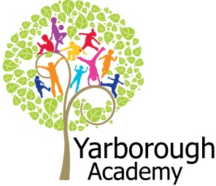
Project Based Learning
Year 1
Term 3
2016-2017
Where does our food come from?
Project Overview
Our project this term is all about looking at where our food comes from. The children will be hooked into their learning by being introduced to the fact that Mrs Rice in the kitchen has noticed that children at lunchtime do not know the ingredients that are in their foods or how they are grown. Year 1 will then complete a survey of children in the school to find out which ingredients the children do not know! They will also be completing a range of hook activities such as fruit tasting, creating a fruit and vegetable role-play, planting vegetable seeds and designing a milkshake! As researchers, the children will discover more about key historical events around such as rationing and the culture of foods from other religions such as Hinduism. As mathematicians, they will work out how to cut fruit into quarters to make a fruit salad, use measures to make a milkshake and use language around time to grow vegetables. As scientists, the children will be growing, observing and describing seeds as they germinate into plants.

As readers and writers, they will be listening to and creating stories based on ‘The Little Red Hen’. Further along, the children will be writing a non-chronological report about different fruits that they have explored. They will use computing to create a program for Little Red Hen to find the ingredients they need when making a chosen food.

All of the children’s work will come together in the dining room where the children will be using all of their knowledge about where food comes from to create tablecloths and bunting that can be used in the dining room to inform other pupils about the sources of food. Our exhibition will reveal our personalised tablecloths and the children will create the bunting to show you where food comes from!
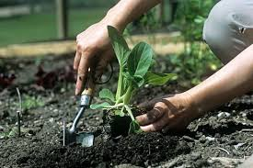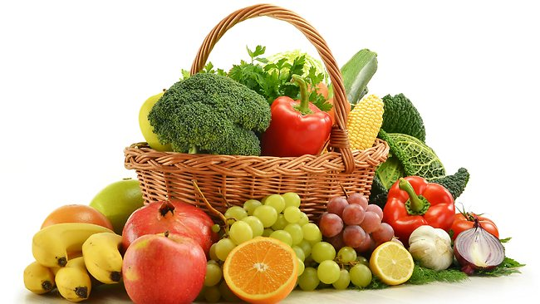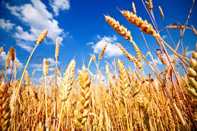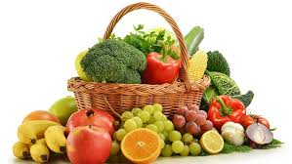

Curriculum Opportunities

Writing
• Write stories based on the traditional tale ‘Little Red Hen’.
• Write instructions.
• Write non-chronological reports.
• Write captions.
Reading
• Read and listen to a wide range of styles of text, including ‘Handa’s Surprise’, ‘Oliver’s Fruit Salad’, ‘Oliver’s Milkshake’ and ‘Oliver’s Vegetables’.
• Listen to and discuss a wide range of texts.
Maths
• Use fractions.
• Use and apply in practical contexts a range of measures such as capacity and time.
• Use greater than and less than in number.
•To use statistics.
Science
• Identify and name plants and animals.
• Understand plants and describe their basic structure.
• Identify and name a variety of common animals.
Geography
• Locate the world’s countries, with a focus of where different foods are grown.
D.T.
• Cut, peel and grate ingredients safely.
• Make a fruit basket using clay and refine the design.
Communication
• Speak to small and larger audiences at frequent intervals.
History
• Historical events relating to food such as rationing.
Computing
• Create a program that controls motion by specifying the number of steps to travel, direction and turn.
Music
• Choose sounds to create an effect.
R.E.
• Study at least two other religion such as Hinduism.
P.E.
• Play competitive games.
- Use dance to recreate the growing of a seed into a plant.
PHSE
• Discuss and learn techniques to improve in the eight areas of ‘success’.

Immersive Environment
Our classroom will have a beast the 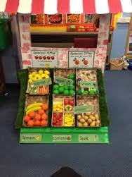

- Design of a barn
- Hay bales
- Various farm animals
- Fishing area
- Fruit and vegetable role play
- Vegetable patch in outdoor area.

Project Timeline
Focus 1 – Fruit
In this focus, we will be looking at the book ‘Oliver’s Fruit Salad’. The children will be making their own fruit salad! They will need to make it easy to eat by cutting the fruit into quarters, write a non-chronological report using their experience of fruit tasting and then use clay to create a class fruit basket.
Focus 2 – Dairy
In this focus, the children will be looking at the book ‘Oliver’s Milkshake’. The children will be building up to making their own healthy milkshake by measuring the ingredients. The children will be researching the different foods that milk can be made into and the processes used. They will also be researching historical events such as rationing.
Focus 3 – Meat and Fish
In this focus, we will be having a visit from a fisherman to share how fish is caught/farmed. We will also have a visit from the Hindu Cultural Society to talk about food in their culture. We will be researching which animals some of our meat based products come from.
Focus 4 – Vegetables
In this focus, we will be looking at the book ‘Oliver’s Vegetables’. We will be looking at how food, namely plants, are grown and harvested. We will see how these ingredients are used to make other foods. In our outdoor area we will be growing our own vegetables. We will be writing stories based on the traditional tale ‘Little Red Hen’. Finally, we will be writing a program that mirrors the story of ‘The Little Red Hen’ or their alternative version.

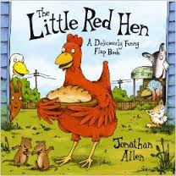

Project Outcomes
This project will involve the children using cross-curricular skills to help them answer the essential question of ‘Where does our food come from?’
Throughout the project, the children will be working towards making tablecloths that can be used in the dining room every lunchtime. They will be printed with all of the information the children have learnt about sources of food.
The final exhibition will be a reveal of the tablecloths and the creation of bunting showing sources of food on Friday 14th July 2017 at 2pm.

Project Enhancements

How can you help?
If you feel you could help us with this project, we would love to hear from you.

Here is a really useful website that will help you get informed about sources of food and healthy eating:

- http://www.foodafactoflife.org.uk (‘Healthy eating and food plates’ and ‘Where do my meals come from?’)

Trips
Wednesday 3rd May – Pink Pig Farm, Scunthorpe
We will be visiting a working farm to see how food is grown and how it is used to make foods.
Tuesday 20th June (Hazel) and Tuesday 27th June (Elm) – Tesco, Cleethorpes
We will visit a local Tesco store to see all of the different foods available and find out about various produce.
Visitors
We will be having a visit from a fisherman and from a member of the local Hindu Cultural Society. Both will visit the school in June.
Class books
‘Oliver’s Fruit Salad’, ‘Oliver’s Milkshake’ and ‘Oliver’s Vegetables’ by Vivian French.
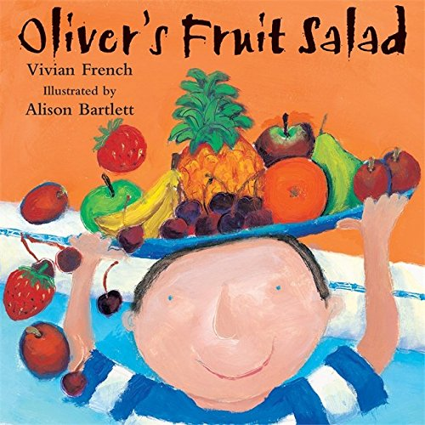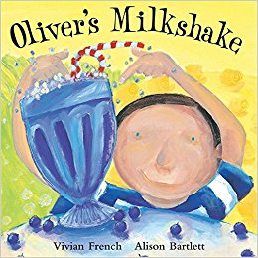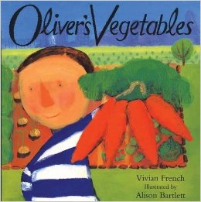

Creative Home Learning
Children are to design their own plate of favourite food and highlight where the ingredients/foods come from.

