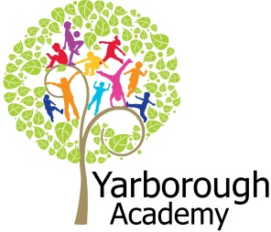
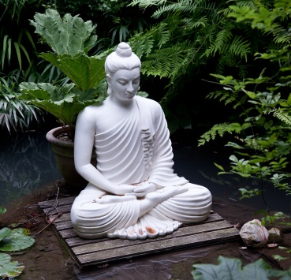
Project Based Learning

Year 6
Term 3
2016-2017
What will be our legacy?

Project Overview
Wow, the final half term of a very busy year is upon us. This will be just as busy as usual but we will pack in as much fun as you can ‘shake a stick at’. We are focusing on the leaving a legacy in the form of a Wildlife Haven. We want to encourage bees, insects and bats to inhabit the area to build up an eco-system that helps the environment.
The pupils will be responsible for fund raising to pay for this legacy- there will be a series of events for this including the pupils painting art works to sell.
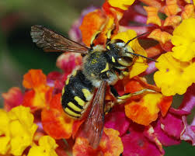
As part of Year 6’s grand finale we will be also preforming Wind in the Willows. Pupils will be making props and creating scenery towards this musical. The performance is on Monday 24th July in the afternoon.

Curriculum Opportunities

Writing
Design an advert to sell our works of art
Write a persuasive letter to local businesses to ask for donations to fund the wildlife area

Reading
Listen to and discuss and wide range of texts
Read and listen to whole books
Take part in discussions related to the class book
Read and follow scripts

Maths
Handle the wildlife haven budget including money

Science
Study the process of food chains
Investigate eco-systems
.
Art and Design
Design and create a wildlife haven.
Create a piece of art to sell to raise funds for the wildlife haven

Communication
Engage in meaningful telephone conversations with unfamiliar people (local businesses)

Computing-
Create an interactive wildlife haven linked to our designs

RE.
Discuss Buddha and the connection with water

PHSE
Examine many issues related to the book Wind in the Willows

Immersive Environment
We will be creating an immersive Wild Wood, as well as Toad Hall and inside Mole’s home.

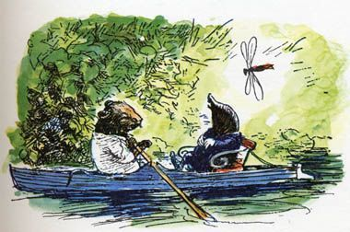
Project Timeline

Focus 1
Plan and design
Plan the wildlife haven.

Focus 2
Persuade
Contact local businesses to raise funds

Focus 3
Produce
Create the wildlife haven

Focus 4
Production
Perform the play
‘Wind in the Willows’

Project Outcomes
This project will involve the children using cross-curricular skills to help them answer the essential question of
“What will be our legacy?”
Throughout the project, the children will be exploring ways to raise funds for the wildlife haven.

During the project, pupils will take into consideration the needs and requirements of wildlife that we want to encourage into our wildlife haven. At the end of the project the pupils will then create a haven as a lasting legacy.

Project Enhancements

Trip
Possible pond dipping trip to investigate aquatic ecosystems.

Class Book
Wind in the Willows by Kenneth Grahame

Creative home learning
Your home learning task is to create a costume for the part you are given (after the auditions). You will be performing in this costume -details to follow after the half term.

How can you help?
If you are a keen gardener or a not such a keen gardener we would appreciate any help you are willing to give to create the wildlife haven. Dates of digging events to follow…

If you have any insect friendly plants that you are willing to donate to add to the area it would be greatly appreciated.

Are you connected to any companies that could donate materials towards the building of a pond and raised beds?

Please contact the school if you can help in any way.

