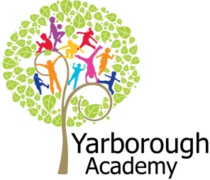
Project Based Learning
Year 2
Term 3
2016-2017
Birds are in trouble: how can we help?
Project Overview
Our project this term is all about looking at the decline in bird numbers and why certain species, especially, are struggling. The children will be launched into their learning through an immersive experience in their class. The classroom will be transformed by backdrops showing both coastal and woodland environments, with flying birds, skyline, cliffs, world map, bird watching area and a central nest site. A colourful bird character will address the children informing them of its plight and this gives them the opportunity to form and ask their own questions. The children will then be given a variety of materials such as: paint, pastels and collage material in order to create their own amazing bird art. This artwork will further decorate and enhance the learning environment.

As researchers, the children will discover all about the different types of birds from those found in our U.K. gardens to exotic and migratory species from afar. They will explore what conditions birds need to be successful and how we can help them by providing additional food, water, shelter and habitat.

As scientists, the children will investigate information from a variety of sources on aspects such as bird adaptation and evolution. These areas of study will give the children opportunities to make predictions and form questions such as ‘which beak shape works best for picking-up seeds?’ etc.

As geographers, the children will study world maps, migratory routes, distant shores and far-off nations in order to consider the distances involved in flying from countries in one continent to another. R.S.P.B. and Y.W.T. visitors are due to come in and give talks to inform us more fully about other locations in the U.K. which are important to bird-feeding, breeding and nesting.

As readers and writers the children will then be immersed in our novel study: Shh! We have a plan. This text emphasises the need for a caring approach to conservation. They will then use this stimulus to write their own story in a similar style.

Finally, the children will create instructions and leaflets which will appear alongside practical products they have made such as: feeders and bird boxes, together with explanations about why certain birds are in danger to showcase at their Summer Fayre.

Curriculum Opportunities
Writing
Write stories that mimic significant authors
Write narrative diaries
Write glossaries
Write non-chronological reports
Write instructions

Reading
Discuss books
Listen to short novels
Use the class and school libraries
Listen to a range of texts

Maths
Use and apply in practical contexts a range of measures
Handle data in practical contexts

Science
Investigate differences
Look at growth, basic needs, exercise, food and hygiene
Observe seasonal changes
Look at the suitability of environments and at food chains

Communication
Engage in meaningful discussions in all areas of the curriculum
Listen to and tell stories often so as to internalise the structure
Debate issues and formulate well-constructed points
Listen to and learn a wide range of subject specific vocabulary
DT
Select from and use a range of tools and equipment to perform practical tasks
Select from and use a wide range of materials and components, including construction materials and textiles.
Geography
Explore weather and climate in the United Kingdom and around the world
Use world maps, atlases and globes
Investigate countries of the United Kingdom
Investigate the world’s continents

Computing
Understand what algorithms are, how they are implemented as programs on digital devices, and that programs execute by following a simple sequence of instructions

P.H.S.E / R.E.
Discuss and learn techniques to improve in the eight areas of ‘success’.
Explore symbolism in different religions

Immersive Environment
Our classrooms will have a bird environment theme, inspired by:
trees, coastal cliffs, skyline, bird-watching area and a nest.

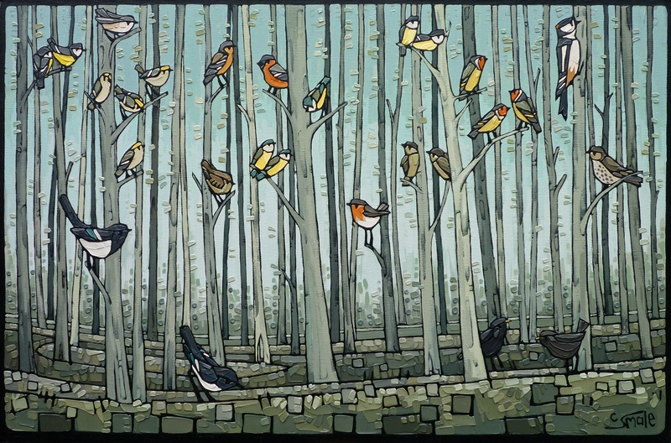
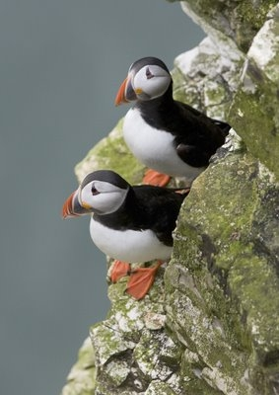
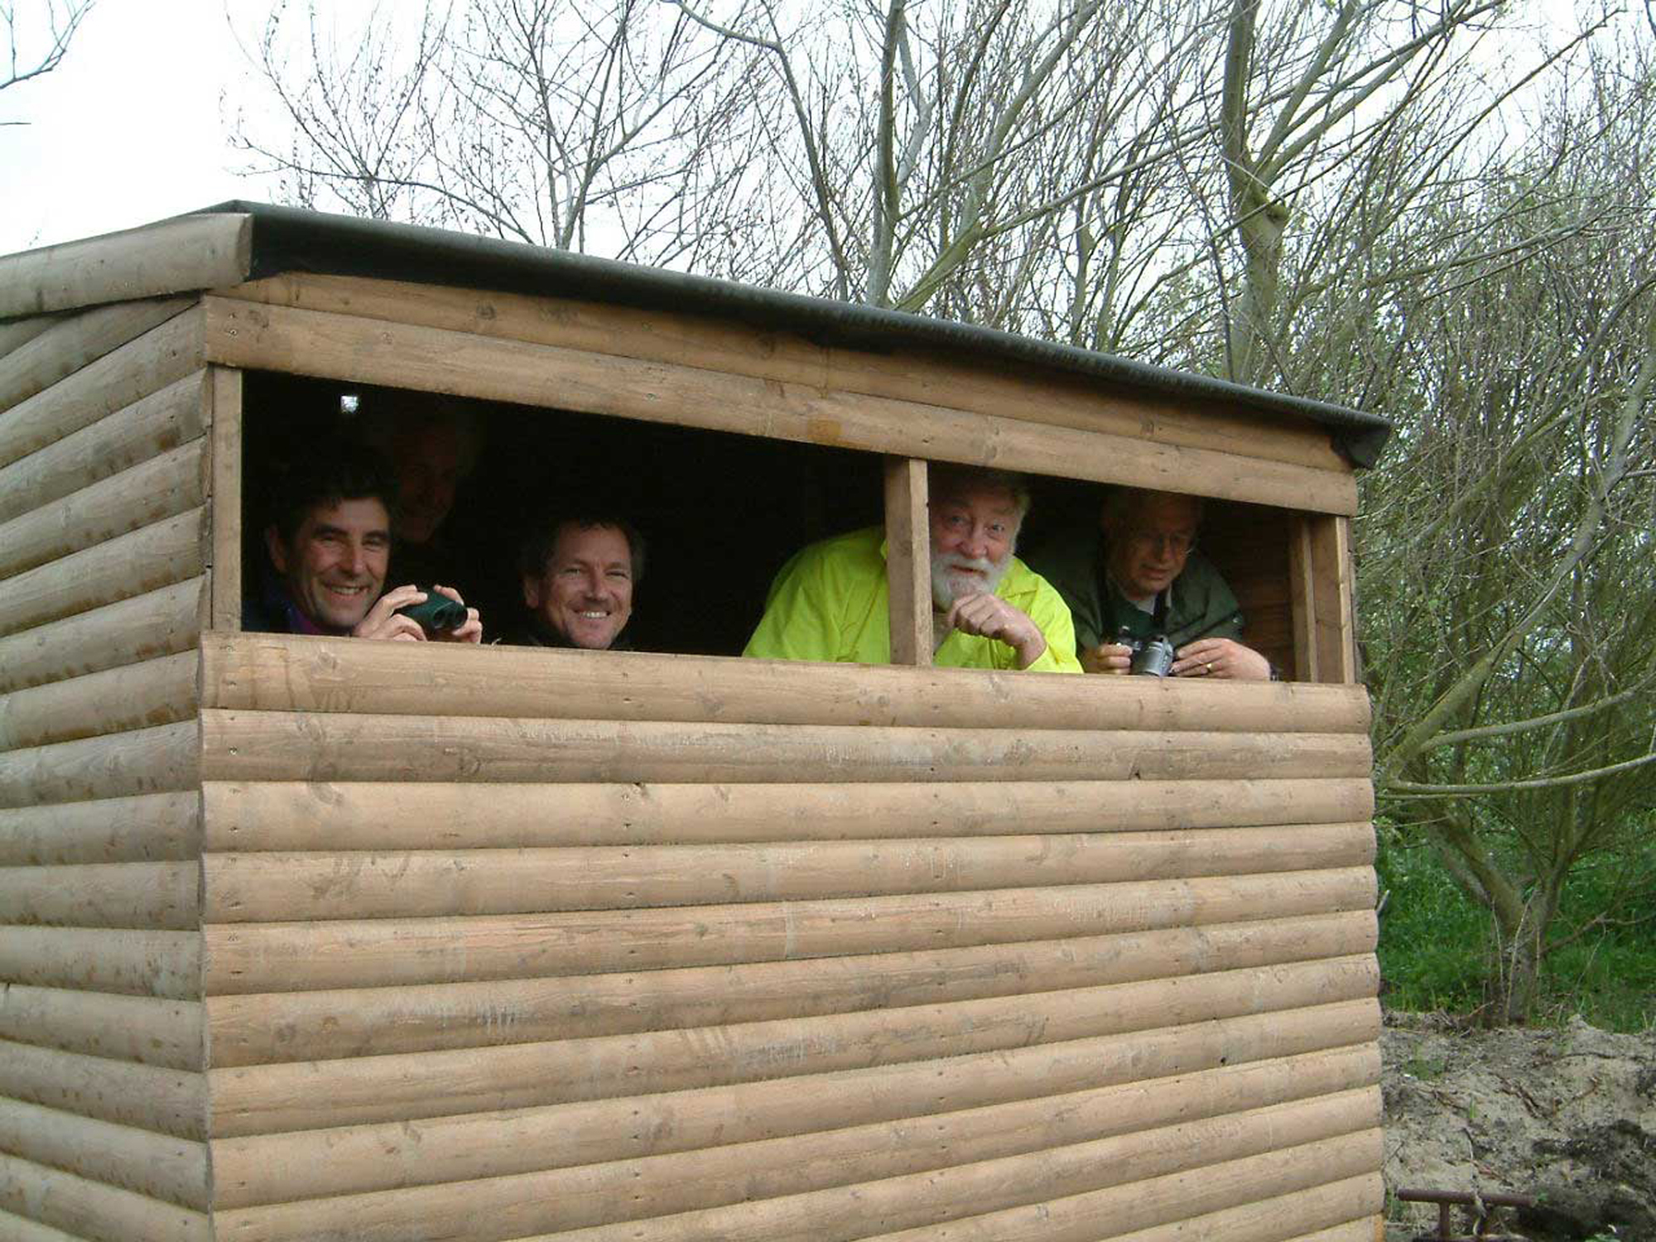
Project Timeline
Focus 1 – The Beauty of birds
In this focus, we will be aiming to create a fabric bird, from textiles, to sell at our exhibition. We will study Shh! We have a plan and explore ideas and feelings within the text. We will also write our own story which will mimic the author’s style as we come up with a plan to help the bird stay alive.
Focus 2a – Birds from distant shores
In this focus, we will be investigating why species such as: the puffin and turtle dove have become endangered. Where do these birds live? How far do they travel? What puts them at risk? Children will create part of a leaflet to hand out at our exhibition informing us by answering these and more questions.
Focus 2b – Home birds
In this focus, we will be researching the importance of locations such as Bempton Cliffs and Spurn Point, here in the U.K., so that we get a fuller picture of the problems bird face: children will complete their awareness leaflet.
Focus 3 – Bring birds back
In this focus, we will be exploring data concerning bird numbers declining and writing instructions on how to make a bird feeder/box. This will result in the children creating bird care products to sell at the exhibition.

Project Outcomes
This project will involve the children using cross-curricular skills to help them answer the essential question of ‘Birds are in trouble: how can we help?’

Throughout the project, the children will be working towards raising awareness by creating information leaflets and bird care products in order to raise much-needed funds for an R.S.P.B. campaign to help save birds such as puffins and turtle doves (see website list below).

The final exhibition will be an immersive experience in which the children share their enhanced environmental knowledge and raise funds with parents. This will take place on Monday 17th July.

Project Enhancements

How can you help?
If you feel you could help us with this project, we would love to hear from you.

Here are some really useful websites that will help you become more informed about birds:
https://www.rspb.org.uk/
https://www.rspb.org.uk/join-and-donate/donate/appeals/globalextinction-appeal/index.aspx
http://www.lincstrust.org.uk/far-ings
http://www.ywt.org.uk/
http://www.yorkshirecoastnature.co.uk/blog/227/bempton-cliffs-seabird-city

Trip

We will be visiting the R.S.P.B. nature reserve at Bempton Cliffs – home to approximately 250,000 seabirds - on Wednesday 7th June.

Visitors

We will be having a visit from both representatives of the Royal Society for the Protection of Birds (R.S.P.B.) and Spurn Point nature reserve through the Yorkshire Wildlife Trust (Y.W.T.).

Class book

Shh! We have a plan by Chris Haughton

Creative Home Learning

Design or make a bird for a specific habitat; fact-finding opportunities for children to extend their learning by creating bird fact cards and files.


