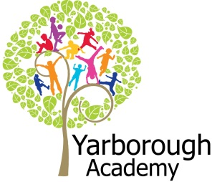

**Curriculum Opportunities**

Personal, Social and Emotional Development

Being more outgoing towards unfamiliar people and more confident in new social situations.

Showing an understanding of boundaries and routines

Communication and Language

Listening to stories with increasing attention and recall

Beginning to understand ‘why’ and ‘how’ questions.

Understanding more complex sentences

Using simple sentences when speaking

Physical Development

Shows increasing control over an object in pushing, patting, throwing, catching or kicking it.

Moves freely and with pleasure and con dence in a range of ways, such as slithering, shuf ing, rolling, crawling, walking, running, jumping, skipping, sliding and hopping.

Literacy

Repeating words or phrases from familiar stories.

Listening and joining in with stories and poems, one-to-one and also in small groups

Distinguishing between the different marks they make.

Hears and says the initial sound in words.

Mathematics

Sometimes matches numeral and quantity correctly.

Beginning to use mathematical names for ‘solid’ 2D shapes, and mathematical terms to describe them.

Understanding the World

Shows interest in different occupations and ways of life.

Shows care and concern for living things and the environment.

Can talk about some of the things they have observed such as plants, animals, natural and found objects.

Expressive Arts and Design

Constructs with a purpose in mind, using a variety of resources. Uses simple tools and techniques competently and appropriately.

introduces a storyline or narrative into their play.

**Project Based Learning**

Nursery

Half Term 1

2017

**Project Overview**

Our project until half term is “What is a farm?” We will be making a piece of art work that will show what we think a farm is.

The children will be immersed into their learning every week with a ‘wow’ activity relating to the focus. Each week we will be adding pictures/ objects onto a canvas to build up to show what a farm is. For our first focus we will have a message from Mrs Wishy Washy telling us that she’s mixed up the farm animals and their babies! We will help her match the animals to their young. For our second focus we will be looking at the role of a farmer. We will be creating pictures using the different crops the farmers have in their fields. We will also help Farmer Duck count his hay bails! After that we will look at farm transport for Spot the dog. We will help him create a 2D tractor picture to add onto our canvas. We will practise writing numerals with our toy tractors and paint! We will then investigate Chinese New Year. We will help the little red hen make some chinese food! We will also help her create a dragon dance to perform to all of her friends on the farm. This will celebrate the year of the rooster! Next we will concentrate on growing food. We will grow our own beanstalk and then help Jasper create a bean diary! For the last part of our project we will look at baking and how produce from a farm can help us with this. We will read the story of ‘Sun bread’ and create movement and marks to go with the story. We will also be talking about the weather and what the crops on the farm needs. Our exhibition will be held at Hall Farm in South Kelsey. We will hand over our canvas to the owners of Hall Farm and then we will be free to walk round the farm and talk to you about all of our learning!

**Immersive Environment**

The classroom will be divided into the following areas: creative, artistic, construction, investigation, small world, home, listening, reading, fine motor, computing and games.

These areas will be changed regularly to immerse children into the focus of that week.

**What is a farm?**

**Project Timeline**

Focus 1

Farm animals

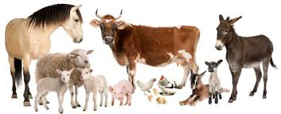

Focus 2

Farmers

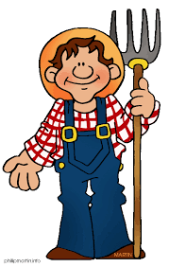

Focus 3

Farm Transport

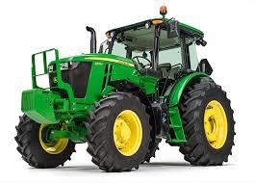

Focus 4

Chinese New Year (the year of the rooster)

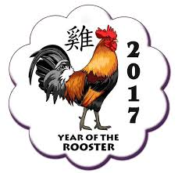

Focus 5

Farm Food

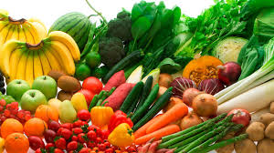

Focus 6

Growing Crops

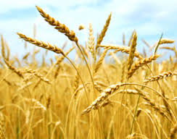

Focus 7

Baking

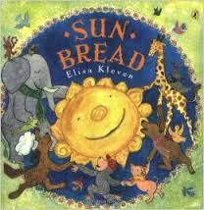

**How can you help?**

If you feel you can help us with our project this term we would love to hear from you. We would love it if you had any connections with a farm to help with any animals or farm vehicle visits.

You can also help with the project by doing the following at home:

* Talking about crops and how they grow
* Talking about different occupations and the role of a farmer
* Talking about where the food that you eat comes from
* Baking using a variety of ingredients

Useful website for parents:

[www.cbeebies.co.uk](http://www.cbeebies.co.uk), <https://www.activityvillage.co.uk/farm-animals>

<http://www.kiddyhouse.com/Farm/>

**Project Outcomes**

This project will involve the children using cross-curricular skills to help them answer the essential question of “What is a farm?’’

The final exhibition will be on the 15th December (morning children) and 16th December (afternoon children) at Hall farm in South Kelsey. This will be an opportunity for you to see the canvas we will be giving to the farm whilst also enjoying the delights the farm has to offer! (if you can’t make it to the farm we will be having a variety of stay and play sessions for you to attend)

**Project Enhancements**

Trips and Visitors

We will be having visits from different farm animals and a tractor. We will also be going on a trip to Hall Farm as part of our exhibition. The trip to Hall Farm will be on the 15th February and parents are invited (morning children) and the 16th February (afternoon children). Transport information will be given in the new year.

Class books – 3 Billy Goats Gruff, 3 Little Pigs, Animal Bop, Farmer Duck, Mrs Wishy Washys Farm, Rosies Walk, Old Mcdonald, The ugly Duckling, The Little Red Hen, Chicken Licken, Chicken Little, Jaspers Beanstalk, The Enormous Turnip, Sun Bread, Little Red Hen

Clips/ Vidoes online – Topsy and Tim at the farm - cbeebies, My First Farm, Poppys Play Dates, School Farm, Come Outside, When I grow up (farmer) - cbeebies, Chicken Run, Justins house – chickens, The Fox and the Chicken, Cake Bake – Cbeebies

Creatve Home Learning – Can you make a farm animal at home for our classroom?