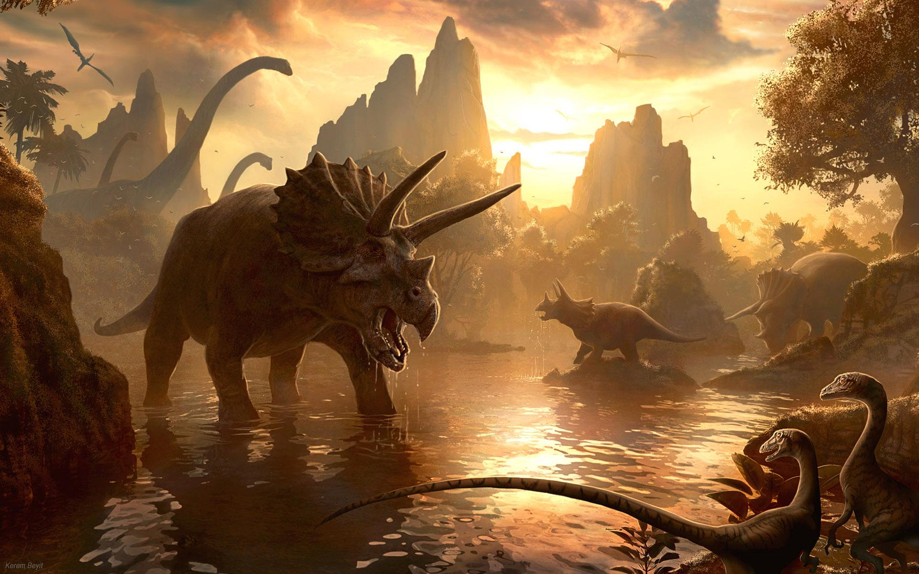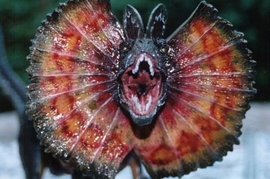 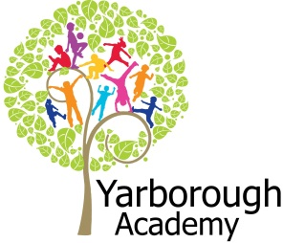

**Curriculum Opportunities**

English

- Write adventure stories

- Learn by heart and perform a significant poem

–Write explanations

– Write persuasively

Maths

– Measuring ratio and proportion – Use and apply measures to increasingly complex contexts,

- Describe position, direction and movement in increasingly precise ways

-Gather, organise and interrogate data

-To use and apply measures to increasingly complex contexts

Science

– Look at teeth, and classification keys

-Look at adaptation to environments

- look at adaptation and evolution

-look at the functions of parts of flowering plants, requirements for growth, water transportation in plants, life cycles and seed dispersal

- Compare and group rocks, describe the formation of fossils

Art and Design

- Use experiences, other subjects across the curriculum and ideas as inspiration for artwork;

-develop and share ideas in a sketchbook and finished products

- Improve mastery of techniques

Computing

- Use computer programs to create games

D.T

- Use clay to create

P.E

- Play and modify competitive games

Geography

- Use maps to describe features studied

- Use eight points of a compass,

**Immersive Environment**

Our classrooms will have a Jurassic theme, with ancient plants, trees, ferns and rocks. The environment will be filled with dinosaurs.

**How can we help Steven Spielberg create the new Jurassic Park?**

**Project Overview**

Our project this term is all about how we can create an amazing trailer for a new Jurassic Park film, which will involve researching dinosaurs and their environment! We will begin by finding out about dinosaurs, what they ate and learning about their teeth.

The children will be hooked into the learning through watching Jurassic Park, finding a dinosaur nest in the school and hatching a dinosaur egg!

We will investigate more about dinosaurs and where they lived and use this information to make an accurate model of a Jurassic world to use in our trailers.

As part of their project, the children will be creating a film trailer to amaze Steven Spielberg and convince him that their ideas should be used for the next Jurassic Park film.

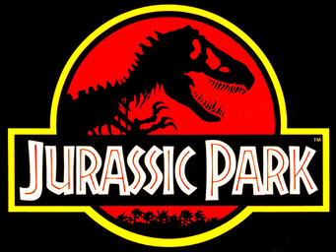 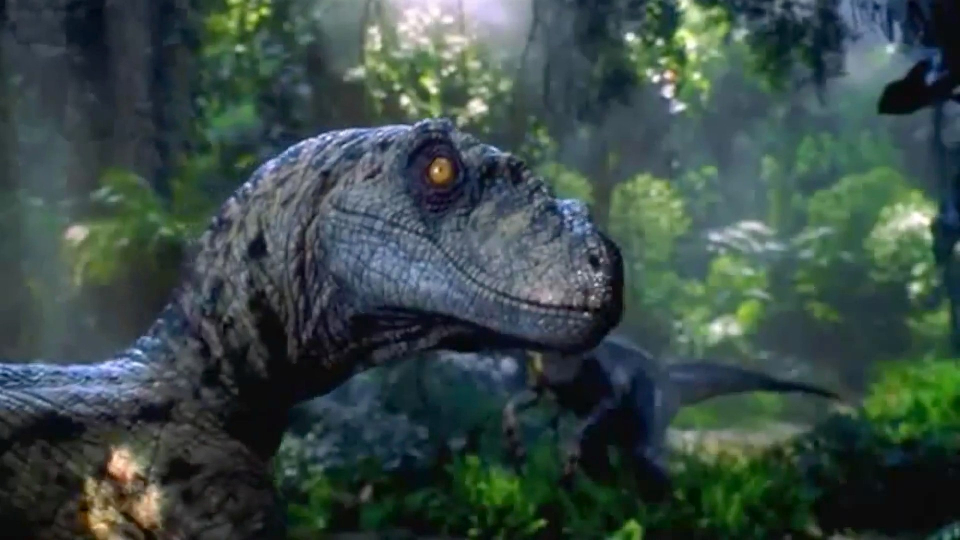

**Project Based Learning**

Year 3

Term 2

2015-2016

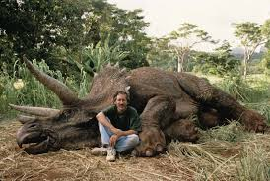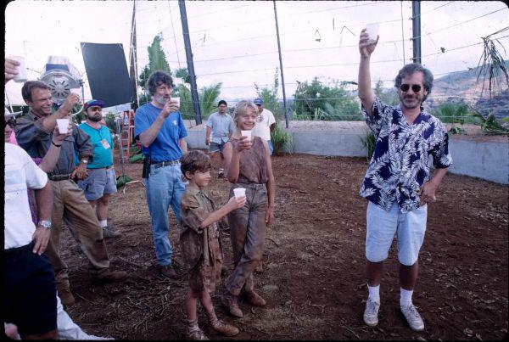

**How can you help?**

If you feel you can help us with our project this term we would love to hear from you.

**Books to read:**

Dinosaur diary by Julia Donaldson

Dinosaur detectives by Judith Bauer Stamper

**Useful websites:**

[www.kidsdinos.com](http://www.kidsdinos.com)

[www.discoverykids.com/category/dinosaurs/](http://www.discoverykids.com/category/dinosaurs/)

**Project Enhancements**

Trip

A trip to the Classroom in the Woods for a dinosaur hunt!

Visitors

A visit from the Dinostar Experience – 6th January

Class book

‘Dinosaur Trouble’ by Dick King-Smith

Creative Home Learning

You can create a dinosaur footprint, dinosaur nest with eggs or a fossil of a dinosaur bone.

**Project Outcomes**

This project will involve the children using cross curricular skills to help them answer the essential question of ‘**How can we help Steven Spielberg create the new Jurassic Park?**’

Their final project will be to create a trailer for their new Jurassic Park film.

The final exhibition, at 9:30am on Tuesday 22nd March 2016, will be a screening of their Jurassic Park film trailers at John Whitgift Academy, with an exclusive behind-the-scenes look at the making of the films!

**Project Timeline**

Focus 1

**Dinosaurs**

We will be looking at the names of the dinosaurs. We will look at the food they ate, and their teeth and bones.

We will be designing and making our own dinosaur.

Focus 2

**Environment**

We will be looking at how animals adapt to their environment. We will concentrate on what plants will be best for the dinosaurs to eat, looking carefully at life cycles and food chains.

We will focus on rocks and soils, as well as rivers and mountains for our landscapes.

We will be designing and creating our own environment for our dinosaurs.

Focus 3

**Production**

We will be focusing on the production of our movie trailer for Jurassic Park. We will be performing our own music to accompany the trailer. We will also make a game that coincides with the movie trailer.