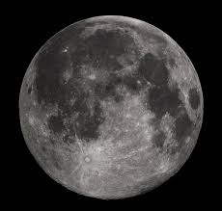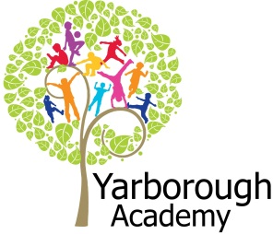

**Project Overview**

Our project this term is all about the moon and space and if it is possible to survive on the satellite. In our hook sessions the pupils will have the opportunity to take part in a Google Hangout with Virgin Galactic. Using the John Lewis advert, man on the moon, we will be working with the local charity, ‘Not alone for Christmas’ and make cards and shoeboxes for the charity. As mathematicians, we will create a fact file about the moon and missions to it. As scientists, we will be investigating the conditions for living; what is essential and luxury as part of the preparations for heading into space. We will also investigate the difference in forces that affect the way we live on earth, compared to in space. As computer scientists, we will be investigating networks and communicating with earth. As geographers, we will investigate the different elements that make a community and what buildings we require on the moon. As writers, we will be creating poetry, set to images and music using iMovie; we will create a travel guide for the moon and create explanation texts on how we would survive on the moon.

**Project Based Learning**

Year 5

Term 2

2015-2016

**How can we convince people to relocate to the moon?**

**Immersive Environment**

Our classrooms will have a moon theme.

* A moon landscape will be in the classroom
* The planets of the solar system
* LED lights will drop from the ceiling
* Black fabric will hang from the ceiling for the effect of space

**Curriculum Opportunities**

**English**

-Children will write Haikus  
- Write explanation texts

-Write non-chronological reports

-Write persuasively

**Maths**

- Rigorously apply mathematical knowledge across the curriculum

- Use the properties of shapes and angles in increasingly complex and practical contexts including constructional and engineering contexts

**Science**

- Look at the movement of the sun and the moon

- Study the life cycle of animals and plants

- Look at the functioning parts of flowering plants, requirements of growth, water and transportation

**Geography**

- Describe and understand key aspects of physical geography including biomes and vegetation belts

- Describe and understand human geography including settlements and the distribution of natural resources including energy, food, minerals and water supply

**R.E**

- Study at least 2 other world religions in depth.

**Communication**

Debate issues and formulate well-constructed points.

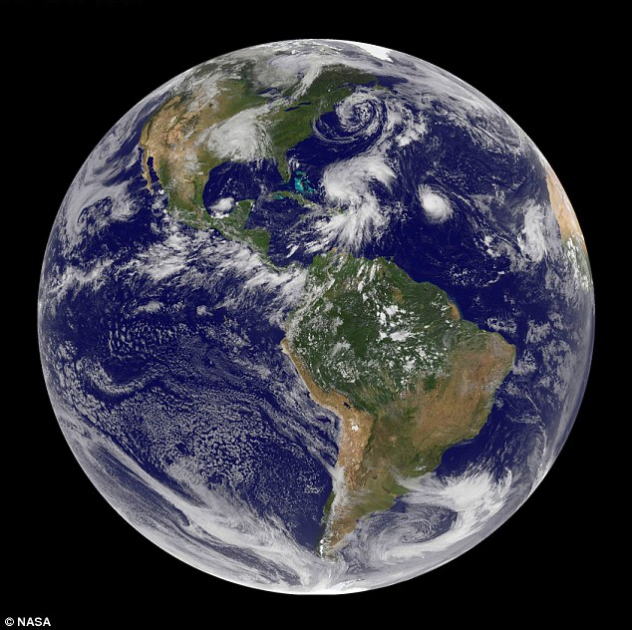

**Project Timeline**

Focus 1

Location, location, location

Focus 2

What is essential to survive?

Focus 3

How can we create a community?

Focus 4

How can we convince people to relocate to the moon?

**Project Outcomes**

This project will involve the children using cross curricular skills to help them answer the essential question of:

‘***How can we convince people to relocate to the moon?***’

Their final project will be creating a sales pitch to convince people to buy our property.

The final exhibition will be the sales pitch, convincing people to buy a piece of property on the moon on Tuesday 22nd March 1.30pm in the hall.

**Project Enhancements**

Trip

A visit to the Space Centre museum- Friday 8th January

Visitors

Estate Agents to talk about sales pitches.

Lego townplanners workshop- Monday 22nd February

Google Hangout with Virgin Galactic

Class book

‘The man on the moon’ by William Joyce

Creative Home Learning

Create and build a lunar moon buggy. This is an extended creative task. Children could explore electrical systems or simply build a model.

**How can you help?**

If you feel you can help us with our project this term we would love to hear from you!

Reading-

It would benefit the children if they could spend moments reading any non-fiction book about the moon or space environments.  
Useful websites:

[www.nasa.gov/audience/forkids/kidsclub/flash/](http://www.nasa.gov/audience/forkids/kidsclub/flash/)

[www.virgingalactic.com](http://www.virgingalactic.com)