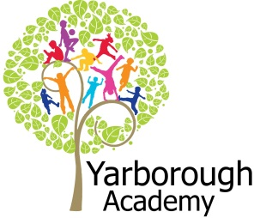

**Project Overview**

Our project this term is all about celebrations and how people celebrate around the world. We will look closely at the rituals of various festivals and learn about different religions.

We will investigate the world and where these celebrations take place.

The importance of food in festivals will be explored through designing, making and tasting.

We will ‘hook’ the children into this project with an invitation to a special party.

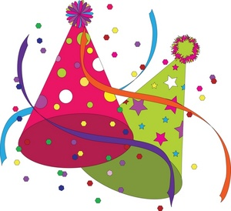

**Project Based Learning**

Year 2

Term 1

2015-2016

**How can we celebrate?**

**Immersive Environment**

Our classrooms will have a party theme and include:

* Balloons, streamers and bunting
* Mexican flowers
* Rangoli patterns
* masks

**Curriculum Opportunities**

**Reading and Writing**

- a recount of our wedding celebration

- traditional tales

- characters descriptions

- poetry

- invitations

**Maths**

- addition and subtraction

- multiplication and division

- position, directions and movement

- measures including money and weighing

**Science**

- sources of light and reflections

**Geography**

- Locating the countries that different festivals take place in

- comparing and contrasting locations

**History**

- the lives of significant individuals

- the story of Guy Fawkes

**Computing**

- Code a festival of light

- research and investigate with ipads

- presenting information

**RE**

- study the beliefs, festivals and celebrations of Christianity and Hinduism

**DT**

– making harvest soup and ice pops

**Art**

– painting a mask

**Project Outcomes**

This project will involve the children using cross curricular skills to help them answer the essential question of

‘***How can we celebrate?’***

The final project will enable the children to plan their own celebration. They will be able to invite their parents, governors and members of the community which have helped us during the project.

The final exhibition will be to hold the celebration in the school hall

**Project Timeline**

Focus 1

How do we celebrate?

Focus 2

The world

Focus 3

Harvest and Thanksgiving

Focus 4

Dia De Los Meurtos and Halloween

Focus 5

Light Celebrations

Focus 6

How can we celebrate?

Focus 7

Christmas

**Project Enhancements**

**Trip**

A visit to the Chocolate Drop in Market Rasen

A visit to St Michaels Church

**Visitors**

A visitor from the Grimsby Hindu Centre

**Class books**

Fantastic Mr Fox by Roald Dahl

The Surprise Party by Tony Bradman

Horrid Henry’s Wedding by Francesca Simon

**Creative Home Learning**

A celebration scrapbook

**How can you help?**

If you feel you can help us with our project this term we would love to hear from you.

Useful websites:

<http://www.kidsgen.com/events/> to find out about different festivals and celebrations

<http://resources.woodlands-junior.kent.sch.uk/homework/religion/> to learn about different religions and how they celebrate