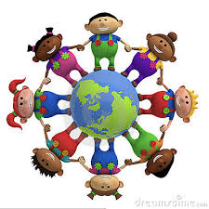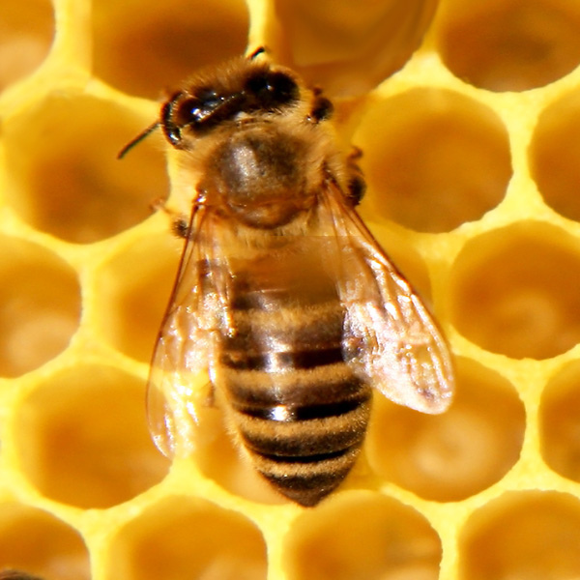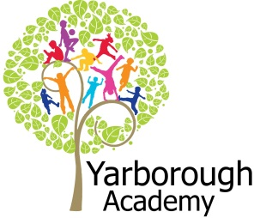

**Project Overview**

This term our project will be exploring how we can change perceptions and become more aware of other cultures and faiths, with an exhibition at Lincoln Christmas market selling products to celebrate our diverse culture.

We will begin our journey by focusing on beliefs. We will investigate the Muslim faith and compare and contrast the similarities between Islam and Christianity. As scientists, we will investigate magnets and forces before attempting to create our own compass and look at the importance of using a compass within the Muslim faith. We will also be investigating sound and how sound travels and the need for loud ‘Call to Prayer’ calls. Finally, as scientists, we will be investigating the phases of the moon in order to understand how predictions are made for when Easter and Ramadan will fall.

As writers, we will be writing from the perspective of God/Allah by writing the creation story, which we will then look at similarities in trends and beliefs, which will help us with our final outcome. As biographers, we will detail the lives of some of the most well known Muslim individuals in sports and entertainment. We will also be writing recipes, inspired from Muslim and Christian delicacies. Finally, we will be poets and create vivid imagery.

As mathematicians, we will use our skills in ratio and proportion, to scale recipes that we are going to make. We will also investigate tessellations when we become artists within the project too.

As designers, we will be studying the artists David Hockney and Jeannie Baker, taking the techniques of David and the inspiration from Jeannie to create pieces of art celebrating diversity onto tote bags. We will also be taking the recipes we’ve created and turning them into real food to cook for staff at our school to celebrate Mawlid-an-Nabi (The birth of the Prophet Mohammed- peace be upon him.)

Our final exhibition is likely to be at the Lincoln Christmas market at Westgate Junior school where we will sell the products that we have made and designed with all proceeds going to Ariana Grande and the Red Cross appeal’s One Love Manchester fund, to help the families of those affected by recent events.

**Immersive Environment**

Hawthorn and Birch classrooms will have the same theme, but will be slightly different.

Hawthorn and Birch classrooms will mirror the two cultures, but the one identity of Britain.

**How can we change perceptions?**

**Curriculum Opportunities**

**Writing**

- Write stories that contain mythical, legendary or historical characters or events.  
- Write instructions.  
- Write haiku.  
**Reading**- Listen to and discuss a wide range of texts.  
- Read and listen to whole books.  
- Look at books with a different alphabet to English.  
**Mathematics**  
- Use and apply measures to increasingly complex contexts.  
- Use the properties of shapes and angles in increasingly complex and practical contexts, including in construction and engineering contexts.  
- Rigorously apply mathematical knowledge across the curriculum, in particular in science, technology and computing.  
**Science**- Look at sources, vibration, volume and pitch.  
- Look at poles, attraction and repulsion.  
**Art**- Improve mastery of techniques.  
- Learn about the great artists, architects and designers in history.  
**Computing**  
- Use logical reasoning to explain how a simple algorithm works, detect and correct errors in algorithms and programs.  
- Use sequence, selections and repetition in programs.  
**R.E**- Study at least two other religions in depth. Christianity and Islam.  
**Geography**  
- Locate the world’s countries, with a focus on Europe and countries of particular interest to pupils.  
- Human geography, including: settlements.  
- Use maps, atlases, globes and digital/computer mapping to locate countries and describe features studied.  
**DT**- prepare and cook a variety of predominantly savoury dishes.

**Project Based Learning**

Year 5

Term 1

2017-2018

**Project Timeline**

Focus 1

Beliefs

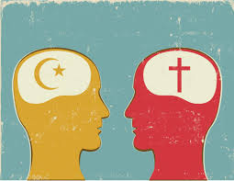

Focus 2

Food

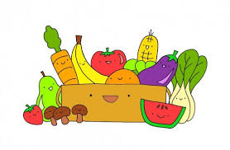

Focus 3

Lifestyle and Culture

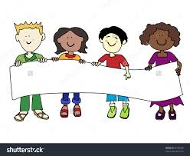

**Project Enhancements**

Visitors

Taste of History visitor. Sampling the foods of Islam- 9th October 2017

Imran 18th July 2017- A guest visitor to the school to explain what it means to live in Britain.

20-21 Visual Art Centre to help children create their virtual reality concept art. Date TBC

Class book

Mirrors by Jeannie Baker.

Creative Home Learning

The creative homework this term is to create a fashion accessory that celebrates Great Britain’s unique, diverse culture. This could be a blueprint of a design, or the real thing ranging from football boots, headbands, scarves, gloves etc.

**Project Outcomes**

This project will hopefully raise awareness that Great Britain is diverse and we should celebrate this, as well as realising that there are so many similarities between Muslim and Christian cultures- despite what is regularly reported in the media.

Throughout the project, the children will be working towards understanding that similarities stem from beliefs within the Holy books, which then translate into all walks of life from food and fashion to the arts and science.

The final exhibition will be a stall at Lincoln Christmas Market located at Westgate Primary School on Friday 8th December, where children will sell items that they have created throughout the journey of this project. All proceeds will go to the Ariana Grande and Red Cross appeal’s One Love Manchester charity, to help those families affected by recent events.

**How can you help?**

If you feel you can help us with our project this term we would love to hear from you.

In the meantime could we please ask you to talk to your child about the different religions within Britain and the idea of a collective and diverse community.