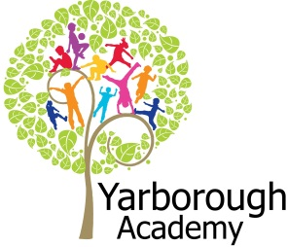

**Should the Victorians be known as vile?**

**Project Overview**

Our project this term is all about the Victorians and discovering if they were truly vile! We will begin by looking at Vile Victorian schools and what they were really like for children and teachers.

The children will be hooked into the learning through looking at episodes of Horrible Histories, clips of Oliver Twist and a special visitor, a Victorian teacher!

We will investigate lots of areas of life in the Victorian times, including what crimes and punishments there were, if the food really was disgusting as well as looking at child labour and what life was like for Victorian children on the streets.

As part of their project, the children will be creating a Vile Victorians episode for the Horrible Histories team to answer the question ‘Should the Victorians be known vile?’

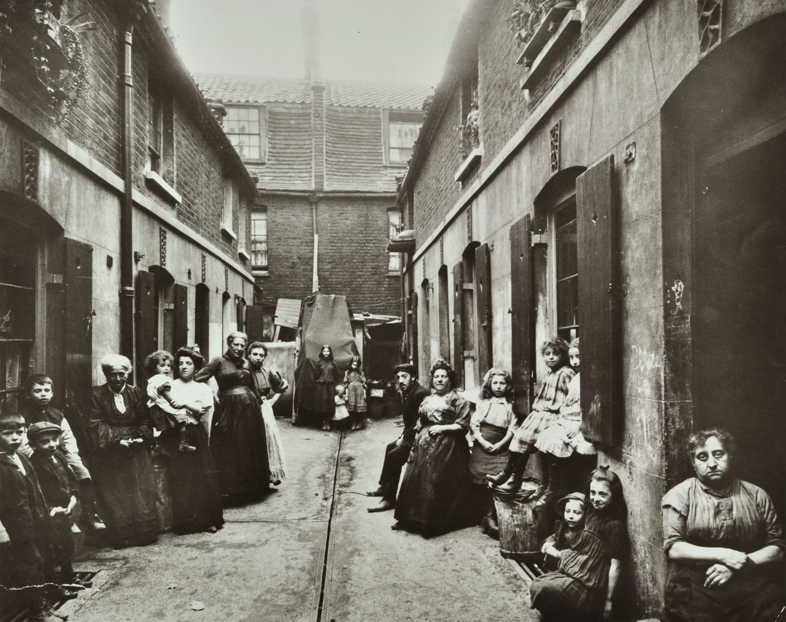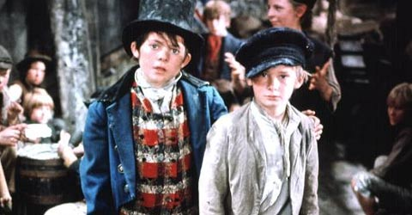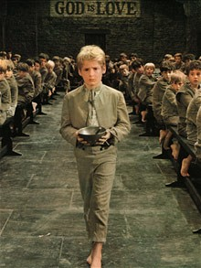

**Project Based Learning**

Year 3

Term 1

2015-2016

**Immersive Environment**

Our classroom will have a Vile Victorians theme and include:

A Victorian bookshop reading corner,

An evolving environment as a Victorian school, prison, and street.

Displays showing Victorian photographs.

**Curriculum Opportunities**

English

-Write instructions

- Write persuasively

- Write poems that convey an image

- Write diaries

Maths

- Use and apply measures

- Add, subtract, multiply and divide

- Money

- Gather, organise and interrogate data

Science

- Examine the properties of materials

- Look at the effect of diet

Art and Design

- Learn about great artists

- Improve mastery of techniques

Computing

- Design and write programs that accomplish specific goals.

D.T

- Design, make and evaluate their own street cart.

P.E

- Play and modify competitive games

Geography

- Use maps to describe features studied

- Use eight points of a compass, symbols and keys to build knowledge of the UK

History

- A study of a theme in British History

- Victorians

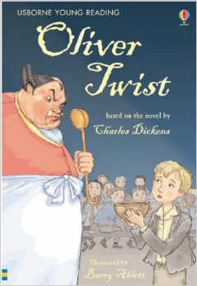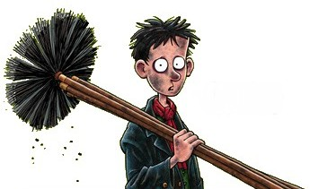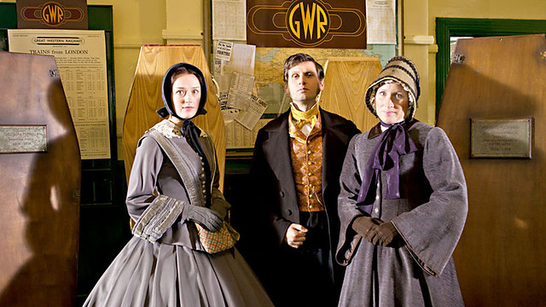

**Project Enhancements**

Trip

A trip to Lincoln Castle to visit a Victorian prison!

Visitors

A Victorian schoolteacher – 20/07/15

Class book

The Usborne version of Oliver Twist by

Charles Dickens

Creative Home Learning

Design and create some Victorian clothing to wear for the Exhibition

**How can you help?**

If you feel you can help us with our project this term we would love to hear from you.

Books to read: Vile Victorians by Terry Deary!

Useful websites:

<http://primaryhomeworkhelp.co.uk/victorians.html> A website with an introduction to who the Victorians were.

<http://www.bbc.co.uk/cbbc/shows/horrible-histories> Take a look at Horrible Histories clips, episodes and songs.

**Project Outcomes**

This project will involve the children using cross curricular skills to help them answer the essential question of ‘Should the Victorians be known as vile?’

Their final project will be to create a Vile Victorians episode for Horrible Histories.

The final exhibition will be an authentic Victorian street with food, protests, and a display of Victorian products!

The children will be Victorian children in the exhibition.

**Project Timeline**

Focus 1

Victorian School -

Looking at schools and creating a Victorian Schoolteacher’s diary entry.

Focus 2

Crime and Punishment –

Investigating the kinds of crimes and punishments from Victorian times and creating a comic strip based on this.

Focus 3

Food Glorious Food –

Researching different foods that were eaten at the time and how they were stored. Then creating food and writing instructions on how to make it!

Focus 4

Work –

Investigating the different kinds of work children had to do in the Victorian era and creating a protest movement about child labour.

Focus 5

Street children –

Looking at what the streets of Victorian London were like and what the difference was between a rich street and slum street. Then making artwork to show vile Victorian streets.