

**Immersive Environment**

Our classrooms will have three areas devoted to the three different focuses. Our classrooms will include Viking longships, shields, arrows flying through the air and sections of the Bayeux tapestry. The immersive environments will be changing throughout the term as we start each focus.

**Project Overview**

Our project this term is all about invasion. Our hook will involve some surprising discoveries in our classrooms and a message from pupils at Franklin College.

Our project will begin by looking at the Resilient Romans and their determination to succeed. Our next focus will explore the voyages of the Vikings and their surprise methods of attack. We will then investigate the Normans by looking at the Battle of Hastings and the Bayeux tapestry.

As Historians we will identify the invasion tactics of the Battle of Medway and evaluate its success. As Scientists we will test materials used for weapons and armour and use this to design our own. As Mathematicians we will choose the best array of soldiers for an invasion. As Historians we will voyage with the Vikings and investigate their methods and reasons for attack. As Writers we will stowaway on a Viking longboat to join a raiding party. As Scientists and Designers we will investigate how long ships float and create our own.

As Historians we will study the Bayeux Tapestry to deduce what has happened. As Writers we will recreate part of the Bayeux Tapestry into a modern day comic strip. As Artists we will create collage background scenery from the Battle of Hastings. As film makers we will re-enact and film battles.

**Resilient Romans, Voyaging Vikings or Nasty Normans – Whose was the Most Ingenious Invasion?**

**Project Based Learning**

Year 4

Term 2

2015-2016

**Curriculum Opportunities**

**History**

The Roman Empire and its Impact on Britain.

The Viking struggle for the Kingdom of England.

A study of a theme in British history.

**Geography**

Locate the world’s countries, with a focus on Europe and countries of particular interest to pupils.

Use maps, atlases, globes and digital/computer mapping to locate countries and describe features studied.

**Science**

Examine the properties of materials using various tests.

**Design Technology**

Select from and use a wider range of tools and equipment to perform practical tasks, such as cutting, shaping, joining and finishing, accurately. Generate, develop, model and communicate their ideas through discussion, annotated sketches, cross sectional and exploded diagrams.

**Writing**

Write non-chronological reports

Write stories that contain historical characters or events.

Write stories, letters and scripts inspired by reading across the curriculum.

**Reading**

Listen to and discuss a wide range of texts

Read and listen to a wide range of styles of text. Learn poetry by heart.

**Maths**

Rigorously apply mathematical knowledge across the curriculum.

**Communication**

Engage in meaningful discussions in all areas of the curriculum.

**Art**

Use experiences, other subjects across the curriculum and ideas as inspiration for artwork.

**Music**

Improvise and compose music using the inter-related dimensions of music separately and in combination.

**Computing**

Select, use and combine a variety of software on a range of digital devices to accomplish goals.

Use sequence, selections and repetition in programs; work with variables and various forms of input and output.

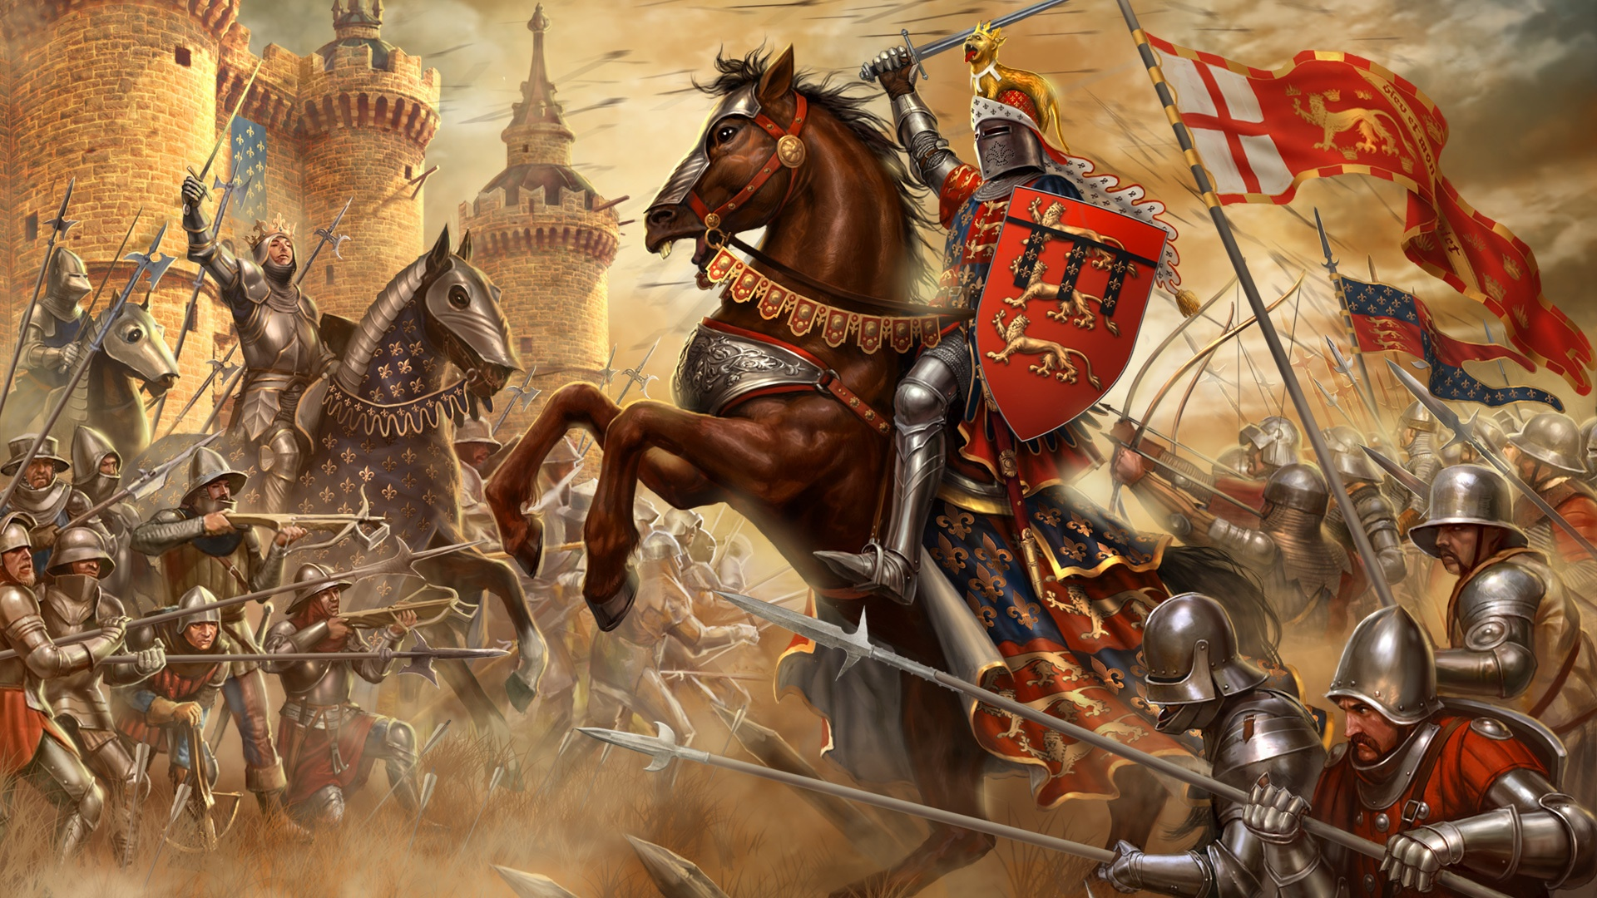

**Project Enhancements**

Trip

A visit to the Collection at Lincoln on 20th January and

Lincoln Castle on 10th March 2016.

Visitors

Franklin College pupils

Class book

‘Horrible Histories – Rotten Romans, Vicious Vikings, Stormin’ Normans’

Creative Home Learning

‘Battle in a box’, weapons and props for their re-enactment.

**Project Outcomes**

This project will involve the children using cross-curricular skills to help them answer the essential question of

**‘Resilient Romans, Voyaging Vikings or Nasty Normans – Who were the Greatest Attackers?’**

Their final project will be a re-enactment of their chosen battle; which will be filmed and edited using iMovie.

The final exhibition will be to showcase these films to pupils from Franklin College. This will take place on Friday 18th March at 10.30am in the school hall.

**Project Timeline**

Focus 1

Resilient Romans

* Battle of Medway
* Creating a shield
* Investigating weapons

Focus 2

Voyaging Vikings

- Battle of Lindisfarne

- Creating a longship

- Story about a Viking Stowaway

Focus 3

Nasty Normans

- Battle of Hastings

- Create collage of elements of Bayeux tapestry

- Comic strip of Bayeux tapestry

Focus 4

Let Battle Commence

- Battle / invasion music

- Performance poetry

- Re-enactment of battles

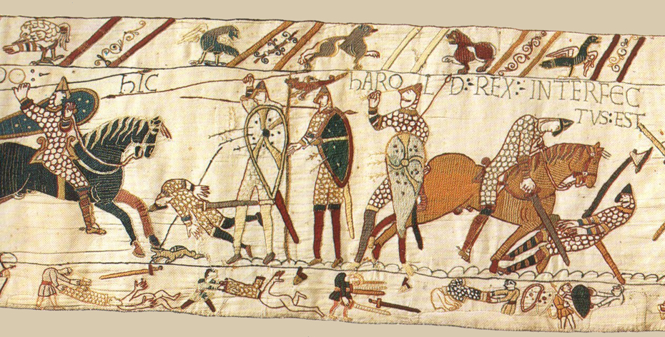

**How can you help?**

If you feel you can help us with our project this term we would love to hear from you.

**Useful websites:**

<http://www.primaryhomeworkhelp.co.uk/Romans.html#3>

<http://www.primaryhomeworkhelp.co.uk/viking/when.html>

<http://www.bbc.co.uk/history/british/normans/>

**Useful texts to read would be:**

Non-fiction texts about the Romans, Normans or Vikings. Please let us know any information that you find out.