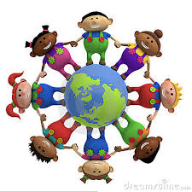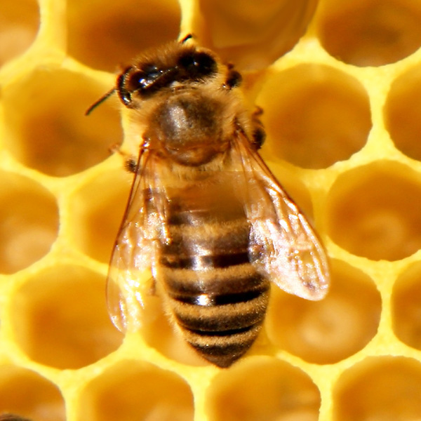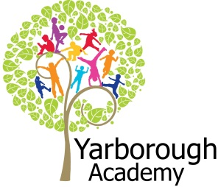

**Curriculum Opportunities**

**Writing**

-Write stories, letters, scripts and fictional biographies inspired by reading across the curriculum

-Write explanations

-Write recounts

-Write stories of adventure

**Mathematics**

-Count and calculate in increasingly complex contexts, including those that cannot be experienced first hand

- Deepen conceptual understanding of mathematics by frequent repetition and extension of key concepts in a range of engaging and purposeful contexts

- Describe position, direction and movement in increasingly precise ways

- Use and apply measures to increasingly complex contexts

- Rigorously apply mathematical knowledge across the curriculum, in particular in science, technology and computing.  
**Reading**

-Increase familiarity with a wide range of books, including myths and legends, traditional stories, modern fiction, classic British fiction and books from other cultures

- Take part in conversations about books

**Science**  
- Look at solids, liquids and gases, changes of state, evaporation, condensation and the water cycle

- Look at the movement of the Earth and the Moon

- Explain day and night

**Art**

- Use experiences, other subjects across the curriculum and ideas as inspiration for artwork

- Develop and share ideas in a sketchbook and in finished products

- Improve mastery of technique  
**Computing**

- select, use and combine a variety of software (including internet services) on a range of digital devices to accomplish given goals, including collecting, analysing, evaluating and presenting data and information.  
**R.E**

- Study the beliefs, festivals and celebrations of Christianity

-Study other religions of interest to pupils  
**Geography**

-Use a wide range of geographical sources in order to investigate places and patterns  
**DT**  
- Use research and develop design criteria to inform the design of innovative, functional, appealing products that are fit for purpose, aimed at particular individuals or groups

- Understand and apply the principles of a healthy and varied diet

**Immersive Environment**

Both classrooms will be turned into Narnia – with a snowy theme. The children will be involved in helping to create the rooms by making snowflakes and the like. This will be especially lovely at the end of term as we prepare for Christmas.

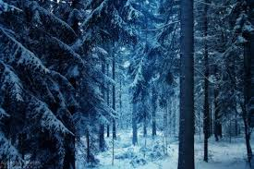

**Project Overview**

This term our project will be exploring how Narnia helped some children to escape the perils of WW2 – studying the novel The Lion, the Witch and the Wardrobe by C S Lewis.

We will begin our journey by immersing the children in a WW2 environment, so to create an empathy with the children of the time. We then move to a house in the countryside, where the children are safe. A clip of the film The Lion, The Witch and the Wardrobe will be shown – up to the part where the characters discover the wardrobe. The characters of the four children in the story will be studied and integrated within the immersive environment.

As writers, we will write a diary entry to record the feelings and emotions of the children as evacuees. We will also be learning the skills required to write a story using the same characters as in the book, but creating our own Narnia scene.

As mathematicians, we will apply our skills to calculating fractions and percentages of child evacuees, using coordinates to navigate a map of Narnia and working out the spacing of our pieces of art work in our exhibition.

As scientists, we will explore the changing states of matter (water to ice), how the seasons change and investigate night and day.

As artists, we will be illustrating Narnia using watercolours and displaying them in our art exhibition at The Grimsby Institute.

As designers our watercolour art is going to be modified, adding a Christmas theme, in preparation for creating our Christmas cards.

Following completion of our Christmas cards, the children will be treated to watching the film version of The Lion, The Witch and The Wardrobe.

Our final exhibition will be the sale of packs of our Christmas cards at the school Christmas fair. All proceeds from this sale will be donated to the War Child charity.

**How Could Narnia Save the War Child?**

**Project Based Learning**

Year 4

Term 1

2017-2018

**Project Enhancements**

Trip

We will be visiting Eden Camp on 11th September 2017, as part of the immersive experience to inspire our children for this project.

Visitors

Sue Baker from the music hub will hopefully be holding a workshop where the

children will learn to play some simple notes on the recorder.

Art Exhibition

Our watercolours of Narnia will be on display at The Grimsby Institute art space, on Tuesday 28th November.

Class book

The Lion, the Witch and the Wardrobe, by C S Lewis.

Creative Home Learning

We will be asking the children to create their own Narnia scene – using materials and presentation of their choice.

**How can you help?**

If you feel you can help us with our project this term we would love to hear from you.

If your child has their own descant recorder, please could they bring it in to school – with its cleaning brush if possible.

If you could talk to your child about how lucky they are not to live in poverty and to be able to receive so many Christmas presents, this would help them to empathise with children that the War Child charity are helping. Browse the website for more information: <https://www.warchild.org.uk/>

**Project Timeline**

Focus 1

Behind Closed Doors

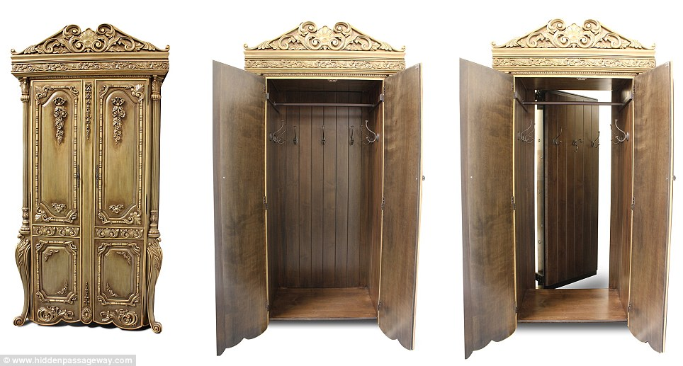

Focus 2

Finding Narnia

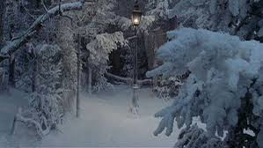

Focus 3

Cold As Ice

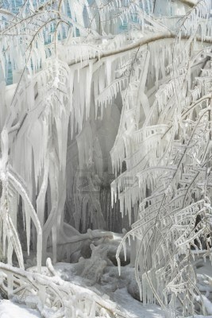

Focus 4

Christmas Cards of Narnia

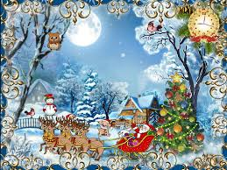

**Project Outcomes**

This project is designed for the children to empathise with other children who are less fortunate than themselves – starting with exploring the feelings of WW2 evacuees and leading on to illustrating the plight of children who will not be receiving any Christmas presents this year. We will then focus on the child evacuees who find Narnia and develop the project around this magical land where they escape from all things war.

Throughout the project, the children will be exploring different topics relating to Narnia – such as how water freezes to create snow, how the different seasons come about, light and dark, coordinates and map skills and percentages of children evacuated to the English countryside during WW2.

Our first exhibition will be displaying our art work which will be the inspiration for our Christmas cards.

Our final exhibition will be creating and producing Christmas cards (inspired by Narnia) to be sold at our Christmas Fair which will be held on Tuesday 5th December. We will donate the proceeds to the charity War Child – which raises funds for children in war-torn countries.