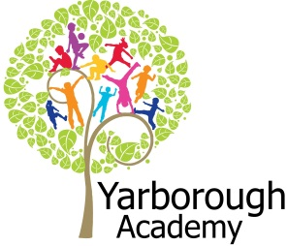

**Curriculum Opportunities**

**Art and Design**

* Use experiences, other subjects across the curriculum and ideas as inspiration for artwork.
* Improve mastery of techniques

**RE**

• Study the beliefs, festivals and celebrations of Christianity.

• Study at least two other religions in depth. Choose from Buddhism, Hinduism, Islam, Judaism or Sikhism.

• Study other religions of interest to pupils

**Geography**

• Use maps, atlases, globes and digital/computer mapping to locate countries and describe features studied.

**Reading**

• Increase familiarity with a wide range of books, including myths and legends, traditional stories, modern fiction, classic British fiction and books from other cultures.

• Take part in conversations about books.

• Learn poetry by heart

* Read and listen to whole books

**Writing**

• Write biographies.

* Write stories of mystery and suspense
* Write Haikus

**Design and Technology**

• Select from and use a wider range of materials and components including textiles according to their functional properties and aesthetic qualities

* Apply their understanding of how to strengthen, stiffen and reinforce more complex structures.

**Maths**

• Use and apply measures to increasingly complex contexts

* Count and calculate in increasingly complex contexts, including those that cannot be experienced at first hand

**Computing**

* Design and write programs that accomplish specific goals

**Science**

* Look at the movement of the Earth and the moon
* Look at the resemblance of offspring
* Look at adaptation to environments
* Look at differences in offspring
* Look at adaptation and evolution
* Identify and name plants and animals

**Music**

* Improvise and compose music using the inter-related dimensions of music separately and in combination

**How can we make school cool?**

**Project Overview**

Our project this term is all about improving and creating immersive areas around school. In our launch sessions the pupils will visit other schools in the area, an opportunity to create a piece of art to improve the school and redesign the classroom in ways to make it ‘cool’ to them. As interior designers, we will be investigating ways of making the sunshine and rainbow rooms ‘cool’. As writers, we will be writing haikus, suspense stories and autobiographies. As mathematicians, we will be investigating how to measure the area and perimeter of the rooms as well as investigating scale in order to create models of various items to go into the room. As scientists, we will examine the animals, plants and lifecycles of those who live in rainforests as the rainbow room is redressed as a rainforest. We will be investigating the adaptation of animals in order to use some in our stories for the room. As religious and cultural experts, we will be investigating what makes us ‘cool’ and make links to the wider community. As computer programmers, we will create moon programmes for children to use in the space room.

**Project Based Learning**

Year 5

Term 2

2016- 2017

**Immersive Environment**

Our classrooms will be designed by the children as part of their hook.

It will consist of what they deem to be ‘cool’.

**Project Outcomes**

This project will involve the children using cross curricular skills to help them answer the essential question of:

**‘How can we make school cool?’**

Their final project will be the transformation of rooms in Yarborough Academy for other children to use.

The final exhibition will be the grand unveiling of the rooms in conjunction with visitors from the other schools on Tuesday 28th March.

**Project Timeline**

Focus 1

How are we cool?

- A look at the cultural diversity around us and how we fit together in our school community.

Focus 2

The Sunshine Room

- The transformation of the Sunshine room to incorporate all things sci-fi.

Focus 3

The Rainbow Room

- Immersion of a rainforest setting with a suspense story interwoven through the trees.

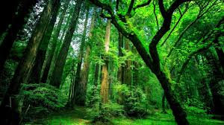

**Project Enhancements**

Trip

A visit to Whitgift Academy to create graffiti arwork (Jan 2017)

A visit to the church to hear presentation by Canon Peter Mullins (Jan 2017)

Visitors

Rachel M Raithby (award winning local author – March 2017)

Novel Study:

The Secret Garden by Frances Hodgson Burnett

Creative Home Learning

Children to create their own immersive ‘cool’ miniature classroom

**How can you help?**

- If you feel you can help us with our project this term we would love to hear from you!

- Perhaps you know of a family member who is a painter/decorator or interior designer who could help us?  
Useful websites:

<http://www.sciencekids.co.nz/sciencefacts/space/moon.html>

<http://www.rainforest-alliance.org/kids>