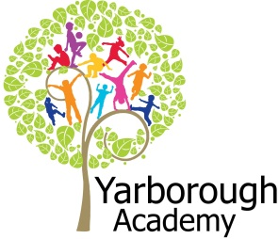

**Project Based Learning**

Year 3

Term 3

2015-2016

**Immersive Environment**

Our classrooms will have a holiday theme. We will take the four countries for inspiration.

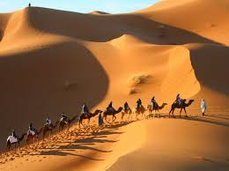 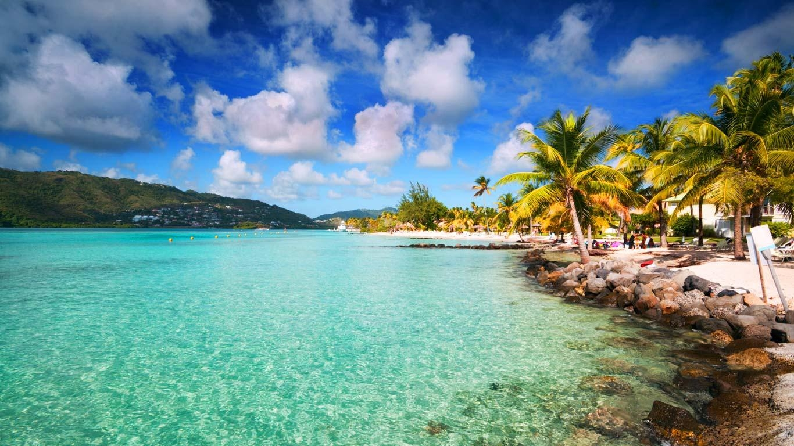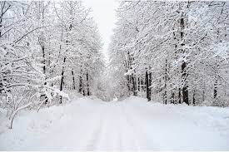

**Project Overview**

Our project this term is all about how we can showcase some amazing holiday destinations! We will start our project by hooking them in some mysterious suitcases. Each suitcase will have clues to what country it is expected to arrive at. We will then use this to create pictures for around our classroom. As geographers, the children will be finding out where the four countries are located around the world. The four countries that we will be focusing on are: France, Morocco, Martinique and Canada. We will also be looking at the weather in these countries. As these are all French speaking countries, we will be learning to speak, read and write in French. As historians and theologians, we will be looking at the famous landmarks that each country has and what religions they follow. We will use music as a basis to listen to and compose our own piece of music and design and technology to make a mode of transport that would get us to our destination. All of this will support the making of a travel brochure – which the children will try and persuade parents and travel agents to buy a holiday to their destination.

**Curriculum Opportunities**

English

* Write a cinquain poem
* Write a report
* Write a recount
* Write a set of instructions

Maths

* Explore numbers and place value so as to read and understand the value of all numbers.
* Use and apply measures to increasingly complex contexts.
* Gather, organise and interrogate data.

Science

* Look at transference of forces in gears, pulleys, levers and springs.
* Explain day and night

Art and Design

* Use experiences as inspiration for artwork;
* Improve mastery of techniques

Computing

* Use sequence, selections and repetition in programs
* Design and write programs that accomplish specific goals

D.T

* Use design, make and evaluate to make an end product

Geography

* Use maps to describe features studied
* Use eight points of a compass
* Locate the world’s countries, with a focus on Europe, North and South America and countries of particular interest to pupils.

Languages

In the chosen modern language:

* Speak
* Read
* Write
* Look at the culture of the countries where the language is spoken.

Religious Education

- Study the beliefs, festivals and celebrations of Christianity.

**How can we, as travel agents, showcase the perfect holiday destination?**

**Project Timeline**

Focus 1 - **Where it is?**

We will be looking at the location of our country and finding out interesting facts about this location

Focus 2 – **Landmarks and religion**

We will be looking at famous landmarks and the religion of the country.

Focus 3 - **Weather**

We will be looking at the weather and rainfall of the country we are studying.

Focus 4 – **History and language**

We will be focusing on the history of the country and the French language.

Focus 5 – **Art of the country**

We will be creating some art work of the landscapes from the four countries.

Focus 6 – **What is it like?**

We will be writing recounts of what life is like in the country we are focusing on.

Focus 7 - **Transport**

We will be designing and making a mode of transport to get to our destination.

Focus 8 - **Music**

We will be listening to music from our country and composing our own.

Focus 9 – **Travel brochure**

We will be putting our entire brochure together for our exhibition.

**How can you help?**

If you feel you can help us with our project this term we would love to hear from you.

**Useful websites:**

* <http://www.sciencekids.co.nz/sciencefacts/countries/france>.
* <http://www.kids-world-travel-guide.com/canada-facts-for-kids.html>
* <http://www.oddizzi.com/teachers/explore-the-world/places/africa/morocco/>
* <http://www.caribsurf.net/martinique/>

You could make a postcard from a place you visit over Easter and bring in some holiday brochures for our new project.

**Project Enhancements**

Trip

A trip to Cleethorpes to compare and contract a local holiday destination to the country we are studying.

Visitors

A visit from travel agents to share how they persuade customers to purchase a holiday.

Class book

Pea’s book of holidays and books from the Flat Stanley collection

Creative Home Learning

Creating artefacts from Morocco, Martinique, Canada and France.

**Project Outcomes**

This project will involve the children using cross curricular skills to help them answer the essential question of ‘**How can we, as travel agents, showcase the perfect holiday destination?**’

Their final project will be to create a travel brochure and persuade parents/ travel agents to book a holiday in that country.

The final exhibition, at 2pm on Tuesday 12th July 2016, will be a sales pitch to parents and travel agents. We will see who has created the best brochure and which country is the most popular holiday destination.