

**Where could a pirate hide his treasure?**

**Project Overview**

Our project this term will be all about pirates and their treasure. We will be finding out what a pirate is and what he looks like. We will consider what a pirate needs to be able to transport and hide his treasure, before finally deciding on suitable places to hide the treasure.

The children will be hooked into their learning through a “Pirate Adventure to find the Golden Underpants” based on the story Pirates Love Underpants. They will also discover the classroom taken over by pirates and have to solve clues to find our hidden resources.

The conclusion of our project will be a treasure hunt around school, solving clues linked to all the different things we have learnt over the term.

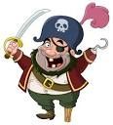

**Project Based Learning**

Nursery/FS1

Term 1

2015-2016

**Immersive Environment**

Our inside and outside classroom will have a pirate theme including: a home corner based in a pirate boat; a big sandpit to find hidden treasure; a treasure chest with our sound of the week inside; a walk the plank obstacle course; and pirate dressing up.

**Curriculum Opportunities**

**Personal, social and emotional development** – self portraits, right or wrong about pirates, making pirate equipment, the value of treasure and visits.

**Communication and language** – pirate talk, parrot talk, nursery rhymes, getting into character of a pirate, making a treasure map.

**Physical development** – dressing up, digging for treasure, swashbuckler challenge, walking the plank, making boats, threading necklaces.

**Literacy** – alliteration, stories, I spy, feathers to paint, message in a bottle, drawing circles and lines for treasure maps.

**Maths** – numcion treasure, shapes on a pirate flag, ordering size of boats, directions, sorting and counting treasure, making gold coins.

**Understanding the World –**pirate biscuits, famous pirates, design a flag, floating and sinking, hiding treasure.

**Expressive arts and design –** pirate sounds with the instruments, colours of bandanas, making pirate equipment, craft boats, design own island.

**How can you help?**

If you feel you can help us with our project this term we would love to hear from you.

If you have any old pirate dressing up clothes that you would be happy to donate to school, please inform a member a staff.

Please read any pirate books with your child and watch pirate films or shows, so they have a basic understanding of pirates.

Sing pirate songs, such as ‘When I was 1 I had some fun the day I went to sea, I jumped aboard a pirate ship, And the captain said to me.’ (See youtube for further lyrics.)

**Project Enhancements**

Trip

Pirate ship at sandpit in Cleethorpes, Wednesday 30th September

Class book

‘Pirates love underpants’ by Claire Freedman and Ben Cort

Creative Home Learning

Making pirate ships and treasure chests

**Project Outcomes**

This project will involve the children using cross curricular skills to help them answer the essential question of “Where could a pirate hide his treasure?”

Their final project will be making clues for a treasure hunt around school. The treasure hunt will be the exhibition at the end of term.

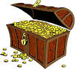

**Project Timeline**

Focus 1

What is a pirate?

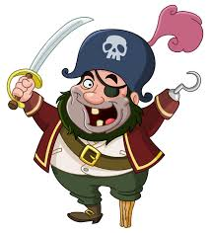

Focus 2

What does a pirate do?

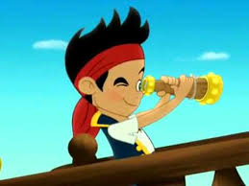

Focus 3

What is a pirate ship?

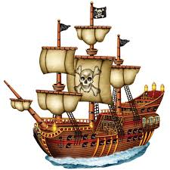

Focus 4

What is treasure?

