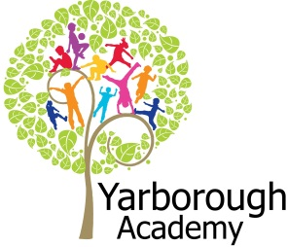

**Curriculum Opportunities**

English

Write labels and captions.

Write Poems that use pattern, rhyme and description.

Write non-chronological reports.

Learn some poems by heart.

Speak to small and larger audiences.

Maths

Multiply and divide.

Use language to describe position, direction and movement.

Use measures, including time.

Odd and even numbers.

Science

Identify, classify and observe animals.

Investiage differences of living things.

Compare properties and changes.

Art and Design

Explore a variety of techniques.

Computing

Participate in class social media accounts.

Use a range of appliances and devices in order to communicate ideas, work and messages.

Music

Use their voices expressively by singing songs and speaking in chants and rhymes.

Geography

Investigate the world’s continents and oceans.

PE

Copy and remember actions.

Link two or more actions to make a sequence.

RE

Identify how they have to make their own choices in life.

Explain how actions affect others.

**Immersive Environment**

Our classroom will look like under the sea and include:

A large submarine.

A variety of fish and sea creatures hanging from the ceiling.

Under the sea displays.

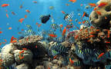

**Project Overview**

Our project this term is to learn about what it would be like to live under the sea. The children will be introduced to oceans and learn about where they are. They will then begin to learn about all the different creatures that live under the sea. They will be using all their new found skills and knowledge to create a video to educate children who visit ‘The Deep’ about living under the sea. We will be visiting The Deep to give us some ideas! The exhibition will be for the children to show a performance of this video that can then be recorded.

The children will be hooked into the learning by watching ‘Finding Nemo’ where children can then decide how they would like their immersive classroom to look and what they would like to put in it.

The children will be Scientists and learn about how water is made, to classify different animals that live under the sea. They will be measuring, comparing and writing non-chronological reports and poetry pieces.

**Project Based Learning**

Year 1

Term 2

2015-2016

**What would it be like to live under the sea?**

**How can you help?**

If you feel you can help us with our project this term we would love to hear from you.

Can you find out about different things that live under the sea?

We will be writing non-chronological reports so any facts and information will help us learn more about various animals that live under the sea!

Here is a useful website to start discussions about life under the sea <http://www.bbc.co.uk/education/clips/zx676sg>

**Project Enhancements**

Trip

The Deep- Wednesday 27th January 2015

Visitors

Margaret Deller- Jonah and the Whale workshop.

Dance and light performance.

Class book

Stories linked to under the sea i.e. The fish who can wish, Rainbow fish, The very smiley shark.

Creative Home Learning

Create an underwater scene.

**Project Timeline**

Focus 1

Oceans

Focus 2

Who lives under the sea?

Focus 3

Commotion in the ocean.

Focus 4

Performance

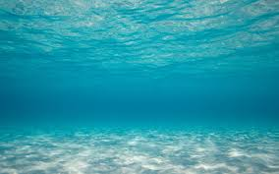

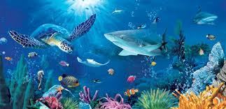

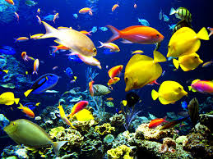

**Project Outcomes**

This project will involve the children using cross curricular skills to help them answer the essential question of ‘What would it be like to live under the sea?’

Their final project will be to create an educational video for ‘The Deep’.

The final exhibition will be a performance of the children answering the essential question. We will be recording the performance to make into our video.

Date- Monday 21st March 2016 at 1.45pm in the school hall.